Using Lagrange Multiplier Method in Dynamic Finite Element Analysis of Frames with Nonlinear Multi-Freedom Constraints under Harmonic Loading

Ngoc Tien Dao 1[0000-0003-0474-0535], Thi Bich Quyen Vu 1[0000-0002-7121-5637], and Thi Thuy Van Tran 1[0000-0003-4873-3898]

1 Faculty of Civil Engineering, Hanoi Architectural University, Vietnam

quyenvtb@hau.edu.vn

**Abstract.** This paper focuses on the dynamic finite element analysis of the frames having nonlinear multi-freedom boundary constraints under harmonic loading. The establishing solving equation of the frame system with nonlinear multi-freedom constraints requires mathematical technique to incorporate the nonlinear multi-freedom constraints into the master stiffness matrix of the frame for dynamic analysis. This work proposes a way to employ the Lagrange multipliers method for constructing the nonlinear dynamic finite element equation of a frame system with nonlinear multi-freedom constraints. Using the Lagrange multipliers method to convert a constrained problem into an unconstrained problem, the nonlinear dynamic finite element system of equation is constructed. For solving the nonlinear dynamic system of equations of frames under harmonic excitation is employed combining the Newmark integration method and the Newton Raphson iteration method. The established incremental iterative algorithm based on combining these methods is used to write the calculation program for investigating the vibration of the plane frames with nonlinear multi-freedom constraints subjected to harmonic load. The numerical test results show the efficiency of the proposed algorithm in the dynamic analysis of frames with nonlinear multi-freedom constraints under harmonic excitation.

**Keywords:** Mixed FEM, Geometrically nonlinear analysis of truss, Lagrange multiplier method, Thermal load, Multi-freedom constraint.

1. Introduction

Studying the dynamic behavior of frames subjected to harmonic load is very important in structural analysis and design. In modern structural analysis, establishing mathematical models and solving algorithms for investigating the dynamic behavior of frame systems deal with utilizing the finite element method [1]. For dynamic finite element analysis of the frames with nonlinear multi-freedom constraints, establishing solving procedure requires a mathematical technique for incorporating the nonlinear boundary relation to the master stiffness equation and consequently complicates the algorithm for solving nonlinear time-dependent problems. The mathematical techniques used for imposing the nonlinear relation to the master stiffness equations are usually based on optimization techniques to convert the constrained problem into an unconstrained problem [2-4]. The most efficient methods for treating the nonlinear boundary constraints in finite element analysis are the Penalty function method and the Lagrange multiplier method. The penalty function method is a straightforward and easy computer implementation but is faced with the difficulty of choice of weight values [5-7]. To overcome the difficulties of implementation of the Penalty function method, in this research, the Lagrange multiplier method is developed for incorporating the nonlinear boundary constraints. The proposed approach in this research is based on the continuation and development of the proceeding published works [8-9]. The finite element dynamic equilibrium equation is built by extremizing the Hamiltonian function of the frame system under a time-dependent load. The nonlinear multi-freedom constraints are incorporated into the dynamic equilibrium equation by developing the Lagrange multiplier method. The combination of the Newmark integration method and Newton Raphson iteration method is adopted for establishing the incremental iterative method for solving the nonlinear time-dependent equation of the frame system. Utilizing the proposed solving algorithm, the calculation program for the numerical test of the dynamic behavior of the frame system with nonlinear multi-freedom constraints under harmonic load is written in Matlab software.

1. Problem formulation

For establishing a FEM dynamic equilibrium equation, consider the nth-DOF plane frame with “m” nonlinear multi-freedom constraints, expressed as or .



**Fig. 1.** Model of the frame system having nonlinear multi-freedom boundary constraints subjected to harmonic load.

The kinetic energy **T** and strain energy **V** can be defined as follows

 (1)

 (2)

The sum of the work done by damping force and external harmonic force is computed as

 (3)

Where:  - time-dependent nodal displacement vector;  - nodal velocity and nodal acceleration vectors; - mass matrix of the finite element frame system;  **K** – frame stiffness matrix; **C** – frame damping matrix;  - Rayleigh damping force vector; - external force vector.

According to Hamilton’s principle of least action [5,6,7,8,9], the motion of the dynamical system between two points at time intervals is extremum for the actual path. The Hamiltonian augmented potential energy function of the frame system can be computed as

 (4)

The modified dynamic equilibrium equation of the system can be developed by minimizing the Hamiltonian function augmented potential with satisfying the nonlinear boundary constraints, described as

 (5)

The Langrage multiplier method is adopted to incorporate nonlinear constraints and convert the constraint problem into an unconstrained problem. By adding the Lagrange multipliers, collected in vector , the augmented potential energy function  can be constructed based on the Hamiltonian function as follows

 (6)

Setting

 (7)

Writing equation (7) in a compact form

 (8)

And the problem is becoming

 (9)

The necessary and sufficient condition for the augmented potential energy function is minima if the Euler equation is satisfied as

 (10)

Adding from equation (7) to equation (10), getting

 (11)

With 

Replacing the kinetic energy, strain energy, and work done by damping force and external force from equations (1-3) to equation (11), having

 (12)

Replacing to the equation (12), getting the modified system dynamic equilibrium equations incorporated nonlinear multi-freedom constraints

 (13)

The vector of nodal displacement and vector of Lagrange multipliers are unknowns of the dynamic equilibrium equation (13) and can be found by solving (14)

 (14)

The system of equations (14) is nonlinear, including a nonlinear second-order differential equation (14.1). The approach for solving the nonlinear differential equation is based on dividing the total load into incremental load steps in finite element analysis. The incremental dynamic equilibrium equation of the system is developed by expanding the Taylor series for a short around of variable point, and keeping linear terms , getting

 (15)

Where: - vector of incremental nodal displacements (unknowns); - incremental acceleration vector, incremental velocity vector, and incremental Lagrange multipliers vector;  - Hessian matrix of a function .

The system (15) can be written as follows

 (16)

The expression  is developed according to the nonlinear boundary constraints.

The solving procedure of a nonlinear dynamic system of equations includes solving dynamic equations and solving nonlinear static equations. Newmark’s method is employed for solving a dynamic system of equations under a time-dependent harmonic force [1,10] to convert differential equations of motion of a structure to an incremental as

 (17)

Where: according to Newmark’s average acceleration method;  according to Newmark’s linear acceleration method.

Replacing  from equation (17) to equation (16), having

 (18)

Designating

- expanded incremental vector of unknowns (including incremental displacements and Lagrange multipliers);

 - expanded tangent stiffness matrix;

 - expanded incremental load vector.

Therefore, the equation (18) can be expressed in compact form as

 (19)

1. Solving algorithm

For solving the time-dependent incremental equation, the incremental-iterative algorithm is established utilizing the Newton Raphson technique [11-14] (shown in fig.2). The incremental equation can be described as

 (20)

Where





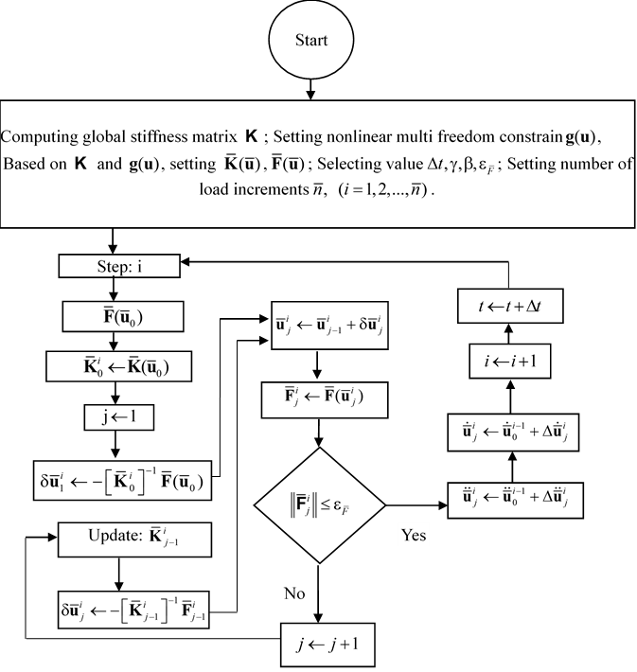

**Fig. 2.** Block diagram of the algorithm for solving dynamic problem of frame system with nonlinear multi freedom constraints subjected to harmonic load based on Newton Raphson technique

1. Numerical example

Investigating the dynamic response of plane frame with nonlinear multi-freedom constraints (at nodes 1,2,3) under the action of harmonic load (shown in fig. 3). All frame elements have the same cross-section area and made of the same material. The parameters are given as follows:





**Fig. 3.** Investigated frame system with nonlinear multi freedom constraints subjected to harmonic load

The boundary relation according to nonlinear multi-freedom constraints is described as

.

The numerical investigation is done as the result of running a calculation program written based on the proposed incremental-iterative algorithm. Employing the Newmark’s average acceleration method (), and investigation time period with time increment.

The calculation results of the dynamic analysis of the investigated system are the displacement-time response and bending moment-time response (shown in Fig.4&5) corresponding to several cases .

**Fig. 4.** Displacement - time response (u1-t) and (u4-t)

**Fig. 5.** Bending moment - time response (M2-t)

1. Conclusion

In this research, the algorithm for solving the dynamic problem of the frame having nonlinear multi-freedom subjected to harmonic load based on FEM had been established. The optimization technique of the Lagrange multipliers method is efficient for incorporating nonlinear multi-freedom constraints and constructing modified dynamic equilibrium equations by extremizing the Hamiltonian function and converting a constrained problem into an unconstrained problem. The established algorithm shows a remarkable advantage in solving the nonlinear time-dependent equations for analyzing the dynamic behavior of the frame system subjected to the harmonic load.

References

1. Anil K. Chopra (2007), Dynamics of Structures Theory and Applications to Earthquake Engineering, Prentice Hall.
2. J. J. Strodiot (2002) Numerical Methods in Optimization, Namur - Belgium
3. W. Sun and Y -X. Yuan (2006) Optimization Theory and Methods - Nonlinear Programming, Springer
4. K. A. Rajesh (2015) Optimization: Algorithm and Application, Taylor & Francis Group
5. V.T.B. Quyen, D.N. Tien and N.N. Dung (2020) A modified penalty function method for treating multi freedom constraints in finite element analysis of frames, J. Phys.: Conf. Ser. 1425 012097. doi:10.1088/1742-6596/1425/1/012097
6. 8. V.T.B. Quyen, D.N. Tien, and P. V. Dat (2020) Treatment of multi freedom constraints in geometrically nonlinear stability analysis of truss structures using penalty function method, IOP Conf. Ser.: Mater. Sci. Eng.962 022069. doi:10.1088/1757-899X/962/2/022069
7. 9. V.T.B. Quyen, D.N. Tien, N.N. Dung, and C.Q. Khanh (2020) Penalty function method for imposing nonlinear multi freedom and multi-node constraints in finite element analysis of frame systems, IOP Conf. Ser.: Mater. Sci. Eng. 869 052063. doi:10.1088/1757-899X/869/5/052063
8. V.T.B. Quyen,, D.N. Tien, and N.T.L. Huong (2020) Treatment of nonlinear multi freedom boundary constraints in finite element analysis of frame system using Lagrange multiplier method, IOP Conf. Ser.: Mater. Sci. Eng. 960 022076. doi:10.1088/1757-899X/960/2/022076
9. V.T.B. Quyen, D.N. Tien, and P. V. Dat, Lagrange Multiplier Method for Treatment of Nonlinear Multi Freedom Constraints in Dynamic Finite Element Analysis of Truss System Subjected to Harmonic Load, Lecture Notes in Civil Engineering, 189 (2021)
10. Newmark, N. M. (1959) ‘A Method of Computation for Structural Dynamics’, Journal of the Engineering Mechanics Division, ASCE, 85, pp. 67-94.
11. 11. Crisfield, M. A., A (1981) Fast Incremental/Iterative Solution Procedure That Handles Snap-Through, Comput. Struct., 13(1–3), pp. 55–62A
12. 12. M. A. Crisfield (1997) Non-Linear Finite Element Analysis of Solids and Structures, Volume 1&2, John Wiley & Sons Ltd. 1997
13. 13. Riks, E. (1972) The Application of Newton’s Method to the Problem of Elastic Stability, ASME J. Appl. Mech., 39(4), pp. 1060–1066
14. Ambrosio L., Dancer N. (1999), Calculus of Variations and Partial Differential, Springer Verlag.