Strengthening Pre-cracked Post-tensioned Concrete Beams with CFRP Composites
Phuong Phan-Vu^{1,*} and Duong T. Tran²
¹ Faculty of Civil Engineering, Ho Chi Minh City Open University, 35-37 Ho Hao Hon, District 1, Ho Chi Minh City, Vietnam
² School of Civil and Mechanical Engineering, Curtin University, Kent St, Bentley, WA 6102, Australia
Corresponding author: phuong.pv@ou.edu.vn
Abstract. The effectiveness of externally bonded carbon fiber-reinforced polymer (CFRP) systems in strengthening pre-cracked concrete beams post-tensioned with unbonded tendons is not yet fully understood. Therefore, the objective of this experimental study is to partially fill this knowledge gap. The experimental program was comprised of four large-scale unbonded post-tensioned concrete (UPC) beams. One of the beams was loaded continuously to failure while the other three beams were first pre-loaded to simulate pre-damage. One of the pre-damaged beams was then loaded to failure while the remaining two beams were strengthened with four and six layers of CFRP composite sheets before being loaded to failure. The CFRP strengthening sheets has demonstrated its capability in restoring the functionality of the heavily pre-damaged UPC beam as well as enhancing the performance of the beam. By controlling cracks, carrying tensile stress and reducing beam stiffness degradation, the CFRP sheets significantly improved the behavior of precracked UPC beams in terms of crack, displacement and loading capacity as compared to the unstrengthened precracked beam. The performance of the FRP-strengthened precracked beams was even better than that of the unstrengthened beam without pre-cracks in the ultimate phase.
Keywords: pre-damaged/cracked; post-tensioned concrete; strengthening; CFRP composite sheets.
- Introduction
Damage in the form of cracks will inevitably appear in concrete structures since during their lifespan, they are subjected to many damage-inducing factors such as corrosion, accidental loads, fatigue loads, overloading, and design and/or construction flaws. Cracks can decrease the integrity, stiffness and load-carrying capacity of the structure [1]. Since possessing many merits such as high strength-to-weight ratio, fast construction and non-corrodibility, externally bonded carbon fiber-reinforced polymer (CFRP) sheets are widely adopted as an effective method to repair and strengthen damaged structures [2-4]. However, strengthening damaged prestressed concrete (PC) beams using CFRP sheets has just been investigated on the beams with bonded tendons [2, 3, 5, 6]. Investigations regarding the CFRP-strengthening effectiveness on damaged beams prestressed with unbonded tendons are very limited and thus much needed. It is noteworthy that unbonded tendons are widely used in practice owing to faster installation and lower construction and maintenance costs in comparison to the bonded counterpart. The response of unbonded PC (UPC) structures is dissimilar to that of bonded PC (BPC) structures due to the unbonded nature of the tendon. In the former, strain compatibility between the unbonded tendon and adjacent concrete cannot be found and prestressing forces are only transferred to the structure via the tendon anchorages [7-9]. Hence, the analysis of UPC structures is more complex than that of BPC structures [10, 11].
This paper is to experimentally investigate the strengthening effectiveness of CFRP composite sheets in restoring and enhancing the performance of precracked UPC beams. The testing program is carried out on four large-scale UPC beams with a T-section. The failure pattern, displacement response and load-carrying capacity of unstrengthened precracked and non-precracked UPC beams and CFRP-strengthened precracked UPC beams are thoroughly examined in this paper.
- Experimental program
  - Beam specimen and materials
Four large-scale concrete beams with a T-section were fabricated and tested, i.e., Beams B0, RB0, RB4 and RB6. Beam B0 is not strengthened with CFRP sheets and loaded continuously to failure while the remaining is first pre-loaded with few loading cycles to simulate pre-damage. One of the pre-damaged beams is then loaded to failure, which is Beam RB0, while the other two beams are strengthened with four and six layers of CFRP composite sheets before being loaded to failure (Beam RB4 and RB6, respectively). Commercial concrete with the mix design mentioned in [9, 12] was used. The concrete slump was 120±20 mm, which was commonly adopted to make reinforced concrete beams [1, 13]. The compressive strength and splitting tensile strength of the concrete were respectively 48.4 MPa (COV = 0.02) and 5.9 MPa (COV = 0.05), which were determined from six 150×150×150-mm³ concrete cubes following [14, 15]. The CFRP strengthening sheets had a longitudinal modulus of elasticity of 201 GPa (COV = 0.08), a tensile strength of 3,579 MPa (COV = 0.16) and a rupture strain of 17.8‰ (COV = 0.1). These properties were determined as per ASTM D3039/D3039M [16]. The nominal thickness of the CFRP sheets was 0.17 mm. The epoxy adhesive used to bond the CFRP sheets had Young’s modulus of 3–3.5 GPa and a tensile strength of 60 MPa, which were provided by the manufacturer.
The beam detail is illustrated in Fig. 1. The design of the beam specimen was also used in previous experimental investigations [9, 12]. The beam has a span-to-depth ratio (L/d_{p}) of 26, which is within a commonly-used range for PC beams [17] and results in the flexural mode being dominant in the beam behavior [18, 19]. Two unbonded tendons acted as the prestressing reinforcement. The tendon was seven-wire strands with a nominal diameter of 12.7 mm, a nominal yield strength of 1,672 MPa, a tensile strength of 1,860 MPa and Young’s modulus of 196 GPa. These properties were guaranteed by the manufacturer. The effective prestress was 960 MPa, which was determined from the strain measurement during the prestressing process. As used in many studies [8, 9, 20], Class U in ACI 318-19 [21] was observed for the beam specimen design. The auxiliary reinforcement used in this study had Young’s modulus of 200 GPa. The longitudinal rebars had a yield strength of 430 MPa (COV = 0.02) and a tensile strength of 600 MPa (COV = 0.03). The corresponding values for the stirrups were respectively 342 MPa (COV = 0.03) and 463 MPa (COV = 0.01).
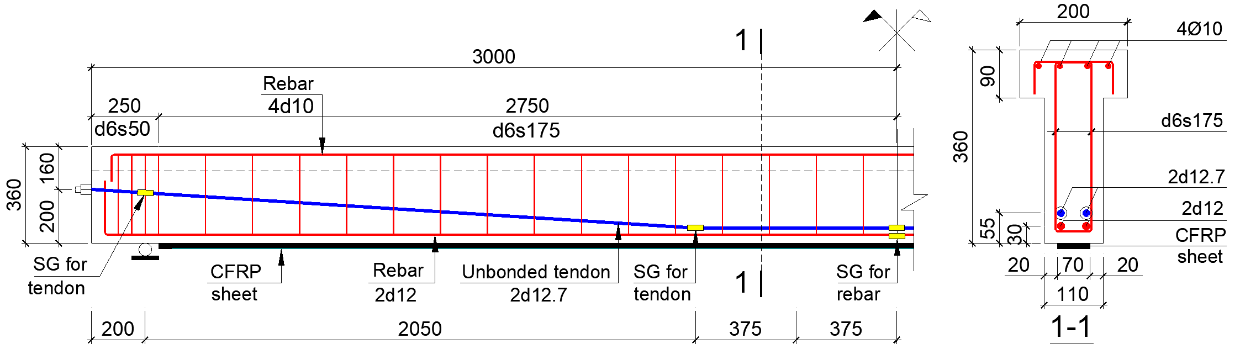
Fig. 1. Details of the beam specimen.

  - Experimental setup
The experimental setup is depicted in Fig. 2. All the beam specimens were subjected to two loading processes, namely pre-cracking and ultimate loading, except Beam B0 which was loaded continuously to collapse. In the pre-cracking process, to create damage, the beam was loaded with 6 loading cycles with the upper and lower load levels of 90 kN and 8 kN, respectively. The number of loading cycles was adopted from [22]. The upper load level was chosen to generate a crack width of 0.3 mm, which is the limit of the serviceability state according to Eurocode 2 [23], based on the test results of the crack width of Beam B0. The upper load level equaled 62% of the real loading resistance of the beam. The lower load level represented dead loads based on [9]. Afterward, the specimen was unloaded completely and the CFRP strengthening took place with a curing period of 7 days. It is noteworthy that the cracks in the beam almost closed when the beam was unloaded due to the prestressing effect. Then, the ultimate loading process was conducted, whereby the beam was loaded to collapse with a load-controlled procedure.
Five strain gauges (SGs) were used to measure the tendon strain with their locations shown in Fig. 1. The strain of the tensile rebar at midspan was recorded with one SG (see Fig. 1). Three SGs were used for the CFRP sheets as shown in Fig. 2. Concrete strain across the beam height at midspan was measured by six SGs (Fig. 2). A hydraulic jack was used to exert loads on the beam and the load was recorded using a load cell. The beam displacement was recorded by linear variable differential transducers (LVDTs) (see Fig. 2). All the test data were obtained through an acquisition device automatically, except for crack width measured manually using microscopes.

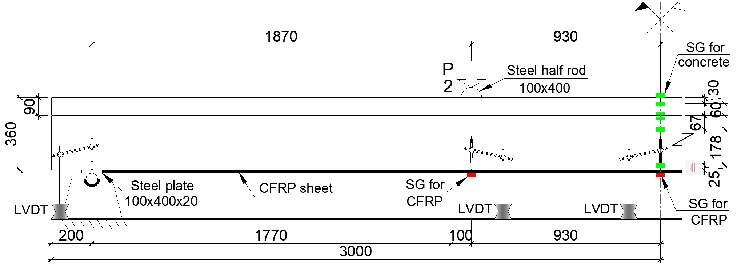
Fig. 2. Setup of the test.
- Experimental Results and Discussions
  - Failure pattern
The experimental results are summarized in Tabe 1 while Fig. 3 shows the crack patterns of the tested beams. Both the unstrengthened Beams B0 (non-precracked) and RB0 (precracked) failed in a bending mode, demonstrated by the crushing of concrete in the compression zone (see Figs. 3a and b) and the yielding of the non-prestressed and prestressing reinforcements. The width of the flexural crack at ultimate (w_{cr,u}) of the tested beams was recorded at a load of roughly 95% of the maximum load (P_{u}) of the beam. By which way, w_{cr,u} of Beams B0 and RB0 were 1.4 mm and 1.5 mm, respectively (see Table 1).
Table 1. Summary of the experimental results.
Beams | P_{cr} or P_{ro} | P_{ser} | P_{u} | δ_{u} | ε_{p,u} | ε_{f,u} | w_{cr,u} | Failure mode
 | kN | kN | kN | mm | ‰ | ‰ | mm
B0 | 46 | 75 | 145 | 75 | 8.9 |  | 1.4
RB0 | 25 | 51 | 126 | 111 | 8.5 | - | 1.5 | CC+ RY+ TY
RB4 | 30 | 63 | 156 | 87 | 7.5 | 7.2 | 0.7 | D+RY
RB6 | 33 | 63 | 173 | 91 | 7.7 | 4.9 | 0.7 | D+RY
Note: P_{cr} (only for Beam B0), P_{ro}, P_{ser} and P_{u} are respectively the cracking load, crack-reopening load, serviceability limit load and ultimate load of the beam; δ_{u} is the ultimate midspan displacement of the beam; ε_{p,u} is the maximum strain of tendons; ε_{f,u} is the maximum strain of CFRP sheets; w_{cr,u} is the width of flexural crack at ultimate; CC = crushing of concrete; RY = tensile rebar yielding; TY = tendon yielding; and D = debonding of CFRP sheets.
The CFRP-strengthened Beams RB4 and RB6 had a failure mode different from the unstrengthened beams. These beams failed due to the yielding of tensile rebars and the debonding of CFRP sheets. The concrete in the compression zone did, however, not crush and the prestressing reinforcement tendon did not yield at these beams’ failure (Figs. 3c and d). The CFRP sheets started debonding in the constant-moment region owing to large flexural cracks. The CFRP debonding then propagated towards the supports of the beams. After the debonding of CFRP sheets, Beams RB4 and RB6 still had a residual capacity as the unstrengthened precracked Beam RB0 (see the load-displacement curve of the beams in Fig. 4). The width of flexural cracks (w_{cr,u}) at ultimate was 0.7 mm for both Beams RB4 and RB6 (see Table 1), which was smaller than of the unstrengthened beams B0 and RB0. This result demonstrates the effectiveness of the CFRP sheets in resisting tensile stress and thus controlling the development of cracks in the beams. The CFRP sheets also helped reduce the stress in the tendons, which is evident from the maximum tendon stress of the strengthened beams smaller than that of the unstrengthened beams as summarized in Table 1.
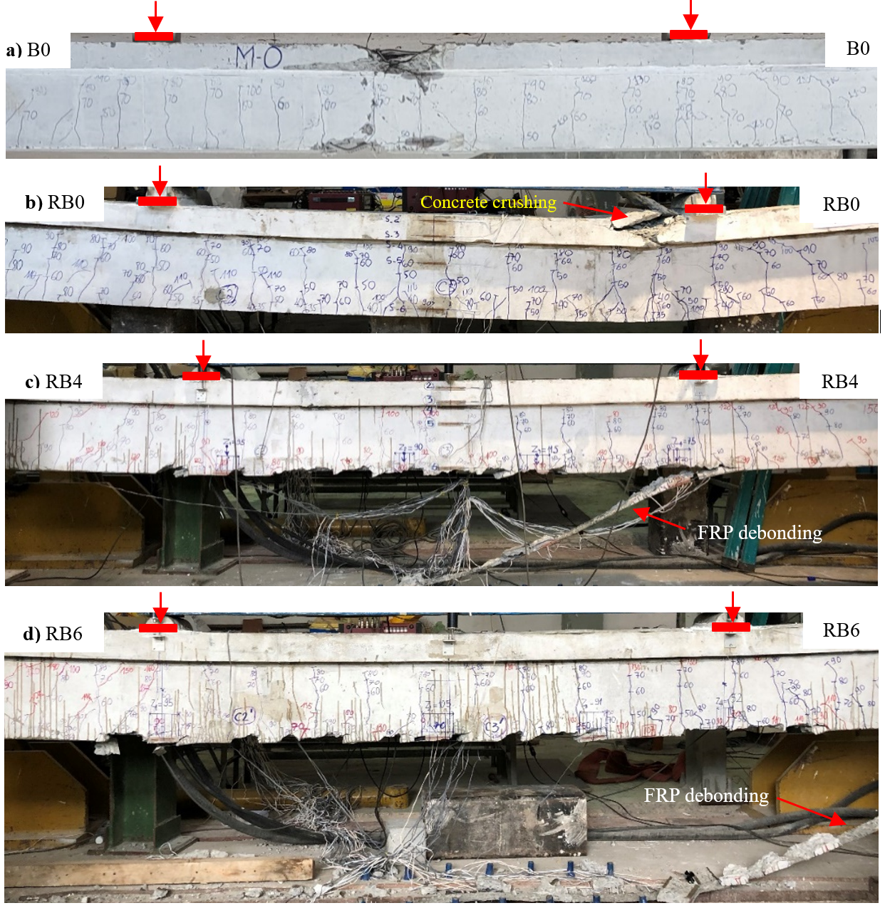
Fig. 3. Failure pattern of the tested beams: (a) Beam B0, (b) Beam RB0, (c) Beam RB4, and (d) Beam RB6.
  - Displacement response
The applied load-displacement relationships of the tested beams are displayed in Fig. 4. The beam displacement can be classified into three phases: linear, serviceability and ultimate phases. The load-displacement curve was linear in the first phase starting from zero to the cracking load P_{cr} for the unstrengthened non-precracked Beam B0 or crack-reopening load P_{ro} (load level corresponding to the re-opening of cracks) for the remaining beams. The crack-reopening load P_{ro} of the unstrengthened beam was 46% smaller than the cracking load P_{cr} (see Table 1). The second phase (serviceability) was from P_{cr} or P_{ro} to the serviceability limit load P_{ser}, which coincided with the serviceability limit in terms of displacement of L/250 = 22 mm according to Eurocode 2 [23]. This was followed by the ultimate phase, i.e., from P_{ser} to P_{u} (the ultimate load).

Fig. 4. Applied load-displacement response of the tested beams.
Prior to the crack reopening, the response of all the precracked beams was almost the same, showing that the CFRP strengthening composites did not contribute to resisting loads during this phase. The CFRP sheets increased the crack-reopening load (P_{ro}) of the beams by 26% on average as compared to the unstrengthened Beam RB0 (Table 1). The CFRP sheets were more effective when the applied loads increased. During the serviceability phase, the displacement of the unstrengthened precracked Beam RB0 was significantly larger than that of the non-precracked Beam B0 as shown in Fig. 4. This result demonstrates the negative effect of pre-damge on reducing the flexural stiffness of the beam. However, the performance of the precracked beams was improved by the use of CFRP sheets. With the contribution to resisting tensile stress and controlling the development of cracks, the CFRP sheets increased the beam flexural stiffness as compared to Beam RB0 (see Fig. 4). More precisely, at the serviceability limit load of Beam RB0 (P_{ser,RB0}), the displacement of the CFRP-strengthened beams was 36% smaller than that of Beam RB0 (Fig. 4). The flexural stiffness of the strengthened precracked beam was still smaller than that of the unstrengthened non-precracked Beam B0 in this serviceability phase. The number of strengthening sheets did not have a noticeable effect in this phase.
During the ultimate phase, the performance of the beam was considerably improved with the use of CFRP strengthening sheets. This is demonstrated via the displacement of the CFRP-strengthened precracked beams was significantly higher than that of unstrengthened precracked Beam RB0 and even unstrengthened non-precracked Beam B0 (Fig. 4). For instance, at the ultimate load of Beam RB0 (P_{u,RB0}), the displacement of the precracked UPC beams strengthened with 4 and 6 layers of CFRP sheets (Beams RB4 and RB6) was smaller by 54% and 57% compared to Beam RB0, respectively (Fig. 4). At the ultimate load of Beam B0 (P_{u,B0}), the displacement of Beams RB4 and RB6 was reduced respectively by 8% and 20% compared to Beam B0 (Fig. 4). Meanwhile, as compared to Beam RB0, the ultimate displacement of Beam RB4 and RB6 was respectively smaller by 22% and 18% as shown in Fig. 5a. However, in comparison with Beam B0, the ultimate displacement of Beam RB4 and RB6 was respectively 15% and 22% higher as demonstrated in Fig. 5b. The ultimate displacement of Beam RB0 was 49% greater than that of Beam B0 (Fig. 5b), which indicates the precracked beam was more ductile. It is noted that after the debonding of the CFRP sheets, the strengthened precracked beams had a similar response to the unstrengthened precracked Beam RB0 as shown in Fig. 4.

Fig. 5. Ultimate displacement of the tested beams versus (a) Beam RB0 and (b) Beam B0.
  - Load-carrying capacity
Fig. 6 illustrates the enhancement in the beam load-carrying capacities in the serviceability and ultimate phases owing to the use of CFRP strengthening sheets. The serviceability capacity equals the serviceability limit load P_{ser} and the ultimate capacity equals the ultimate load P_{u}. As compared to the control unstrengthened beam (Beam RB0), the serviceability capacity of the strengthened beams was 24% higher as shown in Fig. 6a. The serviceability capacity P_{ser} of unstrengthened precracked Beam RB0 was smaller by 32% than that of non-precracked Beam B0 (see Fig. 6b). Using the CFRP sheets helped improved P_{ser} of the precracked beam and thus P_{ser} of the strengthened beams was only 16% smaller than P_{ser} of Beam B0 (Fig. 6b).
In the ultimate phase, the use of 4 layers of CFRP sheets increased the beam ultimate capacity P_{u} respectively by 24% and 7% relative to Beams RB0 and B0 as shown in Figs. 6a and b. The corresponding results for 6 layers of CFRP sheets were 37% and 19%, respectively. In comparison with Beam B0, P_{u} of Beam RB0 was smaller by 13% (see Fig. 6b). Overall, the CFRP strengthening sheets significantly enhanced the performance in terms of cracking and displacement responses and load-carrying capacity of precracked UPC beams in both the serviceability and ultimate phases. Especially, the CFRP sheets could restore and improve the functionality of the precracked UPC beams in the ultimate phase since the strengthened precracked beams outperformed the unstrengthened non-precracked beam in this phase.

Fig. 6. Load-carrying capacities of the tested beams versus (a) Beam RB0 and (b) Beam B0.
- Conclusions
This paper investigates experimentally the effectiveness of CFRP strengthening sheets in restoring and improving the performance of precracked UPC T-beams. Based on the obtained results, the following conclusions can be reached:
1. Precracking reduced the flexural stiffness and thus increased the displacement and decreased the loading capacity of UPC beams. However, both the unstrengthened precracked and non-precracked beams failed in a flexural manner with tensile rebar and tendon yielding and concrete crushing. The failure of the CFRP-strengthened precracked beams was due to tensile rebar yielding and CFRP sheet debonding.
2. The CFRP sheets did not have a significant effect before the reopening of cracks. In the serviceability phase, the CFRP sheets contributed to resisting tensile stress, and controling crack development, which reduced the beam’s stiffness degradation. Hence, strengthening the precracked beam reduced its displacement by up to 36% and increased its serviceability capacity by 24%. The stiffness and serviceability capacity of the strengthened precracked beams was still smaller than those of the unstrengthened non-precracked beam.
3. In comparison with unstrengthened precracked/non-precracked beam in the ultimate phase, using 4 and 6 layers of CFRP sheets reduced the beam displacement respectively by up to 54%/8% and 57%/20%, and increased the beam’s ultimate loading capacity respectively by 24%/7% and 37%/19%. Because of the debonding nature of CFRP sheets, strengthening the precracked beam decreased its ultimate displacement by about 20%. However, compared to the unstrengthened non-precracked beam, the ultimate displacement of the strengthened precracked beams was about 19% greater.

Acknowledgment
The authors would gratefully like to acknowledge the financial support by the Ministry of Education and Training of Vietnam for this research, under Contract No. B2023-MBS-02. The support of facilities from Ho Chi Minh City University of Technology (HCMUT), VNU-HCM is also acknowledged.

References
1. Do-Dai T., Chu-Van T., Tran D.T., Nassif A.Y., and Nguyen-Minh L. (2022) Efficacy of CFRP/BFRP laminates in flexurally strengthening of concrete beams with corroded reinforcement. Journal of Building Engineering 53: 104606. https://doi.org/10.1016/j.jobe.2022.104606.
2. Nguyen T.T.D., Matsumoto K., Sato Y., Iwasaki A., Tsutsumi T., and Niwa J. (2014) Effects of externally bonded CFRP sheets on flexural strengthening of pretensioned prestressed concrete beams having ruptured strands. Journal of JSCE 2(1): 25-38. https://doi.org/10.2208/journalofjsce.2.1_25.
3. Azimi H. and Sennah K. (2015) Parametric Effects on Evaluation of an Impact-Damaged Prestressed Concrete Bridge Girder Repaired by Externally Bonded Carbon-Fiber-Reinforced Polymer Sheets. Journal of Performance of Constructed Facilities 29(6): 04014147. https://doi.org/10.1061/(ASCE)CF.1943-5509.0000544.
4. Nguyen-Minh L., Vo-Le D., Tran-Thanh D., Pham T.M., Ho-Huu C., and Rovňák M. (2018) Shear capacity of unbonded post-tensioned concrete T-beams strengthened with CFRP and GFRP U-wraps. Composite Structures 184: 1011-1029. https://doi.org/10.1016/j.compstruct.2017.10.072.
5. ElSafty A., Graeff M.K., and Fallaha S. (2014) Behavior of Laterally Damaged Prestressed Concrete Bridge Girders Repaired with CFRP Laminates Under Static and Fatigue Loading. International Journal of Concrete Structures and Materials 8(1): 43-59. https://doi.org/10.1007/s40069-013-0053-0.
6. Kasan Jarret L., Harries Kent A., Miller R., and Brinkman Ryan J. (2014) Repair of Prestressed-Concrete Girders Combining Internal Strand Splicing and Externally Bonded CFRP Techniques. Journal of Bridge Engineering 19(2): 200-209. https://doi.org/10.1061/(ASCE)BE.1943-5592.0000475.
7. Phan-Vu P., Tran D.T., Ngo-Huu C., Dang T.D., and Nguyen-Minh L. Flexural behaviour of unbonded post-tensioned concrete T-beams strengthened with CFRP sheets under repeated loading. In 7th International Conference on Protection of Structures against Hazards (PSH2018). 2018. Hanoi, Vietnam, CI-Premier Pte Ltd, Singapore.
8. Truong Q.P.T., Phan-Vu P., Tran-Thanh D., Dang T.D., and Nguyen-Minh L. Flexural Behavior of Unbonded Post-Tensioned Concrete T-Beams Externally Bonded With CFRP Sheets Under Static Loading. In International Conference on Advances in Computational Mechanics 2017 (ACOME 2017). Lecture Notes in Mechanical Engineering. 2018. Phu Quoc Island, Vietnam, Springer. https://doi.org/10.1007/978-981-10-7149-2_19.
9. Tran D.T., Phan-Vu P., Pham T.M., Dang T.D., and Nguyen-Minh L. (2020) Repeated and Post-Repeated Flexural Behavior of Unbonded Post-Tensioned Concrete T-Beams Strengthened with CFRP Sheets. Journal of Composites for Construction 24(2): 04019064. https://doi.org/10.1061/(ASCE)CC.1943-5614.0000996.
10. Tran D.T., Pham T.M., Hao H., and Chen W. (2021) Numerical Investigation of Flexural Behaviours of Precast Segmental Concrete Beams Internally Post-tensioned with Unbonded FRP Tendons under Monotonic Loading. Engineering Structures 249: 113341. https://doi.org/10.1016/j.engstruct.2021.113341.
11. Tran D.T., Pham T.M., Hao H., and Chen W. (2021) Numerical study on bending response of precast segmental concrete beams externally prestressed with FRP tendons. Engineering Structures 241: 112423. https://doi.org/10.1016/j.engstruct.2021.112423.
12. Nguyen-Minh L., Phan-Vu P., Tran-Thanh D., Phuong Thi Truong Q., Pham T.M., Ngo-Huu C., et al. (2018) Flexural-strengthening efficiency of CFRP sheets for unbonded post-tensioned concrete T-beams. Engineering Structures 166: 1-15. https://doi.org/10.1016/j.engstruct.2018.03.065.
13. Phan-Vu P., Tran D.T., Pham T.M., Dang T.D., Ngo-Huu C., and Nguyen-Minh L. (2021) Distinguished bond behaviour of CFRP sheets in unbonded post-tensioned reinforced concrete beams versus single-lap shear tests. Engineering Structures 234: 111794. https://doi.org/10.1016/j.engstruct.2020.111794.
14. VSQI (2011) Standard test method for splitting tensile strength of aggregate material bonded by adhesive binders. TCVN 8862:2011. Viet Nam Standards and Quality Institute (VSQI), Ha Noi, Vietnam.
15. VSQI (2014) Concrete - Control and assessment of compressive strength. TCVN 10303:2014. Viet Nam Standards and Quality Institute (VSQI), Ha Noi, Vietnam.
16. ASTM (2017) Standard Test Method for Tensile Properties of Polymer Matrix Composite Materials. ASTM D3039/D3039M-17. ASTM International, West Conshohocken, PA.
17. Tran D.T., Pham T.M., Hao H., Do T.V., and Tran T.T. (2023) Blast Behaviour of Precast Segmental vs Monolithic Concrete Beams Prestressed with Unbonded Tendons: A Numerical Investigation. International Journal of Impact Engineering 173: 104434. https://doi.org/10.1016/j.ijimpeng.2022.104434.
18. Dang T.D., Tran D.T., Nguyen-Minh L., and Nassif A.Y. (2021) Shear resistant capacity of steel fibres reinforced concrete deep beams: An experimental investigation and a new prediction model. Structures 33: 2284-2300. https://doi.org/10.1016/j.istruc.2021.05.091.
19. Do-Dai T., Tran D.T., and Nguyen-Minh L. (2021) Effect of fiber amount and stirrup ratio on shear resistance of steel fiber reinforced concrete deep beams. Journal of Science and Technology in Civil Engineering (STCE)-HUCE 15(2): 1-13. https://doi.org/10.31814/stce.nuce2021-15(2)-01.
20. Vo-Le D., Tran D.T., Pham T.M., Ho-Huu C., and Nguyen-Minh L. (2022) Re-evaluation of shear contribution of CFRP and GFRP sheets in concrete beams post-tensioned with unbonded tendons. Engineering Structures 259: 114173. https://doi.org/10.1016/j.engstruct.2022.114173.
21. ACI (2019) Building Code Requirements for Structural Concrete (ACI 318-19) and Commentary. American Concrete Institute (ACI), Farmington Hills, MI.
22. El Meski F. and Harajli M. (2013) Flexural Behavior of Unbonded Posttensioned Concrete Members Strengthened Using External FRP Composites. Journal of Composites for Construction 17(2): 197-207. https://doi.org/10.1061/(ASCE)CC.1943-5614.0000330.
23. CEN (2004) Design of concrete structures - Part 1-1: General rules and rules for buildings. EN 1992-1-1. European Committee for Standardization (CEN), Brussels.

