Study on the Effect of Re-burning Temperature of Rice Husk Ash on its activity to use as an Active Additive for Portland Blended Cement
Ta Ngoc Dung¹, Pham Thanh Mai^{2,*} and Tran Thi Xuan Lan¹
¹ School of Chemical Engineering, Hanoi University of Science and Technology, Hanoi, Vietnam
² Faculty of Civil Engineering, Hanoi Architectural University, Hanoi, Vietnam
maipt@hau.edu.vn
Abstract. In this study, Cautre rice husk ash (RHA) was burned at various temperature from 500ºC to 700ºC at different retention period to survey the activity of RHA to use as an active additive for Portland blended cement (PCB). The experimental results show that RHA calcined at 500ºC in 30 minutes has higher puzolanic activity and improves compressive strength of cement. The RHA sample calcined at 700ºC in 30 minutes has suitable chemical properties and fineness according to TCVN 8827:2001, but it decreases the cement strength. The heat-treated RHA samples improve normal consistency and reduce the setting time of cement when comparing to non-heat treated RHA one.
Keywords: Rice Husk Ash (RHA), Portland Blended Cement (PCB), Active Additive, Burning Temperature.
- Introduction
Paddy is obtained from rice. After milling, the outer layer of paddy is removed, the main product is rice and the by-products are bran and husk. Thus, the husk is outer peel of the rice grain that is separated during the milling process. Rice husk (RH) accounts for about 20% of the weight of rice, that has a composition of 50% cellulose, 25 - 30% lignin, and 15 - 20% silica, with a volumetric weight of about 110 kg/m³. The organic matter of rice husk is very long chain of carbohydrates, so most microorganisms cannot use it directly, but these components are very flammable and can be used as fuel. Rice husk ash (RHA) is generated from the combustion of rice husk (RH) through stages: when the temperature reaches to 100ºC water evaporates, to 300ºC organic compounds start to burn, and to 500ºC most of the compounds change to the gas phase, the remaining solid with a stable mass is ash, which is mainly composed of silica.
According to TCVN 8827:2011 - Highly active mineral admixtures for concrete and mortar, rice husk ash is one of the highly active mineral additives with the condition that the loss on ignition (LOI) is less than 3.0%, and if the LOI is 3 - 10%, it is classified as a common mineral additive. However, when using puzolan additives in cement, there’s one problem: it reduces the early strength of cement. Therefore, studying how to make a cement that ensures early strength equivalent to OPC is very important and significant in practical application.
In our previous studies, Cautre rice husk ash has been studied as a mineral additive for PCB production [1,2]. The use content of 15-20% of rice husk ash in the composition of cement is considered to be the optimal content because it not only helps to increase its 28-day strength but also its early strength reduces less [1]. However, because of the high content of loss on ignition (LOI is about 13%), it is not satisfied with TCVN 8827:2011 on highly active mineral additives (LOI < 3%), including the normal activity (LOI < 10%). Therefore, to satisfy the requirements of this standard, it is necessary to reduce the LOI of Cautre RHA. The best solution is re-burning RHA. The RHA’s activity depends on the heat treatment mode [3-7]. The main research results on the effect of heat treatment on the activity of Cautre RHA are presented in this paper.
- Experiments
  - Materials
The materials used in this work are:
- FICO Tayninh clinker meets the requirements of CPC50 according to TCVN 7024:2013. The chemical compositions of clinker are shown in table 1. Three compositional parameters and four main clinker minerals are shown in table 2.
Table 1. The chemical compositions of Fico clinker.
The chemical compositions (% by mass)
SiO₂ | Al₂O₃ | Fe₂O₃ | CaO | MgO | SO₃ | LOI
21,13 | 5,40 | 3,70 | 64,88 | 3,80 | 0,24 | 0,00
Table 2. The parameters and the main clinker minerals.
The compositional parameters |  |  | The main clinker minerals
LSF | MS | MA | C₃S | C₂S | C₃A | C₄AF
95,5 | 2,32 | 1,46 | 61,97 | 13,85 | 12,22 | 8,05

- Thailand gypsum meets the requirements of Gn90 according to TCVN 9807:2013.
- Ordinary Portland cement (OPC) is made from grinding Fico clinker with 4% Thailand gypsum. The fineness (Blaine) of cement is 3100 ± 100 cm²/g in the experimental ball mill.
- RHA is taken from Cautre food factory. It is ground to size less than 1 mm. The chemical compositions of RHA are shown in table 3 (according to the results of chemical analysis (XRF)).

Table 3. The chemical compositions of Cautre RHA
The chemical compositions (% by mass)
SiO₂ | Al₂O₃ | Fe₂O₃ | CaO | MgO | SO₃ | LOI | IR
83,86 | 0,75 | 0,61 | 0,86 | 1,03 | 0,23 | 12,56 | 53,48

  - Experimental methods
The experimental process is presented in figure 1. In this figure, RHA is investigated puzolanic activity by removing unburnt carbon components in crude RHA, then testing the effect of carbon contents on the compressive strength of PCB-Z (mix RHA with OPC) samples. Since then, we choose the best heat treatment conditions to remove RHA-Z with optimal activity.
Cautre RHA is re-burned at 500ºC with retention time of 10 minutes and 30 minutes, and at 700ºC with retention time of 30 minutes until RHA has a suitable loss on ignition of 0÷3%, 7÷9%, and 13÷15% with the heating rate in the kiln from 10÷20ºC/min. After that, RHA-Z samples are ground to the optimal fineness. Next, we analyze the phase compositions of RHA-Z by Ronghen diffraction (XRD), evaluate the activity by conductive method. Mix RHA with OPC at an optimum ratio of 20% to create mixed PCB-Z cement samples (Table 6). Then, we test the mechanical properties of cement samples. Finally, we evaluate and choose the optimal RHA-Z sample with its heat treatment mode.
Cautre RHA is heat treated at 3 levels to compare with non-heat treatment samples. Symbols of samples are shown in Table 4, in which:
+ RHA-Z0 is a non-heat treatment sample;
+ RHA-Z1 is a sample heated at the temperature of 500ºC for 10 minutes;
+ RHA-Z2 is a sample heated at 500ºC for 30 minutes;
+ RHA-Z3 is a sample heated at 700ºC for 30 minutes.
Table 4. Symbols of RHA-Z samples.
Sample | Temperature, ºC | Retention time, minute
RHA-Z0 | No heating
RHA-Z1 | 500 | 10
RHA-Z2 | 500 | 30
RHA-Z3 | 700 | 30

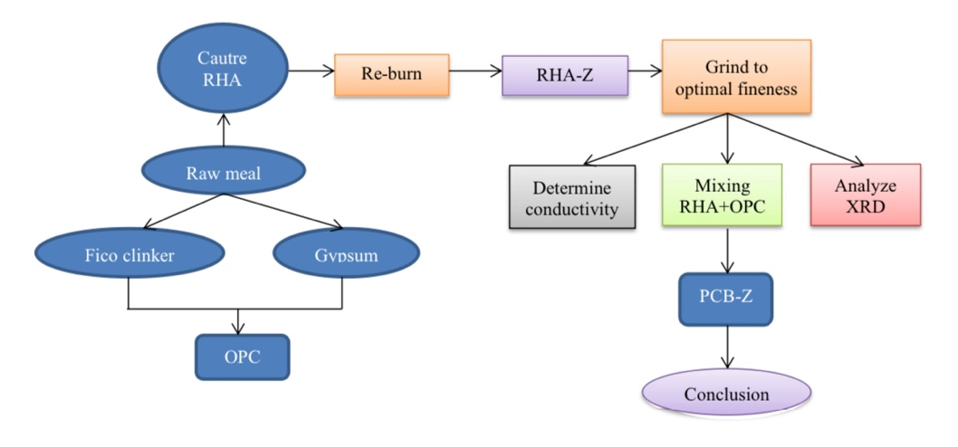
Fig. 1. The diagram of making PCB-Z using heat-treated RHA as an active additive

The chemical compositions of RHA-Z samples before and after heating treatment are shown in Table 5.

Table 5. The chemical compositions of RHA-Z samples
 | The chemical compositions, % by mass
 | LOI | SiO₂ | Al₂O₃ | Fe₂O₃ | CaO | MgO
RHA-Z0 | 13,96 | 79,84 | 0,09 | 0,30 | 3,41 | 0,92
RHA-Z1 | 8,03 | 86,74 | 0,11 | 0,61 | 2,14 | 0,61
RHA-Z2 | 6,11 | 89,86 | 0,85 | 0,91 | 2,34 | 0,46
RHA-Z3 | 0,57 | 94,01 | 0,11 | 0,61 | 4,05 | 0,46

Symbols of cement samples are shown in Table 6:

Table 6. Symbols of PCB-Z samples
Sample | Ingredient
Sample | RHA |  | OPC
OPC | 0 | 0 | 100%
PCBZ0 | 20% | RHA-Z0 | 80%
PCBZ1 | 20% | RHA-Z1 | 80%
PCBZ2 | 20% | RHA-Z2 | 80%
PCBZ3 | 20% | RHA-Z3 | 80%

  - Research methods
The research methods used in this article, including:
+ Chemical analysis method according to TCVN 141-2008, to determine the chemical compositions of experimental materials;
+ Determining normal consistency and the setting time of cement according to TCVN 6017-1995 ISO 9597-1989;
+ Electrical conductivity method to determine puzolan activity of rice husk ash;
+ Determining the compressive strength of cement mortar according to TCVN 6016-1995 ISO 679-1989;
+ Determining minerals by XRD method.
- Results and discussion
  - The activity evaluation results of re-burned RHA-Z samples
The conductivity measurement results of the re-burned RHA-Z samples is shown in Table 7. These RHA-Z samples are then analyzed for XRD. XRD method is used to recognize the difference in silica formation in crystalline or amorphous forms, with RHA samples reheated at different temperature and retention time. The qualitative assessment of the crystal level of these samples can be obtained from the intensity and width of the peak at the diffraction angle of 2θ = 21,98º. The results are shown in Table 8.
Table 7. The conductivity measurement results of heat-treated RHA-Z samples
Samples | RHA-Z0 | RHA-Z1 | RHA-Z2 | RHA-Z3
The conductivity (mS/cm) | 2,02 | 2,13 | 2,24 | 1,84
Table 8. The diffraction intensity of heat-treated RHA-Z samples
Samples | Peak intensity (Cps) at diffraction angle of 2θ = 21,98º
RHA-Z0 | 100
RHA-Z1 | 92
RHA-Z2 | 105
RHA-Z3 | 120

The graph of correlation survey between the conductivity and the diffraction intensity of RHA-Z samples is shown in Figure 2. From this graph we can see that the heat treatment process increases the conductivity at 500ºC, and at this temperature, the longer the retention time, the higher the activity. When the temperature reaches to 700ºC and maintains for 30 minutes, the conductivity decreases. The degree of crystallization (converting silica into cristobalite) initially decreases when heat treatment is at 500ºC for 10 minutes, then increases continuously over time and temperature (the highest conductivity is 2,24 mS/cm of RHA-Z2 that is heat-treated at 500ºC for 30 minutes). This may be due to the initial RHA having high carbon content, so it will increase its SiO₂ content when temperature raises in a short time. However, extending the retention time and increasing the firing temperature will also increase crystallization and aging of SiO₂ crystal.
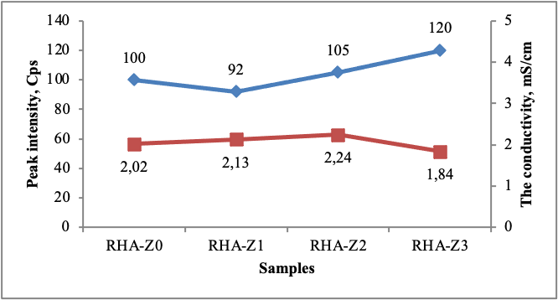
Fig. 2. Correlation survey between conductivity and diffraction intensity of heat-treated RHA-Z samples
  - The mechanical properties result of PCB-Z
The survey results of mechanical properties (normal consistency, setting time and compressive strength) of PCB-Z are shown in Table 9.
Table 9. The mechanical properties of PCB-Z
Samples | Normal  consistency (%) | Setting time (min) |  | Compressive strength (MPa)
Samples | Normal  consistency (%) | Initial | Final | R1 | R3 | R7 | R28
OPC | 26,8 | 115 | 150 | 18,0 | 30,9 | 43,0 | 56,1
PCBZ0 | 32,1 | 155 | 190 | 17,5 | 29,4 | 40,7 | 57,4
PCBZ1 | 30,2 | 135 | 180 | 18,6 | 33,7 | 44,8 | 60,0
PCBZ2 | 30,3 | 140 | 180 | 18,5 | 32,3 | 44,0 | 62,1
PCBZ3 | 30,8 | 145 | 185 | 14,1 | 26,8 | 34,7 | 46,1

+ Normal consistency and setting time:
The correlation between PCB-Z samples, normal consistency and setting time is shown in Figure 3.
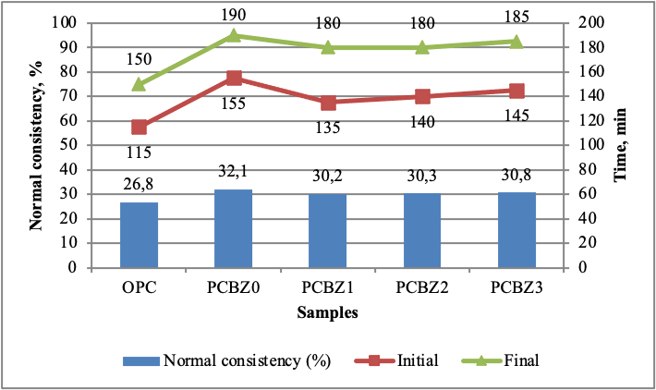
Fig. 3. The setting time of PCB-Z
The standard amount of water and the setting time of cement samples (with heat-treated RHA components) are not much different from the original cement samples. These values tend to rise with increasing temperature of firing temperature and retention time. RHA-Z increases the initial and final of setting time, especially, they significantly boost the normal consistency of cement. This can be explained by the large amount of carbon remaining in rice husk ash, thus increasing the water absorption capacity of cement.
+ Effect of RHA-Z on the compressive strength of PCB-Z.
The relationship between heat-treated RHA-Z samples and the compressive strength of cement PCB-Z is shown in Figure 4.
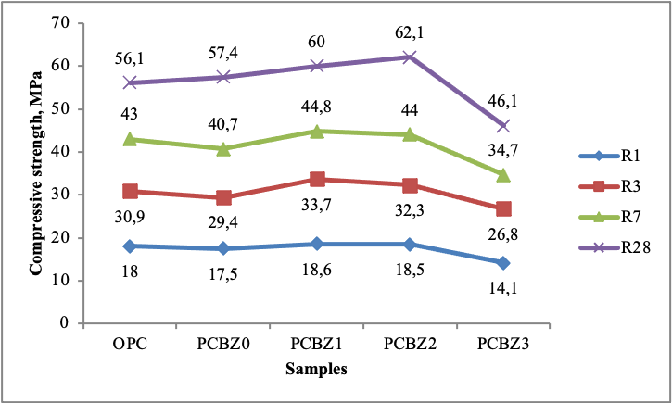
Fig. 4. Effect of re-heated RHA-Z on the compressive strength of PCB-Z
The graph in Figure 4 shows that heat-treated RHA samples at 500ºC ascend cement strength at all days when comparing to the original cement and PCB-Z0 samples. Specifically, the intensity at 28 days of PCB-Z2 increased by 8,2% compared to the sample using PCB-Z0. However, with the PCB-Z3, its strength decreases sharply by 19,7% compared to PCB-Z0. Thereby, we can see that the activity of RHA-Z samples shoot up when it is reheated at 500ºC, and falls when the heating temperature is 700ºC.
Through this study, we can recognize that the RHA-Z2 sample (reheating at 500ºC and maintaining for 30 minutes) gives the best results among the samples, so it will be proposed for testing in subsequent studies when researching on the activity of heat-treated rice husk ash to the properties of Portland blended cement (PCB).
- Conclusions
This study has investigated the effect of the temperature of re-burned rice husk ash (RHA) on its activity. The heat treatment at 500ºC for 30 minutes significantly improves the puzolanic activity of RHA, and intensify the compressive strength of cement, so it can be used as an active additive for Portland blended cement. When re-heating at 700°C for 30 minutes, the RHA-Z3 sample has suitable chemical compositions and fineness according to TCVN 8827: 2011, but its intensity is very low (cement strength at 28 days of age only reaches 46,1 MPa), so it cannot become an active additive for cement.
There is a good correlation between cement strength and conductivity. XRD analysis method should be used to evaluate the crystallization level of silica, while the puzolan activity should use the conductive method. Heat-treated RHA-Z samples increase the normal consistency and reduce the setting time of cement. Studying how to treat industrial RHA more systematically or how to treat current rice husk ash incinerators for RHA to meet the the requirements of TCVN 8827: 2011, and ASTM C618 is still an essential research topic for cement industry.

References
- Tran Thi Xuan Lan, Ta Ngoc Dung. Research the possibility of using rice husk ash as an activated mineral additive for cement PCB50 FiCO, Research and Development of Building Materials, 33-37, No. 2, (2017).
- Ta Ngoc Dung, Huynh Dang Chinh, Tran Thi Xuan Lan, Nguyen Van Hoan and Pham Thanh Mai. Research the optimal content of rice husk ask composition in the production of Portland Blended Cement, Chemical Journal, 56(6E2) 148-152 (2018).
- Leong Tuck Lun. Effects of RHA produced from different temperatures on the performance of concrete, (2015).
- Habeeb & Mahmud. Study on properties of RHA and its use as cement replacement material, Materials Research 13(2) 185-190 (2010).
- Ismail, M. S., & Waliuddin, A. M. (1996). Effect of rice husk ash on high strength concrete. Construction and Building Materials, 10 521-526 (1996).
- Nehdi, M., Duquette, J., & El Damatty. Performance of rice husk ash produced using a new technology as mineral admixtures in concrete. Cement and Concrete Research, 33 1203-1210 (2003).

