**An Improved Local Damage Model with Alternative Equivalent Strain for Quasi-Brittle Materials**

Nhu-Quan Tran1,2, Ngoc-Minh Nguyen3,4, Quoc-Tinh Bui*3,4, and Duy-Duc Ho*1,2

1 Faculty of Civil Engineering, Ho Chi Minh City University of Technology (HCMUT), 268 Ly Thuong Kiet Street, District 10, Ho Chi Minh City, Vietnam

2 Vietnam National University Ho Chi Minh City, Thu Duc City, Ho Chi Minh City, Vietnam

3 Duy Tan Institute for Computational Engineering (DTRICE), Duy Tan University, Ho Chi Minh City 700000, Vietnam  
4 Faculty of Civil Engineering, Duy Tan University, Da Nang 550000, Vietnam

*Corresponding author: buiquoctinh@duytan.edu.vn; [hoducduy@hcmut.edu.vn](mailto:hoducduy@hcmut.edu.vn)

**Abstract.** This paper presents an improved local damage model with an alternative equivalent strain for quasi-brittle materials. The state of material is represented by a damage parameter *d* in the range [0,1] to describe the degradation from intactness (*d* = 0) to complete failure (*d* = 1). Here, the fracture energy and the element characteristic length are incorporated into the calculation of the damage parameter. This improvement helps to mitigate the issue of mesh-dependency being inherent to the local continuum damage model, while the advantage of low computational cost remains. It was pointed out in the literature that the evaluation of equivalent strain may affect the prediction of the numerical model on the growth of the damage zone, especially when mixed-mode loadings are involved. Therefore, for better modeling the failure behavior under mixed-mode loadings of quasi-brittle materials such as concrete and limestone, in which compressive strength is higher than tensile strength, here two alternative equivalent strain, one based on Ottosen criterion and one based on the bi-energy norm concept, are adopted. The accuracy and efficiency of the proposed approach are demonstrated via comparison with existing experimental data and other numerical models available in the literature.

**Keywords:** Improved local damage model, Quasi-brittle material, Equivalent strain, Ottosen criterion.

1. Introduction

Some materials such as concrete, stone, limestone, etc. are not entirely brittle materials, but they still exhibit the behavior of brittle materials when it comes to fracture. These kinds of semi-brittle materials are widely used in the engineering design of buildings, especially in the infrastructure system. Due to their prevalence, predicting the fracture behavior of these materials has attracted researchers for many decades through various methods such as experiments, simulations, theories, and calculations.

In computational modeling, material damage can be represented by a continuous field that ranges in value from 0 (representing the intact state) to 1 (representing complete damage) [1]. This simple model aims to depict the decrease in load-carrying capacity of individual material points resulting from damage, without considering the causes of failure such as the formation of microcracks or defects in materials. If the equivalent strain value at a point exceeds the allowable threshold, the damage level of that point increases. Since damage is considered on the material point, this model is also referred to as the local failure model. Despite the advantage of simple computation, the classical local model has the disadvantage that the results are density-dependent and difficult to converge. To address this, some non-local models have been proposed [2], [3]. In general, there are two groups of non-local models: i) gradient-enhanced damage and ii) integral-type nonlocal damage. In group i), the non-local equivalent strain is treated as an unknown quantity to be solved (alongside the displacement components), and is linked to the local quantity through a differential equation. Because the system of two nonlinear equations needs to be solved (the equilibrium equation and the relational equation between local and non-local equivalent strains), and the total number of unknowns to be solved increases, the computational cost is significantly higher compared to the local model. For group ii), the non-local equivalent strain at a particular point is determined by computing the weighted average of neighboring local equivalent strain values. This averaging calculation is expressed as an integral. However, in essence, damage occurs locally. Delocalization can cause damage areas to be predicted to be much larger than they actually are. This width can be controlled by a dimension parameter. Many recent studies utilize this dimension parameter with variable values to reduce the width of the damage zone, making it closer to reality. However, when the characteristic length parameter is small, the element size also has to be small accordingly, contributing to an increase in computational cost. In addition, there is the phase field model [4], [5]. Although being originated from different physical and mathematical foundations (borrowing the phase transformation phenomenon to describe the material state changing from intact to failure, and the crack opening energy based on the Griffith criterion), the phase field model has many similarities with the non-local damage model [6].

Recently, Kurumatani [7] proposed an improvement to the local failure model by incorporating fracture energy and particle size into the damage growth function. This not only adds physical meaning to the damage growth function, but also helps to reduce the dependence of results on mesh density. However, the equivalent strain used by Kurumatani's group, based on the corrected Von Mises criterion, does not accurately represent the behavior of semi-brittle materials under mixed loads [8]. Therefore, Ref. [8] proposed an equivalent strain based on the maximum strain energy criterion, with a correction factor to account for the better compressive than tensile properties of common semi-brittle materials like concrete and limestone, namely the bi-energy norm based equivalent strain. This equivalent strain has been investigated with a non-local damage model in [8]. In another independent attempt on development of non-local damage model, an equivalent strain based on Ottosen failure criterion, which accounts for the influence of shear force as well as tensile and compressive properties, has been proposed [9]. In this paper, we investigate the performance of the two alternative equivalent strains, i.e. the bi-energy norm based equivalent strain and the Ottosen criterion-based equivalent strain, in an improved local damage model, for simulation of the behavior of materials under mixed mode loading.

Typically, three-node or four-node triangular or quadrilateral elements are used in calculations due to their simplicity. However, many recent studies have shown several advantages of polygonal elements over traditional finite elements. The concept of polygonal elements is a generalized form that allows the construction of elements with convex *n*-sided geometry (*n* = 3, 4, 5, 6, ...), which was initially proposed by Wachpress [10]. The polygonal finite element method has been studied and further developed by many other authors [11]–[13], highlighting the higher accuracy of polygonal elements compared to commonly used triangular or quadrilateral elements. In terms of geometry, polygonal meshing can be automated [12] on the basis of Voronoi cells.

This article presents the construction of a non-local failure model that takes into account the equivalent strain according to the bi-energy norm, with an applied direction in analyzing the behavior of semi-brittle materials with higher compressive load capacity and lower tensile strength, such as concrete. In the calculation process, it is suggested to use polygonal elements instead of the usual triangular and quadrilateral elements. The accuracy and efficiency of the model will be investigated and compared with the experimental data and other numerical results reported in the literature.

1. An improved model for analyzing the failure of quasi-brittle materials

**2.1 The growth function of material damage evolution**

In many previous studies ([1], [2], [7], [8]), the stress-strain relationship under damage was expressed as follows.

** (1)

Here, *σ* is the stress tensor, ***ε*** is the strain tensor, ***C*** is the tensor of material constants, and *D*(κ) is the function representing the level of damage. For materials such as concrete and limestone, the growth of the level of damage is often expressed using an exponential function.

** (2)

where D is the characteristic damage quantity, *κ* is the maximum equivalent strain value in the loading history, κ0 is the strain corresponding to the tensile strength *f*t, and *α* and *β* are two parameters that describe the softening branch of the stress-strain curve, and are typically calculated from experimental stress-strain data. For simplicity, we can choose *α* = 1 and only determine the value of *β*.

In order to overcome the drawback of mesh-dependence in the classical local damage model, Kurumatani et al. [7] proposed to calculate *β* according to the cohesive force model of fracture mechanics as follows

** (3)

With E being the elastic modulus of the material; G*f* being the dissipated energy due to fracture, calculated by the area under the softening curve of the stress-strain relationship (see Figure 1); *h*e is the characteristic length of the element.

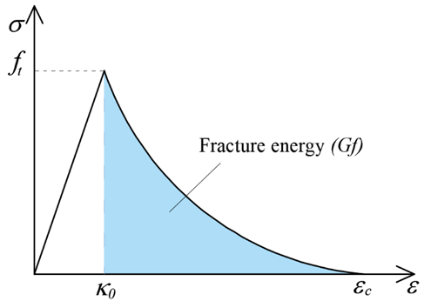

**Fig. 1.** Fracture energy [8]

For two-dimensional elements such as triangles and quadrilaterals, *h*e can be calculated based on the element area *A*e as follows [1]:

Triangular element: 

Quadrilateral element: 

In the case of using polygonal elements, 

In this section, the fundamental formula of the damage model has recently been developed and adopted to describe the brittle behavior of materials. Many definitions for equivalent strains have been proposed in the literature to describe the influence on load-deflection curves and strain states. In this paper, we investigate two alternative equivalent strains for concrete, the bi-energy norm based equivalent strain, and the Ottosen’s criterion based equivalent strain, in comparison with the commonly used modified von Mises’s criterion based equivalent strain.

**2.2 The modified von Mises criterion based equivalent strain**

The equivalent strain  is defined such that a compressive uniaxial stress has the same effect as a tensile uniaxial stress.

** (4)

where

 represent the Poisson’s ratio.

 is the first invariant of the strain tensor and is the second invariant of the strain tensor.

 is a model parameter influenced by the compressive strain component compared to the tensile strain component (the ratio between compressive and tensile uniaxial strengths ).

The equivalent Von Mises strain has been modified to be adjustable for various materials, especially those that are brittle, with different ratios between compressive and tensile strengths: concrete () or limestone ().

**2.3 The bi-energy norm based equivalent strain**

The calculation of equivalent strain is often proposed based on different failure criteria, such as the Rankine model, the Mazars model, the modified von Mises model... Among these models, the modified von Mises model [14] is a widely used model by many authors, including the Kurumatani group [7]. However, this model is not really suitable for representing the behavior of materials where the compressive strength is much different from the tensile strength, for e.g. concrete. The energy density parameter can be calculated as follows [15]:

** (5)

where **ε** is the strain tensor and **C** is the material characteristic tensor. This value is then divided by the elastic modulus *E* and square rooted to become a quantity with the same integer as strain, thus it is called the equivalent strain.

** (6)

However, the above expression does not distinguish between the tensile and compressive components, so it has been proposed to modify it as follows in reference [8]:

** (7)

where  and respectively denote the tensile and compressive components of the equivalent strain. In equation (6), *k* is the ratio between compressive and tensile strengths, and  is a parameter used to adjust the model based on experimental data.

The tensile component of the equivalent strain can be calculated by:

** (8)

In there

** (9)

With being the *m*-th principal strain and representing the *m*-th principal direction. The Macaulay operator 〈〉 returns the positive value of  and returns 0 if is negative, specifically:

 (10)

The equivalent compressive strain component is calculated similarly:

** (11)

In there

 (12)

with being the tensor containing principal strain components.

As it is originated from the maximum strain energy criterion with a modification such that the strain energy is separated into tensile and compressive components, the equivalent strain in equation (6) is called the bi-energy norm based equivalent strain.

**2.4 The Ottosen’s failure criterion based equivalent strain**

The literature extensively reports that improving the definition of equivalent strain can enhance the performance of a damage model. In this paper, we have utilized the four-parameter equivalent strain based on the Ottosen’s failure criterion [16] for mixed-mode fracture problems. As stated in [9], [14], [17], the equivalent strain is expressed as:

** (13)

Here, 𝐼1(𝜺) and 𝐽2(𝜺) represent the first invariant of the strain tensor and the second invariant of the deviatoric strain tensor, respectively. Additionally, 𝜈 denotes the Poisson’s ratio.

In Eq. (12) 𝐴, 𝐵, 𝐾1, and 𝐾2 are four parameters defined by Ottosen's failure criteria [16] and are determined by.

** (14)

The strain invariants defined in Eq. (13) can be related to the respective stress invariants

** (15)

In Eq. (14), 𝑓𝑐 is the compressive strength, and *𝜆* is a variable corresponding to parameters 𝐾1 and 𝐾2 as follows

** (16)

with . Note that *J*3 is the third invariant of the deviatoric strain tensor.

It is important to determine the four parameters *A*, *B*, *K*1 and *K*2 from the three failure states: uniaxial tension, uniaxial compression, shear [14]. The following conditions must be satisfied: *, , , .*In the Ottosen’s criterion, the meridians (of the failure surface) are represented by parameters 𝐴 and 𝐵, while the size and shape of the cross-section in the deviatoric plane are described by 𝜆 [18].Details on determination of the four parameters based on experimental data for the three failure states can be found in Ref. [14], [18].

A second method for calculation of *A*, *B*, *K*1 and *K*2 is also mentioned in Ref. [18] as follows

** (17)

The value of 𝑥𝑝, as described in Eqs.(17) is determined by the ratio (), where  is used [16].

1. Polygonal finite elements

The triangular three-node or quadrilateral four-node elements are commonly used in finite element analysis due to their simplicity in computation. The triangular three-node element has the advantage of being convenient in meshing with complex geometric domains, but the assumption of constant derivative field in the element domain leads to significant errors. The quadrilateral four-node element has higher accuracy but encounters certain difficulties in meshing. Therefore, polygonal elements have been proposed [9]. The element shape will then be a polygon with an arbitrary number of edges n (n = 3, 4, 5, 6, ...), or *n*-gons. Figure 2 illustrates different forms of polygonal elements. The geometric shape of the element is not limited to the convex range, but can be concave, and there can be multiple nodes on each edge. This brings flexibility in meshing [12]. On the other hand, polygonal elements are also evaluated to have higher accuracy and less sensitivity to distortion than conventional finite elements [11], [13], [19]. The advantage of more accurate calculation of the derivative field (deformation, stress) is also a benefit of using polygonal elements in the analysis of material damage phenomena, as mentioned by [20] for the nonlocal model.

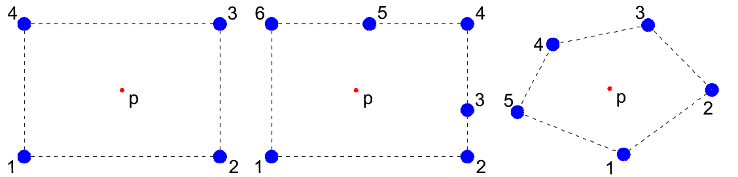

1. b) c)

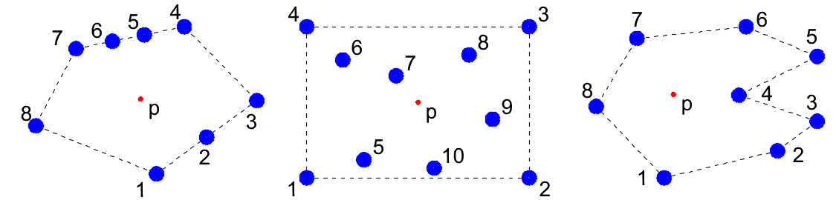

d) e) f)

**Fig. 2.** Polygonal elements. (a) Quadrilateral element (n=4); (b) Quadrilateral element with nodes on edges and mid-edges (n=6); (c) Pentagonal element (n=5); (d) Pentagonal element with nodes on edges and mid-edges (n=8); (e) Decagonal element with interior nodes (n=10); (f) Concave heptagonal element (n=7) [21].

The polygonal shape function is constructed from a set of non-negative weight functions . Each  weight function achieves its maximum value at *x*i and decreases as the distance from increases *x*i. Polygonal shape functions can be represented in general as follows [21].

** (19)

The representation ensures the property of the sum of the shape functions being equal to 1 (*partition of unity*). The Laplace weight function at point **p** inside the polygonal element is given by [21].

** (20)

In which *n* is the number of vertex nodes, is the Laplace weight function, is the length of the Voronoi edge related to point **p** and vertex *a*, and is the distance between point **p** and node *i* (see Fig. 3).

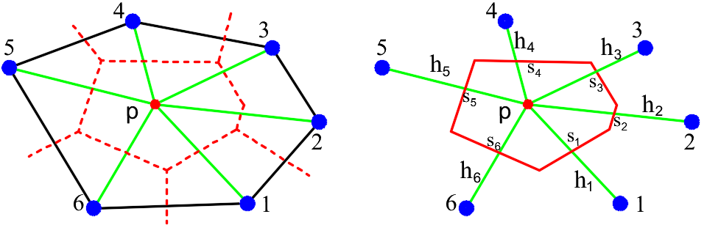

**Fig. 3.** Construct Laplace functions in a polygonal element

1. Results and discussion

This paper proposes an improved local damage model for quasi-brittle materials (Sections 2) combined with the polygonal finite element method (Section 3). The accuracy and effectiveness of the proposed approach are investigated through two two-dimensional problems.

1. The three-point bending beam problem.
2. The L-shaped plate problem.

**4.1 The three-point bending beam problem**

In this example, the three-point bending experiment of Kormeling and Reinhardt [22] will be simulated using the proposed computational model. Material parameters such as fracture energy are referenced from the literature [22] and presented in Table 2. The model uses a coarse 600 quad element mesh (662 nodes), a fine 5505 quad element mesh (5671 nodes), and a 2000 polygon element mesh (4019 nodes). The finite element meshes are shown in Fig 4. In addition to comparison with the experiment, the computed results of the proposed model are also compared to the numerical simulations by Jirasek [23] using a local approach.

**Table 1.** Material properties for the three-point bending beam problem.

|  |  |  |  |  |  |
| --- | --- | --- | --- | --- | --- |
| *E* |  | *k* |  |  | G*f* |
| 20000 MPa | 0.2 | 10 | 90x10-6 | 1 | 63.5 N/m |

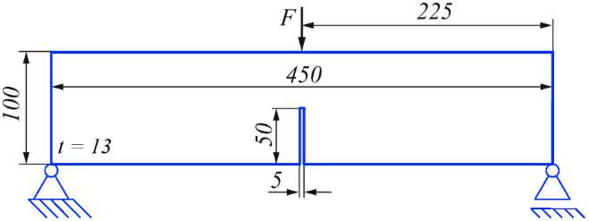

**Fig. 4.** A three-point beam model has three dimensions with a certain thickness *t*=13 mm

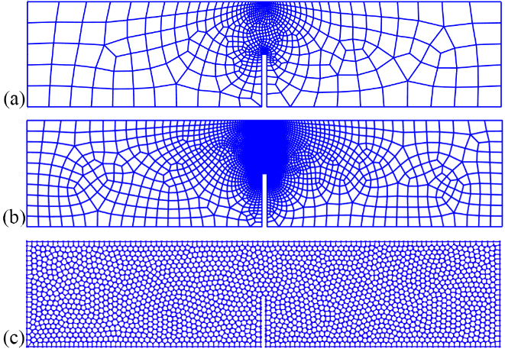

**Fig. 5.** Meshing for three-point beam bending model: (a) Coarse meshing with quadrilateral ele-ments; (b) Fine meshing with quadrilateral elements; (c) Meshing with polygonal elements

Figure 6 illustrates the development of cracks in each stage, specifically: (i) the crack starts to develop, corresponding to the peak of the load-displacement curve; then the crack continues to propagate straight up towards the loading position (from (ii) - (iv)); finally, severe damage (v) occurs when the crack advances to the top surface of the beam.

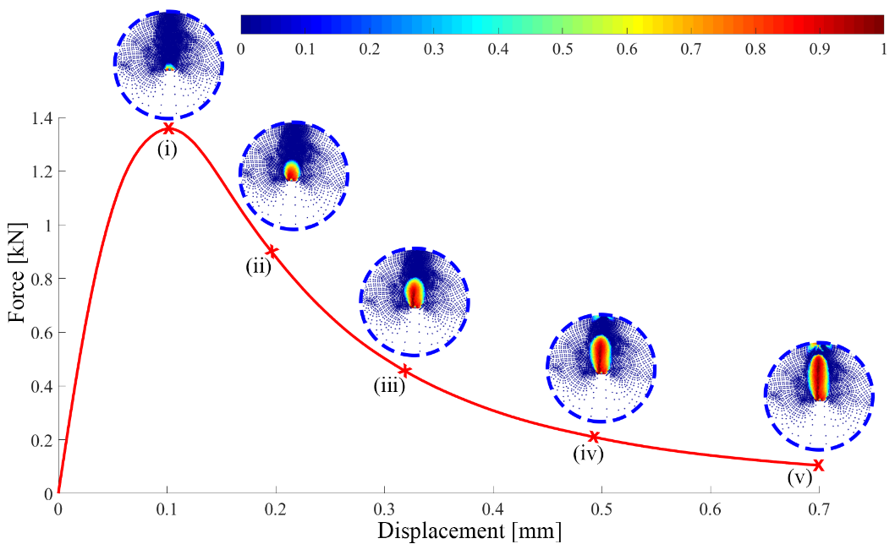

**Fig. 6.** The crack development under increasing load of a large three-point bending beam model.

Figure 7 compares the load-displacement curves obtained from the proposed model using both quadrilateral elements (both with coarse and fine mesh) and polygonal elements with experimental data [22] and Jirásek's simulation [23]. From the graph, the proposed computational model using both quadrilateral and polygonal elements provides results that are quite close to the experimental data region. On the other hand, the calculated results using von Mises equivalent strain correction for predicting the peak of the curve are much lower than the experimental data. This shows the advantage of using Bi-energy norm equivalent strain over von Mises correction. In addition, by using both coarse quadrilateral mesh and fine quadrilateral mesh (fine mesh being 9 times finer than the coarse mesh) and utilizing polygonal mesh, the results of load-displacement curves for all three models are almost equivalent. Therefore, it shows that the model is not significantly affected by the mesh refinement in the calculation results.

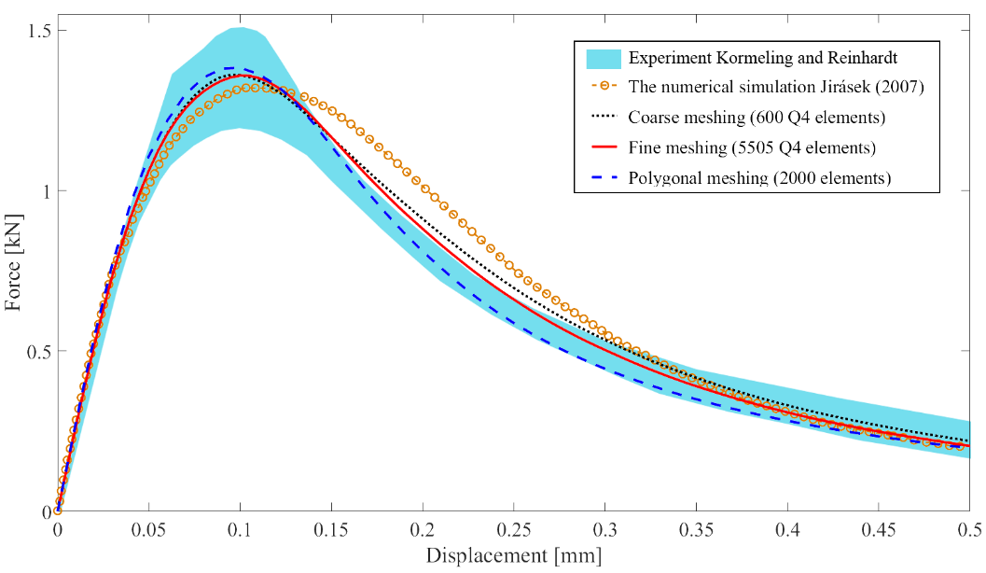

**Fig. 7.** Load-displacement comparison chart of three-point beam model. In this Figure, the bi-energy norm based equivalent strain is used for the proposed local damage model

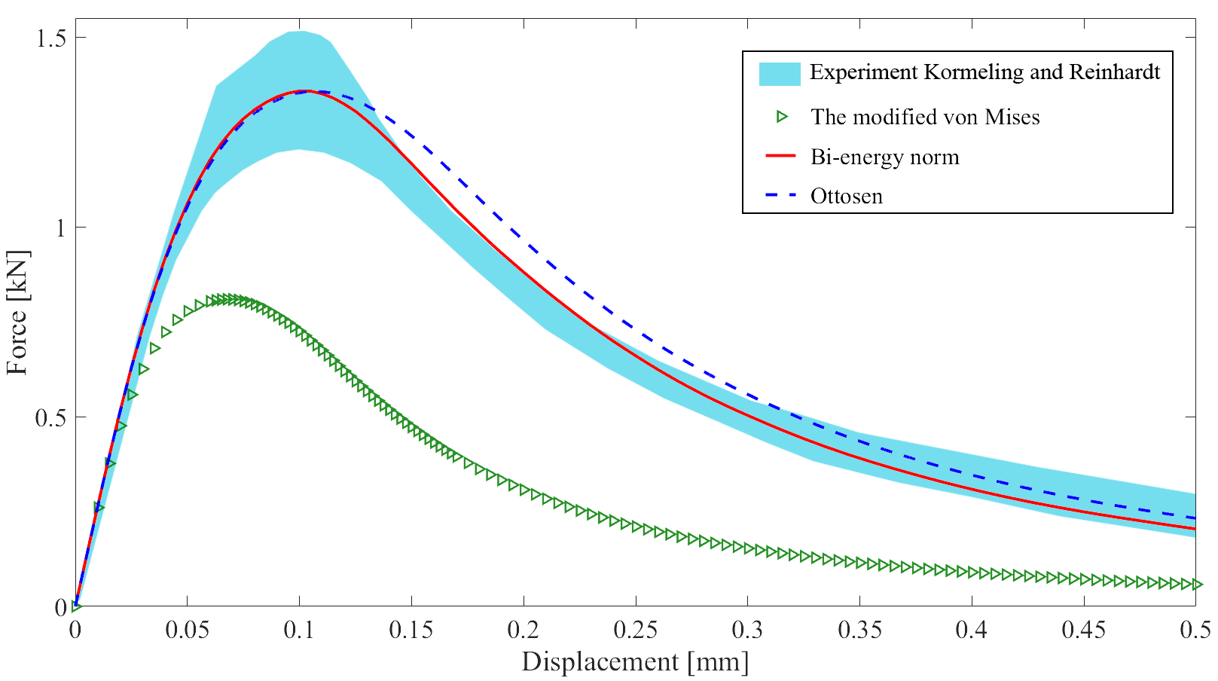

**Fig. 8.** Comparison chart of load-displacement between modified von Mises, Bi-energy norm model and Ottosen model using 5505 quadrilateral elements.

From Figure 8, we can see the results of the load-displacement curve, which shows that the peak load using the proposed equivalent strain measures of bi-energy norm and equivalent strain of Ottosen, considering shear force, are both about 1.4 kN. There are some differences in the post-peak branch of the curves, but both are in good agreement with experimental data.

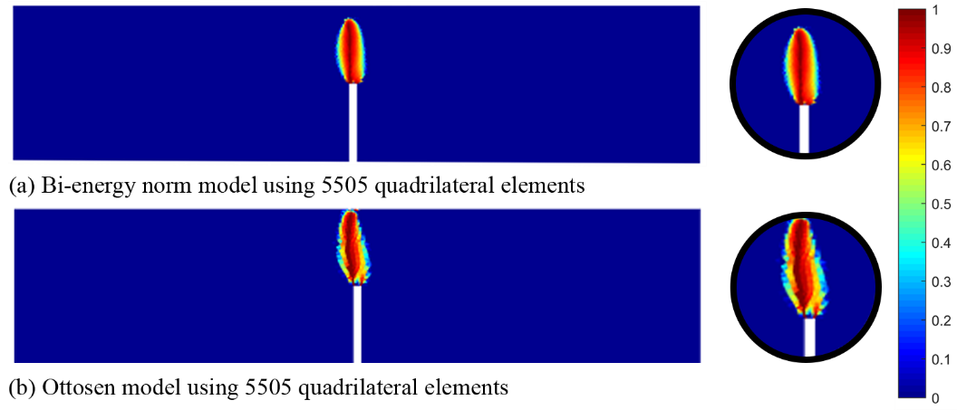

**Fig. 9.** Comparison of crack propagation using the improved Bi-energy norm model and the Ottosen model.

In Figure 9, it is observed that the results crack propagation predicted by the proposed model, using either the bi-energy norm based equivalent strain or the Ottosen’s criterion based equivalent strain, are quite similar. The crack tends to propagate upward, towards the loading area, which is as expected.

**3.2 The L-shaped plate problem**

Firstly, consider an L-shaped concrete plate under plane stress conditions. The geometry and boundary conditions of the plate are shown in Figure 10. The main objective of this example is to demonstrate the influence of selecting equivalent strain measures on the results. In addition, the role of the mesh division is also considered. The computed results are compared with the experimental data by Winkler [23], with the material properties given in Table 1. The force-displacement curve is obtained by recording the displacement at the loading point and the reaction force at the boundaries of the plate.

**Table 2.** Material properties for the L-shaped plate problem [23].

|  |  |  |  |  |  |
| --- | --- | --- | --- | --- | --- |
| *E* |  | *k* | *Ft* |  | G*f* |
| 25850 MPa | 0.18 | 10 | 2.7 | 0.8 | 95 N/m |

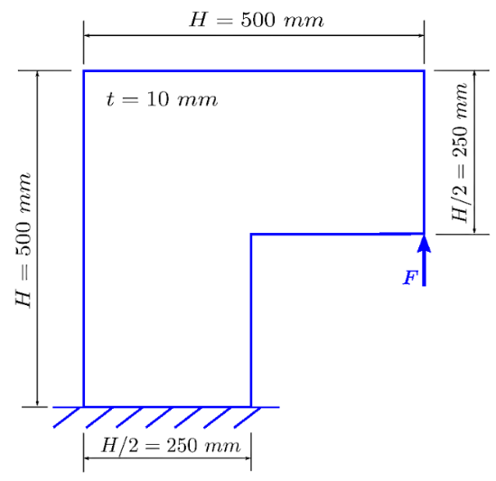

**Fig. 10.** L-Shaped model: geometric characteristics, boundary conditions - loading and plate thickness t.

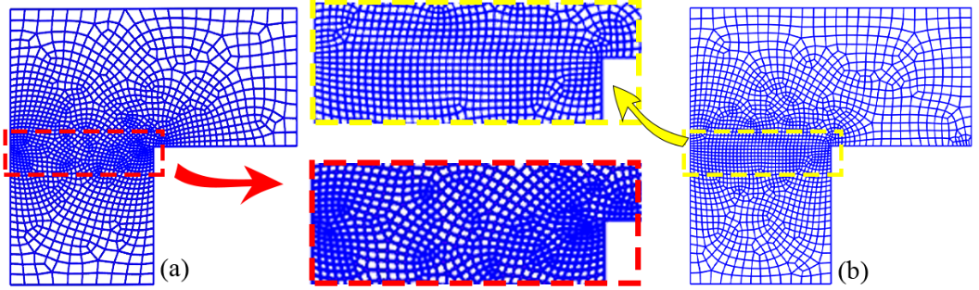

**Fig. 11.** L-Shaped model: geometric characteristics, boundary conditions - loading and plate thickness t.

Firstly, two types of quadrilateral 4-node (Q4) meshes are considered in Figure 11. The total number of elements is 1600 (1677 nodes), and they are both smoothed at the crack vicinity. It should be emphasized that based on the reference experimental data, the crack location is known beforehand and serves as the basis for mesh refinement. In practical engineering problems, the crack propagation direction is often unknown. In such cases, it is necessary to have appropriate adaptive meshing techniques to automatically update the mesh during the analysis process. This issue will be investigated in further studies.

In Figure 12, two different element orientation schemes (in the smooth mesh region) are investigated using the bi-energy norm equivalent strain. For Figure 11 (a), the elements have a free orientation; whereas for Figure 11 (b), the elements are arranged in order and have relatively equal sizes. The predicted crack region is presented in Figure 12, compared with the crack region in the experiment [24]. According to the experiment, the crack forms and develops from the L-shaped corner (a location of stress concentration, with a tendency to propagate diagonally upward at an angle of about 45 degrees before going horizontally towards the left). The mesh with a free orientation (or no orientation) predicts the crack region very closely to the experiment. Meanwhile, the mesh with a uniformly oriented division did not predict well the stage of upward propagation, resulting in the crack region being lower than in the experiment. This phenomenon is often referred to as "mesh-bias" in the literature [25], [26]. The use of polygonal elements will help to reduce this phenomenon, as polygonal mesh is in general unstructured. This is evidenced in Figure 12, where the predicted results of the polygonal mesh (1600 elements) are close to the experiment.

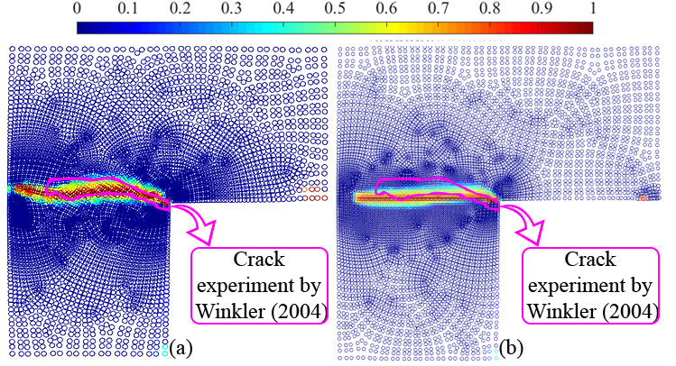

**Fig. 12.** Crack results for the L-shaped plate model: (a) Free mesh; (b) Uniform mesh that incorrectly determined the direction of crack propagation due to mesh element division.

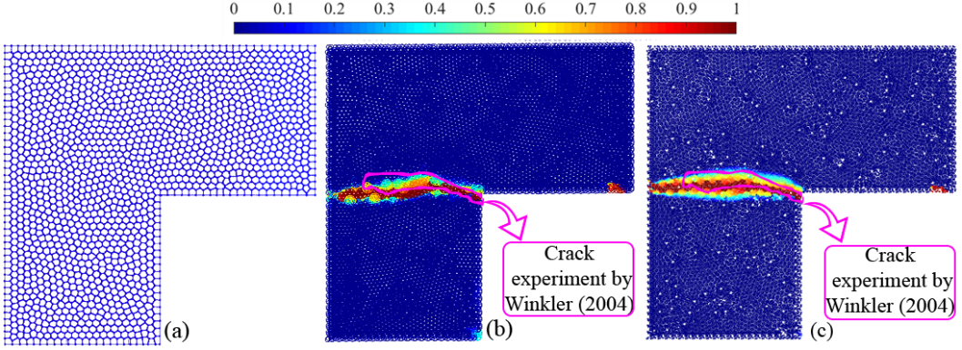

**Fig. 13.** Comparison of the results of the L-shaped panel model using a polygonal mesh with experimental data: (a) Polygonal element meshing; (b) Damage zone predicted by local damage model with the bi-energy norm based equivalent strain; (c) Damage zone predicted by local damage model with the Ottosen based equivalent strain.

Using the same polygonal mesh with 1600 elements in total, the damage zone predicted by the proposed local damage model using the two alternative equivalent strains (the bi-energy norm based equivalent strain and the Ottosen’s criterion based equivalent strain) are depicted in Figure 13. Both numerical results are in agreement with the experimental data by Winkler, though the Ottosen’s criterion based equivalent strain seems to be closer, probably because the effect of shear deformation is (implicitly) taken into account via the four parameters.

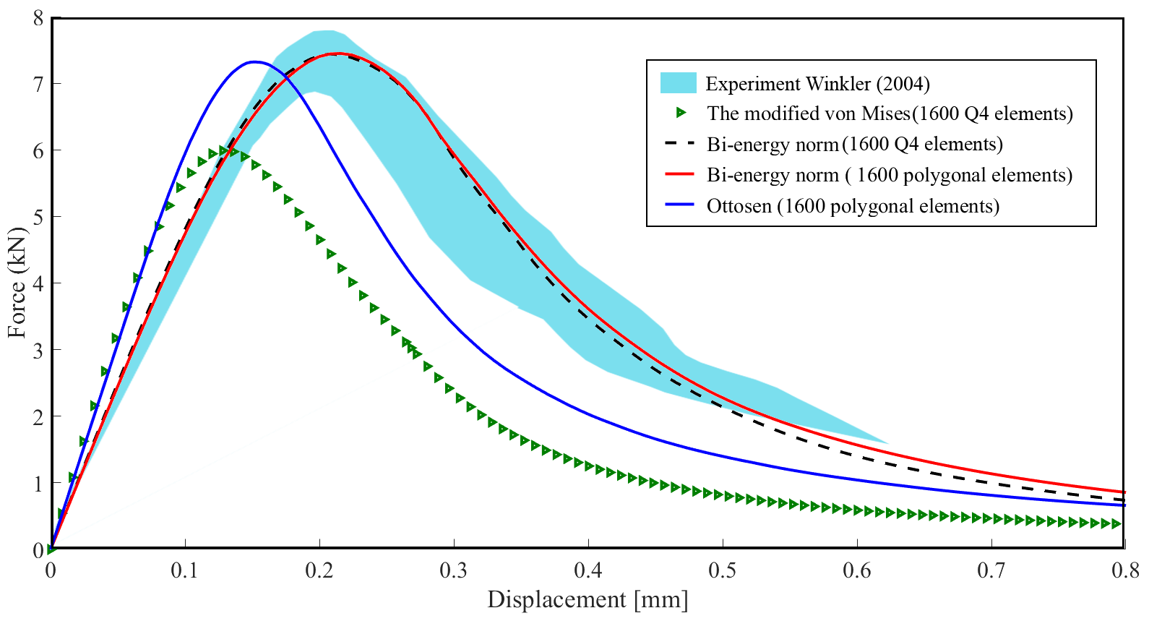

**Fig. 14.** Load-displacement relationship chart of L-shaped plate model

Figure 14 once again demonstrates that the use of quadrilateral or polygon mesh does not make a significant difference in the load-displacement graphs, similar to the observation in the previous example. Again, the use of von Mises equivalent strain tends to under-estimate the maximum load value, compared to the experimental data. Meanwhile, when using the bi-energy based equivalent strain and the Ottosen’s criterion based equivalent strain, the results match well with the experimental values. However, the load-displacement curve by the use of the bi-energy norm equivalent strain seems to agree with the experiment better than that of the Ottosen’s criterion equivalent strain. This observation is interesting, considering that the damage zone exhibited by the Ottosen’s criterion better matches the experiment.

1. Conclusion

In this contribution, an improved local damage model has been developed with two alternative kinds of equivalent strain, based on the bi-energy norm and the Ottosen’s criterion for quasi-brittle materials. The issue of mesh-dependency usually encountered in local damage models is treated by incorporation of the fracture energy and element size into the calculation of damage parameters. The nonlinear analysis is then solved by the finite element method using the Newton-Raphson iterative equation. Here, it is proposed to employ the unstructured mesh of polygonal elements instead of usual triangular or quadrilateral elements. A series of crack propagation analyses were conducted to verify the performance of the proposed model. The presented results were validated and compared with experimental data and reference numerical results from available literature.

The following findings are obtained:

i) The improved local damage model is less affected by element mesh (both element type and mesh size).

ii) Numerically, the employment of unstructured polygonal element may allow coarser meshes (less number of elements and nodes) while accuracy (of the load-displacement curve) could be maintained.

iii) Both the bi-energy norm based equivalent strain and the Ottosen’s criterion equivalent strain could help to provide better predictions of the load-displacement curve than the modified von Mises criterion based equivalent strain.

iv) In the numerical examples being considered, the bi-energy norm based equivalent strain may provide load-displacement curves closer to experimental data than the Ottosen’s criterion based equivalent strain. However, the damage zone predicted by the Ottosen’s criterion based equivalent strain for the L-shaped panel (which is a case of mixed mode loading) seems to be better.

It is noticed that the shear deformation is taken into account by the Ottosen’s criterion equivalent strain, but the effect of tensile and compressive components of the strain tensor is not explicitly separated, and vice versa for the bi-energy norm based equivalent strain. This could be a suggestion for further development of equivalent strain in future works.

Additionally, in practical applications, direction of crack propagation is often unknown in advance. Therefore, an adaptive meshing technique is needed, which means that the mesh will be locally refined locally vicinity of the crack (which could be indicated by the high damage value). This is a challenging task for conventional finite elements (for e.g. the triangular or quadrilateral elements), where certain restriction on geometry of element must be satisfied to reduce the numerical errors. In particular, the element must have a convex shape, and the aspect ratio of element edges should not be too large. In contrast, polygonal elements are known to be less sensitive to geometric distortion, making them better candidates for adaptive meshing.

Acknowledgments

We would like to thank Ho Chi Minh City University of Technology (HCMUT), VNU-HCM for the support of time and facilities for this study.

References

[1] L. M. Kachanov and D. Krajcinovic, “Introduction to Continuum Damage Mechanics,” *J. Appl. Mech.*, vol. 54, no. 2, 1987, doi: 10.1115/1.3173053.

[2] R. H. J. Peerlings, R. De Borst, W. A. M. Brekelmans, and J. H. P. De Vree, “Gradient enhanced damage for quasi-brittle materials,” *Int. J. Numer. Methods Eng.*, vol. 39, no. 19, 1996.

[3] G. Bonges, “A stress-based gradient-enhanced damage model,” 2011.

[4] C. Miehe, M. Hofacker, and F. Welschinger, “A phase field model for rate-independent crack propagation: Robust algorithmic implementation based on operator splits,” *Comput. Methods Appl. Mech. Eng.*, vol. 199, no. 45–48, 2010.

[5] C. Miehe, F. Welschinger, and M. Hofacker, “Thermodynamically consistent phase-field models of fracture: Variational principles and multi-field FE implementations,” *Int. J. Numer. Methods Eng.*, vol. 83, no. 10, 2010.

[6] R. de Borst and C. V. Verhoosel, “Gradient damage vs phase-field approaches for fracture: Similarities and differences,” *Comput. Methods Appl. Mech. Eng.*, vol. 312, 2016.

[7] M. Kurumatani, K. Terada, J. Kato, T. Kyoya, and K. Kashiyama, “An isotropic damage model based on fracture mechanics for concrete,” *Eng. Fract. Mech.*, vol. 155, 2016.

[8] T. H. A. Nguyen, T. Q. Bui, and S. Hirose, “Smoothing gradient damage model with evolving anisotropic nonlocal interactions tailored to low-order finite elements,” *Comput. Methods Appl. Mech. Eng.*, vol. 328, 2018.

[9] A. S. Shedbale, G. Sun, and L. H. Poh, “A localizing gradient enhanced isotropic damage model with Ottosen equivalent strain for the mixed-mode fracture of concrete,” *Int. J. Mech. Sci.*, vol. 199, 2021.

[10] E. L. Wachspress and S. M. Rohde, “A Rational Finite Element Basis,” *J. Lubr. Technol.*, vol. 98, no. 4, 1976.

[11] N. Sukumar and E. A. Malsch, “Recent advances in the construction of polygonal finite element interpolants,” *Archives of Computational Methods in Engineering*, vol. 13, no. 1. 2006.

[12] C. Talischi, G. H. Paulino, A. Pereira, and I. F. M. Menezes, “PolyMesher: A general-purpose mesh generator for polygonal elements written in Matlab,” *Struct. Multidiscip. Optim.*, vol. 45, no. 3, 2012.

[13] H. D. Huynh, M. N. Nguyen, G. Cusatis, S. Tanaka, and T. Q. Bui, “A polygonal XFEM with new numerical integration for linear elastic fracture mechanics,” *Eng. Fract. Mech.*, vol. 213, 2019.

[14] L. H. Poh and G. Sun, “Localizing gradient damage model with decreasing interactions,” *Int. J. Numer. Methods Eng.*, vol. 110, no. 6, pp. 503–522, 2017.

[15] A. Tabarraei and N. Sukumar, “Extended finite element method on polygonal and quadtree meshes,” *Comput. Methods Appl. Mech. Eng.*, vol. 197, no. 5, 2008.

[16] N. S. Ottosen, “A FAILURE CRITERION FOR CONCRETE,” *ASCE J Eng Mech Div*, vol. 103, no. 4, 1977.

[17] L. Gambarotta and S. Lagomarsino, “A microcrack damage model for brittle materials,” *Int. J. Solids Struct.*, vol. 30, no. 2, 1993.

[18] C. D. Vuong, T. Q. Bui, and S. Hirose, “Enhancement of the smoothing gradient damage model with alternative equivalent strain estimation for localization failure,” *Eng. Fract. Mech.*, vol. 258, 2021.

[19] H. Chi, C. Talischi, O. Lopez-Pamies, and H. G. Paulino, “Polygonal finite elements for finite elasticity,” *Int. J. Numer. Methods Eng.*, vol. 101, no. 4, 2015.

[20] H. D. Huynh, S. Natarajan, H. Nguyen-Xuan, and X. Zhuang, “Polytopal composite finite elements for modeling concrete fracture based on nonlocal damage models,” *Comput. Mech.*, vol. 66, no. 6, pp. 1257–1274, 2020.

[21] A. Latifaghili, M. Bybordiani, R. E. Erkmen, and D. Dias-da-Costa, “An extended finite element method with polygonal enrichment shape functions for crack propagation and stiff interface problems,” *Int. J. Numer. Methods Eng.*, vol. 123, no. 6, 2022.

[22] H. Kormeling and H. Reinhardt, “Determination of the fracture energy of normal concrete and epoxy modified concrete,” *Delft Univ. Technol.*, pp. 5–83, 1983.

[23] M. Jirásek, “Nonlocal damage mechanics,” *Rev. Eur. génie Civ.*, vol. 11, no. 7–8, 2007.

[24] J. E. Bishop, “Simulating the pervasive fracture of materials and structures using randomly close packed Voronoi tessellations,” *Comput. Mech.*, vol. 44, no. 4, 2009.

[25] M. Jirásek and P. Grassl, “Evaluation of directional mesh bias in concrete fracture simulations using continuum damage models,” *Eng. Fract. Mech.*, vol. 75, no. 8, 2008.

[26] S. E. Leon, D. W. Spring, and G. H. Paulino, “Reduction in mesh bias for dynamic fracture using adaptive splitting of polygonal finite elements,” *Int. J. Numer. Methods Eng.*, vol. 100, no. 8, 2014.