A Model for Predicting the Bearing Capacity of the Soil-Cement Columns Using the Soil Resistivity

Tham Hong Duong1

1 Ho Chi Minh City Open University, Viet Nam

[tham.dh@ou.edu.vn](mailto:tham.dh@ou.edu.vn)

**Abstract.** Soil-Cement Column (SCC) is a semi-rigid structure of which quality could not be thoroughly assessed by non-destructive tests such as Impact Echo, Impulse Response, Impedance Log, Parallel Seismic, etc. Unlike concrete piles as rigid structures, the problem of SCC is due to its relatively low stiffness and inhomogeneity. The reason in the process of mixing at the site, re-using the in-situ disturbed soil, and conducting to the deep zones of the soil stratum, the product faces so many risks of questionable quality. Because the structure is semi-rigid, the method of using electrical resistivity (ER) in geophysics is suggested. This article deals with an experimental model in which an axisymmetry SCC with a sufficiently wide soil medium is created for measuring the ER, having electric probes installed in a Wenner and Schlumberger configuration. By tracing the change of electric resistivity (ER) within the structure having different stiffness, and comparing the ER map of the homogeneous soil medium before and after cemented treatment, between non-defective and defective structure, etc., the change in mechanical properties of the structure is predicted quantitatively. The bearing capacity of the structure could be then estimated by applying formulas in traditional calculations. The results of the bearing capacity of a soil-cement column calculated would be compared to those predicted by the artificial neural network (ANN) and tests in a small-scale model. The model which uses ER in predicting the bearing capacity of a semi-rigid structure indicates a quantitative tool in geotechnical engineering.

**Keywords:** Soil-cement Column, Wenner Test, Schlumberger Array, Electric Resistivity.

1. Introduction

Soil-Cement Columns are a semi-rigid solution of man-made intrusion that is used to improve weak soil. The concept of soil improvement is to turn out the original disturbed soil into a modified soil that has greater stiffness and bearing capacity. By mixing the in-situ soil with the cement as a binder, the soil is hardened in both the pozzolanic and hydration reactions. The quality of this kind of structure depends on many factors, including the quality of the material ingredients at the site, the technology of mixing, the depth of workability, soil stratification, and others, etc. Without any transmission from the shaft to the outer medium, this structure cannot be called the “pile” and the structure is uniquely different compared to that of a pile. So, testing the integrity of a soil-cement column is vital. In general, according to ASTM D 5882, integrity refers to three main kinds of defects, as follows:

* Insufficient physical dimensions of structure (i.e, length and/or cross-section;
* Discontinuity of structure (presence of voids or segregation, cracks);
* No consistency of the structure material.

Unlike reinforced concrete (RC) cast-in-place piles, soil-cement column (SCC) is mixed at the site, and the SCC may have some same defects, including bulging, necking, discontinuity, inconsistent quality, and void. For RC structures, techniques such as Pile Integrity Test (PIT), Impedance Log Technique (IL), Cross-hole Sonic Logging (CSL), etc. [1] are successfully practicable. For deep mixing structures, quality control (QC) normally deals with binder quality and percentage of ingredients, effectiveness and performance of mixing, time of curing, etc. during the construction process. Quality assurance (QA) aims at checking the quality of the DSM columns installed in situ. The work description is sampling cores from in-situ structures, applying geophysical methods, loading test methods, and choosing relevant non-destructive (NDT) methods on the structure [2]. Two popular methods in QA are the “down-hole seismic method” and the “spectral analysis of surface waves (SASW) test method”. Because of having the highest velocity of propagation, P-wave is chosen. The electronic device measures the interval traveling between two points and assesses the quality of semi-rigid structure with depths (Fig. 1b), and the latter studies the characteristic of seismic surface Rayleigh waves traveling in a vertically heterogeneous medium (Fig. 1c). Reason for using Rayleigh wave is that the wave obsesses most the energy of wave propagation, especially in greater distance of probes apart the borehole. The concept of using vibration, exactly the change of the velocity of the wave traveling inside the structure for diagnosing the outshape of the structure is applicable (Fig. 2). Nevertheless, vibration impact techniques appear to be irrelevant for semi-rigid structures due to the inhomogeneity of the mixture as per theoretical model [3]. Combined with uncertainties in signal data processing and software (epistemic), and others on the side of nature (aleatory), it is a complex task for the quality assessment for this semi-rigid structure, especially with conventional testing approaches for a single pile.

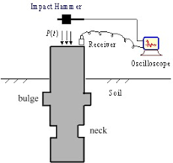 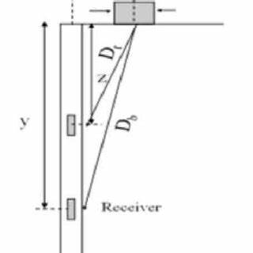 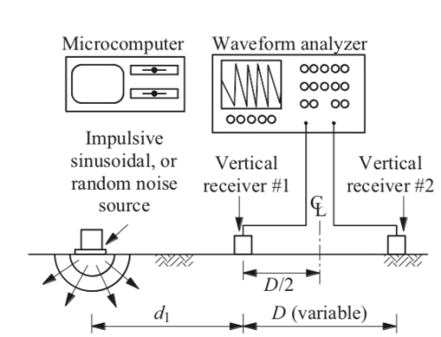

**Fig. 1.** a) Pile integrity test (PIT) in RC pile [1]; QA test for soil-cement columns: b) down-hole seismic method; c) spectral analysis of surface waves (SASW) test method [2].

The abovementioned method of SASW is an application of geophysics and some surveys worldwide conducted by Puppala and Porbaha (2004) also indicated a limited use of nondestructive geophysical testing for semi-rigid structures [2]. In most cases, the slope of the plot of the ratio length divided by the time of wave travel stands for the velocity of the propagating wave (Fig. 3), but this is only practicable for reinforced concrete piles.

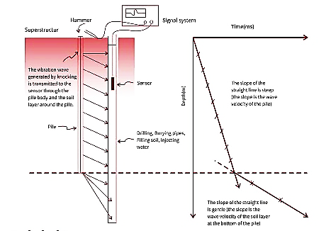

**Fig. 2.** The change in recorded wave velocity as the sensor moving along a pile could determine the length of an buried structure [2].

The fact is that there are a lot of physics-based tests in technology, especially in construction. For instance of concrete, there are at least eight methods for assessing the durability of concrete structures [4], of which more than half are based on physical concepts, including optical, acoustic, electromagnetic, laser radiological aspects, etc.

1. 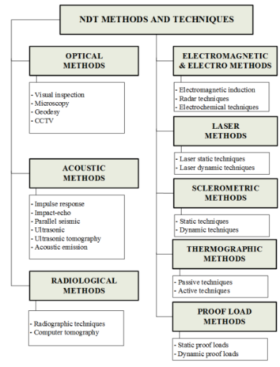 b) 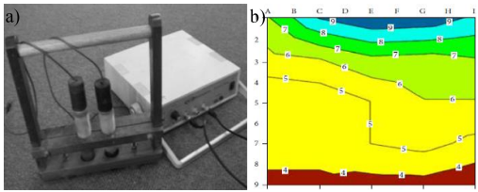

**Fig. 3.** a) Variety of methods for assessing the concrete structure durability; b) Concrete consistency is measured and assessed via electrical resistance [4].

Construction materials have different indicators which help assess the physical, mechanical, compressible, and deformable characteristics. Concrete is stiffer than soil-cement mixture or improved soil in terms of comparing the modulus of elasticity, density, electrical conductivity (EC), etc. On the other hand, there are some measures of investigation in which the dimensions of the structure could be determined.

Nowadays, geophysics is a branch of physics in which the objective is to investigate the morphology of soil stratum, and embedded or buried obstacles during construction. The achievements in geophysics is uncountable, and practicable in mine technology, biology, hydraulics and fluid dynamics in the river or ocean, material science, etc. [5]. One of the most common techniques is Ground Penetrating Radar (GPR) which is based on the reflecting wave concept to detect some subsurface anomalies or obstacles, stratification of soil layers, and determine the sinkholes, etc.

1. 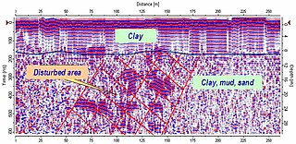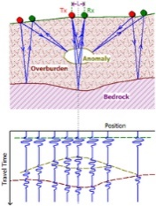 b) 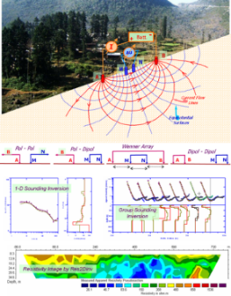

**Fig. 4.** Branches of the Exploration Geophysics: a) Ground Penetrating Radar (GPR); b) Electrical Resistivity Imaging (ER) [5].

The GPR uses electromagnetic waves traveling through the soil layer and reflecting at the obstacle or abnormal areas beneath the soil surface (Fig. 4). By reflecting electromagnetic waves at the boundaries between different layers, the soil conductivity for any individual soil layer could be determined. Another technique that uses electrical current injected into the soil and measures the difference in voltage between some specified points is Electrical Resistivity Imaging (ERI). A typical technique is Wenner’s Test Method (1915) and some close variations developed by many authors [6]. This method is the most popular testing method for determining the ER of the material [5][6]. The concept of the method is illustrated in Fig. 4.

1. 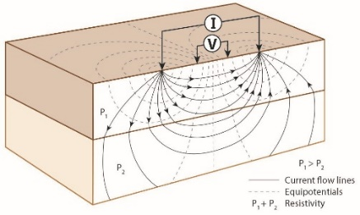 b) 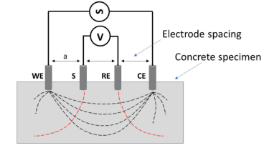

**Fig. 5** a) Wenner’s test method for determining the resistance of the material; b) current injecting at electrode WE, going out at CE, voltage difference at S and RE electrodes is measured [6].

Injecting current electrode WE and output current electrode CE are of a known current I, the difference in voltage between the two electrodes S (normally higher voltage) and voltage electrode RE, namely ΔV, is measured, then the apparent electrical resistivity ρa (in Ohm-meter, Ωm) is defined as

 (1a)

 (1b)

in which, *a* is the equal spacing between four electrodes WE, S, RE, and CE; *h* is the penetrating depth of the electrode into the object measured. According to the method, for measuring the soil resistivity, two outer electrodes as current probes, source electrode WE injecting the current (energy) into the ground and sink electrode CE for outsorting the current, and two inner electrodes as potential electrodes, are located somewhere to sense and measure the potential at the surface [7]. Potential contours are perpendicular with current flow in a same way of a flow net of underground water. By varying the spacing *a*, and keep the current electrode fixed, potential difference is measured, and the apparent electrical resistivity is computed by formula (1a) or (1b). A remarkable point in the formula (1) is the zero penetration *h* is possibly practicable meanwhile it is theoretically confirmed zero contact (i.e., contact at the surface) leads to infinity of the earth resistance and results in a deep penetrating distance into the ground [7].

Soil-cement columns is a product of mixing the in-situ soil with cement using blades and mandrel. The mixture normally has higher density, strength, stiffness, and physical properties; the water content is obviously reduced due to hydration and pozzolanic reaction [8]. The change in temporature and humidity during hardening process is a notable and quantitative point to focus on measurement.

a)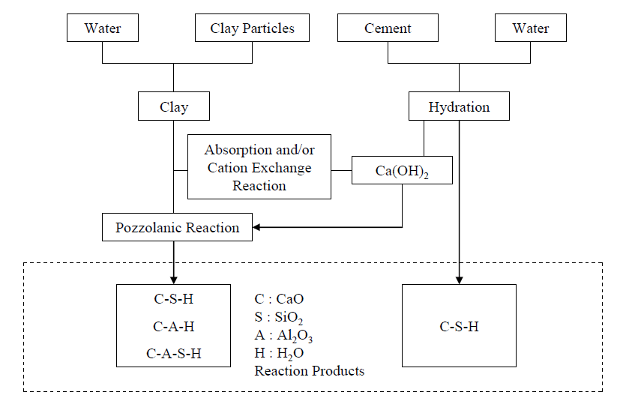 b)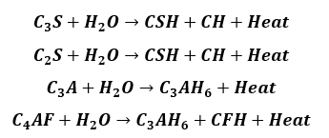

**Fig. 6.** a) Chemical reactions are pozzolanic and hydration reactions; b) Heat emitted during hydration reation causes the reduction in humidity, affecting resitivity of the material [8].

By connecting the abovementioned concepts, i.e., applying physics-based non-destructive tests to diagnose structures experiencing a hardening process (i.e, concrete, soil-cement mixture, etc.), it is necessary to understand some interpretation relating to the water content, chemical reaction with heat emission during curing process; the electrical resistivity (ER) could be a parameter to use in assessing the consistency, integrity and quality of the material. Several frequent questions for this method are that: how to assess efficiently the quality of the material and what is the most typical factor for evaluating the strength or the rigidity of this semi-rigid structure?

This article would study a model which the electrical resistivity method is applied to assess the quality of a soil-cement column (SCC) in laboratory and in site.

1. Building model using the Wenner’s test method for SCC
   1. Determining the target

Strength. SCC is not a rigid structure and its physical, mechanical, and compressible properties should be determined. The conventional method for determining the strength is the uniaxial compression test carried out in the laboratory. This test measures unconfined compression strength (UCS) qu at the axial strain not exceeding 15%. Then, the undrained strength in-situ, namely qu,field is defined as:

 (2)

Depending on many different factors such as soil plasticity, mixing conditions (i.e., dry or wet mixing method), speed of rotating, percentage of binder (by weight in each m3 soil to be improved), water content, soil plasticity, pH concentration, curing regime, etc., the factor α is around 0.6-0.7). The value of qu,field could be used to calculate the bearing capacity (BC) of a column and the shear strength of a productive mixture.

Stiffness. Although the resilient modulus of a soil-cement sample is not linearly proportioning with the UCS [8], as for some regulations such as ASTM G57-20 [8], the modulus of elasticity could be defined at a stress-strain level of about 50% of the maximum load, or E50=E as in the triaxial compression test with zero surrounding cell pressure, as follows:

 (3a)

 (3b)

This means if qu is known by tests, the stiffness for mixture could be estimated. In several studies, the correlation between the UCS and tangential/secant modulus E is a tightly linear [10]. So qu or UCS is the key parameter to evaluate both strength and compressibility of SCC.

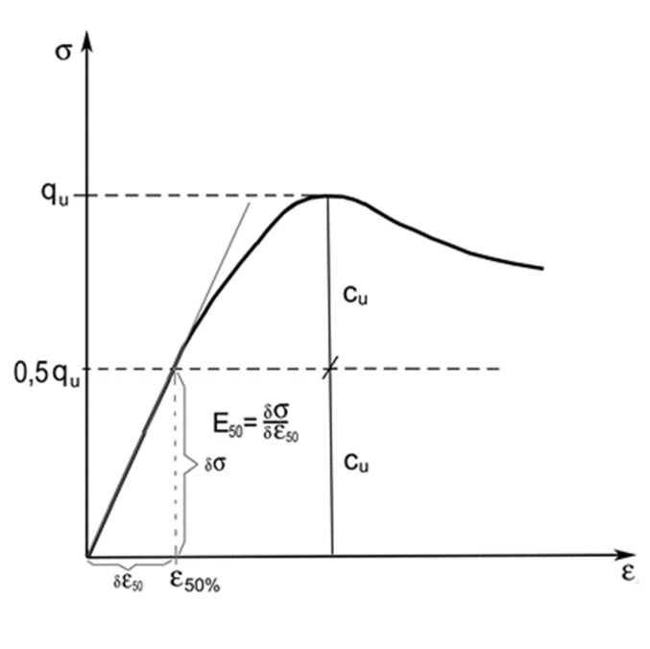

**Fig. 7.** Modulus at 50% out of the peak pressure in the unconfined compression test could be used alternatively as the modulus of elasticity [10].

Integrity. The quality of mixing is the first controversy that is proceeded right at the start stage of the mixing process. The mixing blade and the rod determine the diameter and the length of the structure; in most cases, for a group working condition, the difference in diameter and length of the columns is negligible for calculating the replacement ratio and BC. As such, the diameter and the length of the SCC are not the most important factor to diagnose. The diameter in reality is not greater than the nominal diameter.

1. 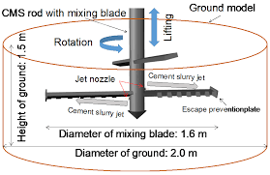 b) 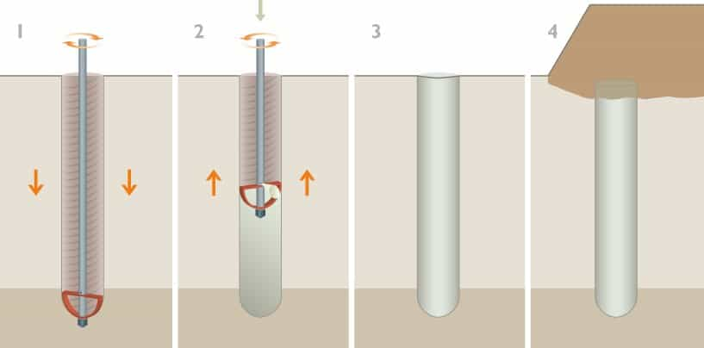

**Fig. 8.**  a) Diameter of soil mixed with cement and the depth of mixing are controlable factors during constructing by jet grouting [11]; b) dry mixing with cement injecting tool [12].

The remaining properties required to check are the quality of the mixture, including the stiffness (as constantly proportioning to the qu UCS by formula 3b), and the water content during the time of curing (7 days, 14, or 28 days of curing). The density seems to be not significantly varied [13]. As such, the integrity could be assessed via the ER by which, the water content, cohesion Su for soil, c for SCC, UCS, and modulus of deformation (i.e., material stiffness) could be predicted.

* 1. Specific issues for different arrays of geophysical methods

*Wenner array*. In this configuration postulated by Wenner in 1915, the spacing between electrodes is kept to be constant. Nowadays testers sometime alter the roles of electrodes in a reciprocity model (Fig. 9b).

a)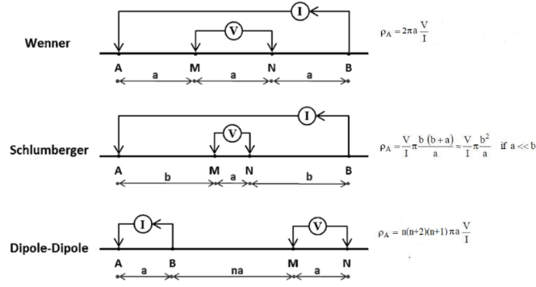

b) 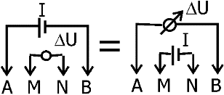

**Fig. 9** a) Different arrays [14]; b) A reciprocity array.

*Schlumberger and Dipole-Dipole array*. In the Schlumberger array, inner spacing between voltage electrodes is fixed, a together with the outer distance between the current source/sink electrodes and voltage ones is b (always greater than a). In the dipole array, spacing between the two voltage electrodes and two current electrodes are the same, or a, and the inner distance between the sink (source current B) and the voltage M is na, with n being an integer (Fig. 9). When B (sink of current electrode) moves to infinity (or greater than 10 a), the array is called Pole-Dipole array, and ρa=2n(n+1).πa.V/I; when both sink electrode B and the voltage electrode N move to infinity (or >10a), the array is called Pole-Pole array, giving the value of ρa=2πa.V/I, or the same as Wenner’s array. By plotting the resistivity to the spacing *a*, the soil stratification and other geotechnical properties could be predicted.

1. 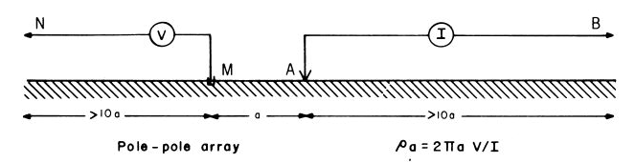
2. 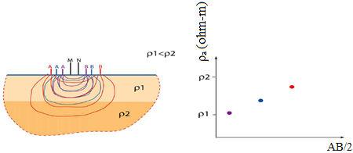

**Fig. 10.** a) As the electrode N (voltage) and B (current) move far in the distance, the result of ER will be the same as that in Wenner array [15]; b) By changing the spacing *a* between electrodes, the values of resistivity ρ could be measured, and the curve of ER versus *a* is plotted.

* 1. Strategy for obtaining the required parameters and variables from model

As mentioned above, for assessing the soil-cement mixtures, it is necessary to determine the ER (or its reciprocation, electrical conductivity σ, EC). The first step is for cemented soil sample in which its ER is measured [16]. In the second step onwards, the model of finite elements is developed to govern the site measurement. The strategy for determining ER is:

**Stage 1**: Preparing experimental samples for soil and column. There are 2 steps:

* Step 1: Choose the ER (or Conductivity in S/m) of soil and SCC for samples.
* Step 2: Calibrate the value of ER for two materials by two probe methods in which, ER values are obtained by experimental model and laboratory test (configuration as in Fig. 11a and 11b). This step is to confirm the value ER of soil and SCC chosen and check the correlation between ER and physical properties of the sample [11]. Resistivity for the soil could be calculated as well-understood formulas (i.e., formula 1a and 1b) [19].

1. 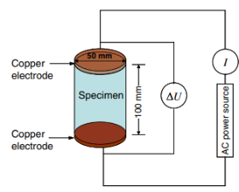 b) 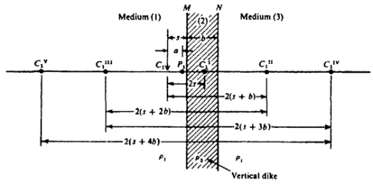

**Fig. 11** a) Schematic diagram of two probe method for measuring the ER [17]; b) Schema in plan of configuration array in which SCC is a vertical structure, many images could be obtained as current electrode, C1 and voltage electrode P1 locate at one side of the structure [21].

**Stage 2**: Create a 2D or 3D numerical model using Quickfield [20] with a far field, and site test for verifying the results of voltage and current measured in step 2.

* Step 3: Model the columns and the surrounding semi-space of soil medium, use the 2D parallel plane and 3D conductivity model. SCC plays a role like a vertical dike as postulated in [21]. Sets of images at points on both side of the structure, C1II or C1III when potential P1 and current C1 locate at one side of the structure (Fig. 11b) could be computed [21].
* Step 4: Run the 2D model in which the structure has no defect using the 2D conduction model and the calibrated ER or conductivity obtained by steps 2 and step 3. Two approaches are suggested:
  + forward approach. The input data are ERs to be assigned, apply a current injecting, measuring the drop in voltages between potential electrodes M and N;
  + backward approach. Measuring values of current at reference points and concerning a predetermined drop in voltage.

If the results of current and voltage are matched, further to step 5.

* Step 5: Validating the results of soil and semi-rigid structure by comparison of the calculated values of voltage and measured ones.
* Step 6: (this step is optional) An Analysis of Variance (ANOVA) is studied to select the most important factor(s) and the percentage of contribution of the individual variables and parameters. The factors that govern the measurement at the site should be sensitive ones. The structure is first studied without any defects.
* Step 7: Implementing Wenner’s test. The depth of penetration could be zero, providing the contacts are guaranteed (for instance, wet contact).
* Step 8: Conducting other different arrays in the abovementioned subsection 2.2 (i.e., Schlumberger’s array or others). The structure model is deliberately defective and observes the results in imaging maps, including the distance apart from the probes with recorded values of current and potential, etc. Comparisons between the calculated values to the measured values are recommended.
* Step 9: In each specific case of scenario with the intentionally created defect, measure ERs for structure and soil. As a usual procedure, the spacing between electrodes a and b could be varied to figure out the stratification of soil layers.

**Stage 3**: Predicting the mechanical properties of the structure and soil.

* Step 10: Mechanical properties of the surrounding soil and column, are determined by some correlation equations [24].
* Step 11: Calculating the bearing capacity of SCC based on the mechanical properties of surrounding soil and SCC, and the dimensions of SCC measured. A site test is normally necessary to confirm the results.

The abovementioned strategy could be summarized in a flow chart of Fig. 12.

**Stage 1**

**Stage 3**

**Stage 2**

1. Select ER of soil and SCC..)

3. Assign ER to the 2D and 3D conduction models including soil medium, structure, etc.

2. Calibrate the value of ER to water or air

4. Run the 2D model (forward solver: rho solves for U, I; backward solver: U I solve for rho);

7. Run the model using Wenner’s four point array and check by the Schlumberger and others.

11. Predicting the bearing capacity of SCC.

10. Use regression equation to predict the mechanical properties of soil and structure [23]

End

8. Run the numerical model with defecs (i.e.,bulging, necking, discontinuity...) and measure U and I at reference points, using alternatively different arrays (i.e., subsection 2.2)

9. Calculate the ER of soil and defective structure, using contour map U and I.

6.ANOVA to determine dominant factors and percentage of contribution of each factor

5. Check: Does rho match b/w the assigned and tested, assigned and calculated values

Start

No

Yes

**Fig. 12** Steps for using ER to predict the bearing capacity of a soil-cement column.

* 1. Data preparation for model

A 0.6-meter diameter soil-cement column is studied. In this paper, an axisymmetric model is converted to a planar one having 0.25 m of thickness. Wenner’s array is studied firstly with spacing s=0.25m (Fig. 13), right at the edges of the column. The contact area is assumed to be well conductive. In this paper, electrical conductivity (EC) is chosen to use in the forward approach. Values of conductivity could be tentatively and carefully get from reference books [21]. For a site to be checked, some soil properties are listed in Table 1. For the very wide range of the resistivity (ER) of soil and soil-cement mixture, it is necessary to calibrate the ERs of these materials to those of known ER such as water, air, etc., or ER-exactly known other materials studied. Calibration could also be conducted between the lab test and the numerical model (Step 2, with two array methods using Quickfield software [20]).

**Table 1.** Data prepared for a site to be modeled [22].

|  |  |  |  |  |  |
| --- | --- | --- | --- | --- | --- |
| Description | Properties | | | Conductivity*, σ (S/m) | Depth |
|  | Unit weight | Modulus of Elasticity (kPa) | Friction coefficient |  |  |
| Upper layer of soil | 19.3 | 1.5e4 | 0.5 | 0.0005 | 0.5 m |
| Lower layer of soil | 22.5 | 1.0e4 | 0.6 | 0.005 | 1 |
| Layer of discontinuity | 20 | 1.5e4 | - | 0.0001 | (L/10) |
| Concrete pile D100 | 24 | 3e4 | N/A | 0.02 | (very stiff) |

There are some errors when transforming the axisymmetric model to the planar strain model, but in the preliminary stage of the study, it is temporarily negligible. Nevertheless, the issue of errors could be easily solved by a 3D model with sufficiently wide boundaries (i.e., far field), together with a site test. The model with SCC could be viewed as a vertical layer [18][19][21] with the resistivity of the soil-cement mixture as postulated in some prior studies. The model depends on the number of nodes, and blocks edges. According to the configuration of the instrumentation described in Fig. 9 and Fig. 10, A is the source electrode for injecting current, B is the out-sorting current (namely ‘sink’ electrode), M and N are voltage electrodes with the potential drop to be measured, respectively. Zero depth of penetrating for electrodes is theoretically acceptable, based on the formula (1) with h equal to zero (this would be discussed later in section 4). The soil medium, structure with Wenner four-point array, current probes A, B, and current probes M and N, are located as in Fig. 13 below:

1. 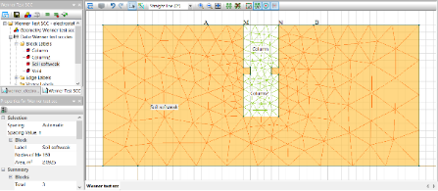
2. 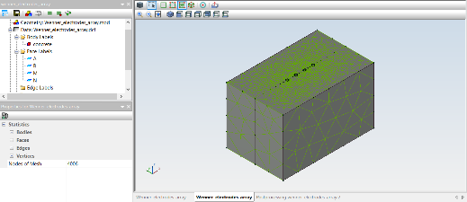

**Fig. 13** Model for virutally testing SCC using Quickfield software; a) 2D model, structure with necking; b) 3D model for comparison in far field (An example in [20]).

The boundary condition should be prescribed as a zero voltage one as instructed in the user manual [20]. The forward approach with a specific array seems to be more rigorous for easily calibrating to several other configuration arrays such as Wenner’s, Schlumberger’s, di-pole, and others (Fig. 9, 10). In the framework of this paper, for simplicity, the forward approach is chosen to illustrate the model, in which ECs for materials are assigned, and output data (voltage values at electrodes) are measured as local values (the icon to be circled in Fig. 14) at selected points. The target is to trace the voltage difference ΔV in the model in the case of possibly occurred defects.

1. Results
   1. Calibrating the resistivity with soil-cement mixture samples

In step 2 of the strategy, EC could be calibrated by both laboratory experiments (Fig. 11a) and numerical models (Fig. 14).

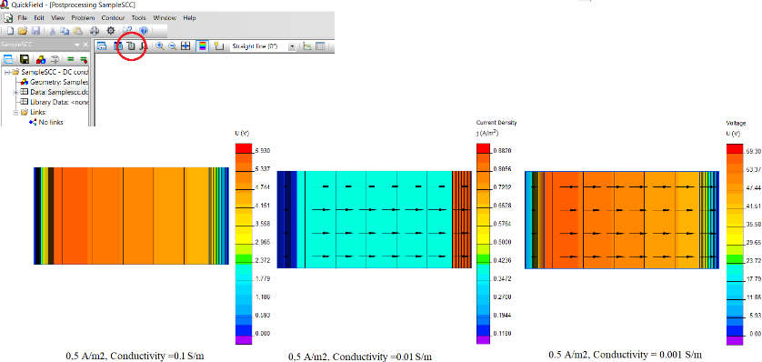

**Fig. 14.** Comparison on the current density with respect to different conductivity from the least conductivity (dried concrete or dry clayey soil) to the largest conductivity (for instance, wet concrete or saturated clay) [22]. Red circle to pick a point to obtain values of voltage and current.

According to formula (4), the ER for the soil sample could be exactly determined, by lab tests and computed using data from a calibrated numerical model. Table 2 lists some values of electrical conductivity chosen as calibrated. The smaller stiffness of SCC compared to soil, the higher conductivity. Three kinds of stiffness are studied: soil and column (σ=0.02 S/m, problem number ‘111’), SCC stiffer than soil (σ=0.001 S/m, problem number ‘312’), and SCC stiff (σ=0.0001 S/m, problem number ‘413’). Results are prescribed in the following sections.

**Table 2.** Calibrated soil and SCC.

|  |  |  |  |  |
| --- | --- | --- | --- | --- |
| Description | Conductivity, σ (S/m) | | Electrical resistivity | Note |
|  | Range | Calibrated | (Ω-m) |  |
| Water | - | 0.01 | 100 |  |
| Weak soil (sample) | 10-4 to 10-2 | 0.02 | 50 | Sandy clay, sand saturated |
| Soil-cement sample | 10-3 to 10-1 | 0.05-0.0001 | 20-10000 | Dry to wet concrete, low to very high integrity |

* 1. Calibrating the model using data from previous study

The second model to be studied for calibration purposes has no defect. Data on soil and structure are taken from Table 1 [22]. The target is by calculating ER, the soil and pile properties are predicted; if matched with data of the document, the model is acceptable to model SCC by reducing the modulus of elasticity from concrete (pile) to soil-cement mixture (column).

For sandy soil, there is a tight relationship between the density and the ER [23]. In most cases, the void ratio of loose sand e ≈ 0.4, or porosity n ≈ 0.28, correlation equation for the calculated value of ER will be:

 (4a)

 (4b)

Porosity leads to a factor F equal to 6.54, and the apparent (measured) ER equals 970.12 Ωm (for SCC) and 2408.32 Ωm (for soil) and the calculated ER for loose sand is 368 Ωm. It is seen surrounding soil has a higher ER or lower EC than SCC. These complied with Archie’s law as described in formula (4a) concerning a transformation from the apparent ER to computed ER. Then the results obtained by correlations [24] are: cohesion and the angle of internal friction of the soil is 34.42o; the friction coefficient equals 0.68, very close to the data input in Table 1). As such, the model is essentially calibrated.

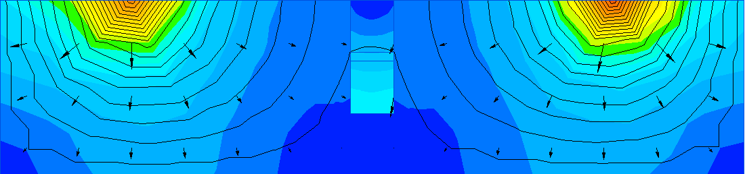

**Fig. 15.** Calibrated model with data in [22], ER of SCC is 970.12 Ωm, soil ER is 2408.32 Ωm;.

* 1. Configuration array to be used in model

Different four-point arrays are used in the model, Wenner’s and Schlumberger’s arrays. An injecting current at A electrode will result in a voltage difference between two inner electrodes. The voltage could be measured then; and by a converse approach, a test with a difference in potential (voltage) could have only one value of current thru the soil mass. In the case, there is a defect, the change in resistivity leads to a change in the direction of the current vector. As such, two variables in formula (1), i.e. voltage and current for a specific material tested will be uniquely determined. Therefore, in the numerical model, two values of voltage and current would be assigned to the model with a fixed value of conductivity.

Wenner’s array with four points is the most common model having an equal spacing between the electrodes. The soft soil surrounding the column has a conductivity σ=0.5 S/m for very soft and saturated clay, and the upper and lower part of the column has a conductivity σ=5×10-3 S/m (resistivity 200 Ω-m for sand); as such, it could be figured out that the soil medium is slightly softer than the column. Three cases of the conductivity for the sand layer (i.e., discontinuity) are σ=10-1 for wet sand, 10-3 for dry clayey sand (for instance, when sand mixed with slurry), and 10-4 S/m for saturated sand or completely discontinuous layer. Table 2 introduces some conductivity for a specific soil [13].

**Table 3.** Typical range of conductivity for different soils [13].

|  |  |  |  |
| --- | --- | --- | --- |
| Description | Conductivity | Relative permittivity, εr | Electrical resistivity ρ (at 20oC) |
|  | (S/m) | F/m | (Ω-m) |
| Air | 3×10-15 – 8×10-15 | 1 | 1.3×1016 – 3.3×1016 |
| Water (drinkable) | 10-4 – 10-2 | 81 | 0 – 200 |
| Concrete dry | 10-7 – 10-3 | 4 – 10 | 5000 – 10000 |
| Concrete wet | 10-2 – 10-1 | 10 – 20 |
| Clay saturated | 10-1 – 1 | 15 – 40 | 15 – 150 |
| Sand saturated | 10-4 – 10-2 | 10 – 30 | 200 – 3000 |
| Sandy dry soil | 10-4 – 10-1 | 4 – 6 |

*Necking.* The assumption to be verified is that the contour and distance measured at the ground surface are not equal at an arbitrary selected point, both in values of voltage and current. Other arrays as described in Fig. 9 and Fig. 10 could be applied to check and confirm the parameters of the model (ECs of soil medium and the SCC, etc.). These different arrays could be useful to confirm the nearly exact value of the conductivity, in a very wide range of the values of conductivity.

1. 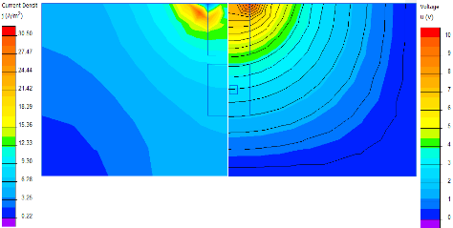 b) 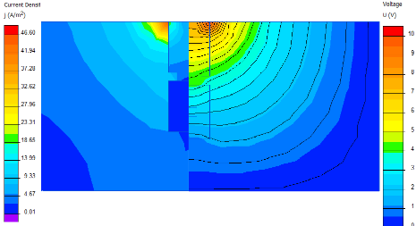

**Fig. 16.** a) Zero different conductivity between soil medium and necking structure; b) Conductivity for soil is greater than column (or the ER of soil is smaller than column).

In the first model, the EC of SCC is taken the same as surrounding soil (Fig. 16a). Sink current at A is 0.5 A and the voltage at both electrodes M and N equals 10 Volts. These values are kept to be constant to study the change in voltage and current at different points at the ground surface. The left half of the image is the contour of the current and the right is the image of the voltage contour. The difference in contour maps for the two cases (i.e., with/without necking) is easily recognized at points of measurement.

*Discontinuity*. Another scenario of the defective structure is that there is a discontinuity, i.e., a distributed layer of sand 0.05 m of thickness in the middle of the shaft. A parallel test (for instance, spectral analysis of surface waves, denoted SAWS) reveals the column has two parts, namely upper and lower part, a sandy layer separates into two. The soil medium is of sandy soil, having σ=2×10-2 S/m (sandy wet soil); the column is a dried sandy material having σ=2.5×10-3 S/m; and the layer of wet sand σ=1×10-3 S/m. Predictably, the load transfer is seriously affected, and the bearing capacity (BC) depends only on the upper part of the column, right under the load platform. As the column is discontinuously constructed, a questionable issue is how to identify this kind of defect by studying the change in voltages measured in the model.

Results obtained by the model point out that in the case of discontinuous layer(s) in the column, the contour of potential has varied shapes, and there is a clear difference in current at the same point along the structure.

1. 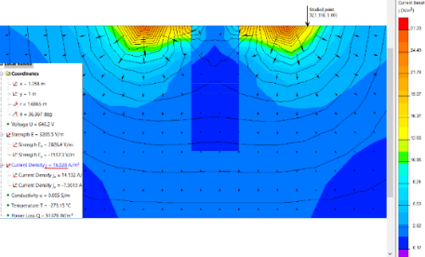b) 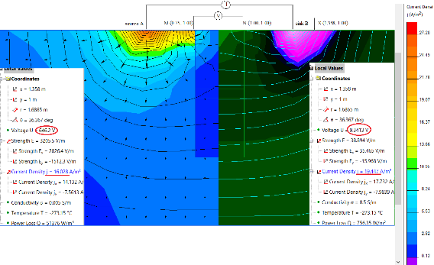

c) 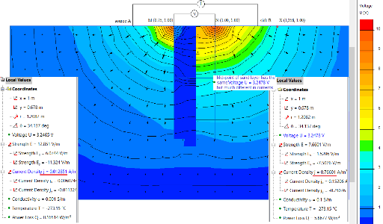 d) 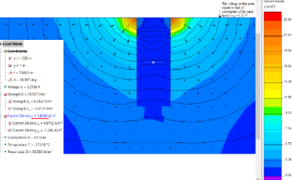

**Fig. 17.** A column with discontinuity: a) Soil and column have equal conductivity σ=0.005S/m; b) Soil and column have equal conductivity σ=0.5S/m (right half); c) Soft soil (σ=0.5S/m) with SC column (σ=0.05S/m), and two cases are studied: Discontinuity by wet sand (left half, σ=10-1 S/m) and by dry sand (right half, σ=10-3 S/m); d); Discontinuity, saturated sand layer, σ=10-4 S/m.

A remarkable thing is that at the spacing between Wenner’s electrodes equal to thrice out of column diameter and non-zero voltage at M and N electrodes, there is a zone of equipotential that cover nearly total the column (Fig 17c). The voltage in this zone varies insignificantly. This could be a notable point to measure the voltage at the top of the column, calculating the resistivity (i.e., inverse of conductivity), and predict the mechanical properties of the structure. By injecting a current at A and B, and then measuring the voltage at M and N together with the current through the column, the resistivity of upper part of column would be calculated as per relevant formulas. In case of Fig. 17d, voltage at M, VM=49.806 V; at N, VN=49.64 V. By taking integral for countour straight line, from top to bottom of the column, the calculated area S = 0.65 m2. Results are described in detail in Table 4 and Fig. 18. These data are compared to those of site measurement, and after calibrating, they could help to determine properly the electrical conductivity or ER. Due to symmetry, the voltages at M and N are nearly equal. To any contour, the current will be a line integral of the current density j along the length of contour; the potential difference between starting point and the last one divided by the current would be a constant, namely geometric factor. All these data could be found at the right part of the post-processing images (Fig. 17b).

**Table 4.** Values of voltage and current measured at inner electrodes M and N.

|  |  |  |  |  |  |  |  |
| --- | --- | --- | --- | --- | --- | --- | --- |
| Problem number | Electrical Conductivity (S/m) | | | Voltage measured at (V) at | | Current measured (Amps) at | |
| Soil | SCC | Discontinuity | M | N | M | N |
| ‘111’ | 0.02 | 0.05 | 10-2 | 48.425 | 48.282 | 1.098 | 1.0587 |
| 10-3 | 10-3 | 49.680 | 49.62 | 1.0825 | 0.97717 |
| 10-4 | 10-4 | 50.003 | 49.93 | 0.9988 | 0.9582 |
| 10-4 | 10-5 | 50.548 | 49.96 | 1.011 | 0.9560 |
| ‘312’ | 0.002 | 0.05 | 10-2 | 452.11 | 449.01 | 1,2986 | 1.2511 |
| 10-3 | 10-3 | 467.66 | 465.43 | 1.2061 | 1.1567 |
| 10-4 | 10-4 | 483.91 | 481.62 | 1.1092 | 1.0578 |
| 10-4 | 10-5 | 486.26 | 484.92 | 1.0831 | 1.0377 |
| ‘413’ | 0.0002 | 0.05 | 10-2 | 4488.4 | 4467.1 | 1.3161 | 1.2687 |
| 10-3 | 10-3 | 4520.0 | 4498.4 | 1.2986 | 1.251 |
| 10-4 | 10-4 | 4671.1 | 4654.3 | 1.2031 | 1.1567 |
| 10-4 | 10-5 | 4839.1 | 4816.2 | 1.1092 | 1.0578 |

1. 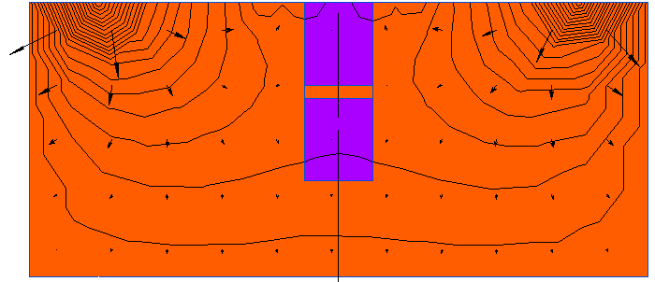 b) 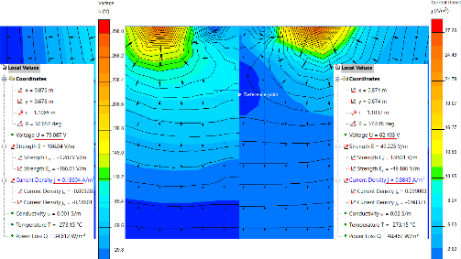
2. 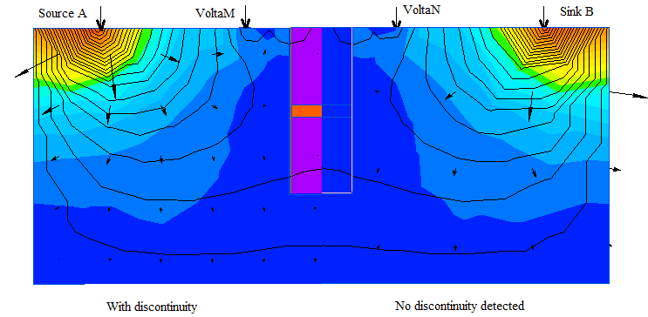 d)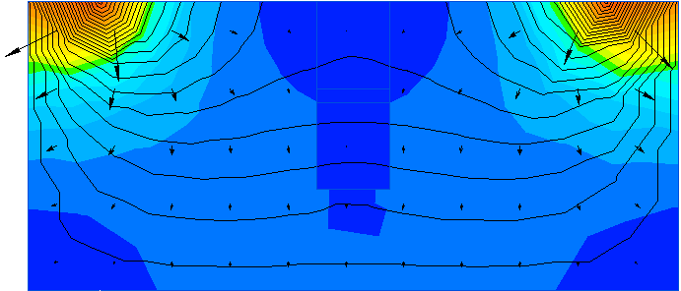

**Fig. 18.** a) Column with a sand layer, 50mm of thickness as a discontinuity; b) Comparison between before and after construction with discontinuity (soil medium σ=0.02S/m (right half); column σ =0.0025S/m (left half); saturated sand layer, σ=10-4 S/m; c) U=10V at both M and N; the equal spacing between electrodes is increased; d) Contour map by zero voltage at M and N.

By measuring the resistivity at different points along the longitudinal axis of the shaft, voltage is decreased (see Fig. 19a) whilst the current is varied to segments (Fig. 19b). By examining the plot curve of voltages at various depth points along the column shaft, it is recognized the change in voltage within the sand layer is nearly negligible, while the currents are completely scattered. This results in a segregation (i.e., discontinuity).

1. 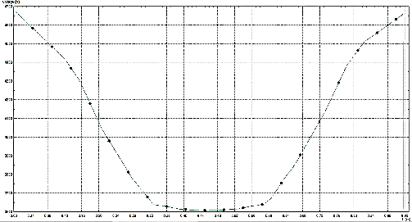 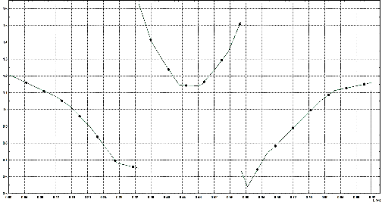
2. 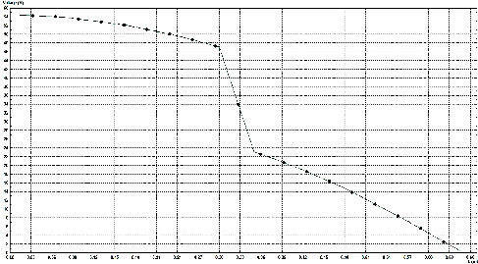 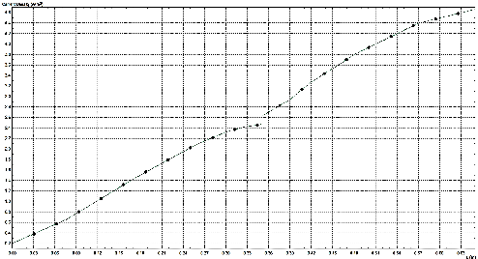
3. 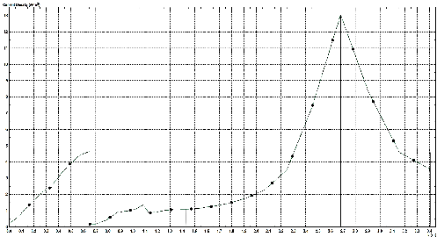 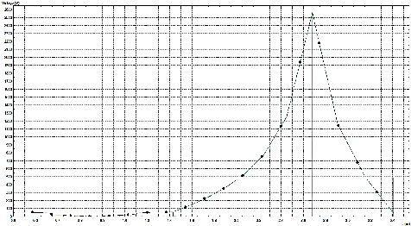

**Fig. 19.** Using half a circle contour connecting edge to edge of the column. a) Voltage w.r.t depths of the structure; b) Straight contour at the centerline of the structure having a discontinuity, from top to the bottom of column (voltage on left, current on right); c) Current and voltage at different points at the ground surface, apart the electrodes M and N (current on left, voltage on right, peak is B electrode).

Quickfield software supplies tools for reading voltage and current at various points in the field. By plotting a contour, potential difference (not depending on the path of the contour) and current density could be measured; integral value could be read by the output data (Fig. 20a), in associated with a wider boundary (Fig. 20b). By tracing the contour, voltage, and current at any point in the field could be determined by both calibrated numerical model and measurement. Contour line (as listed in the left side of Fig. 20a) could be of straight, half circle, etc. for calculating the ER of soil and structure.

1. 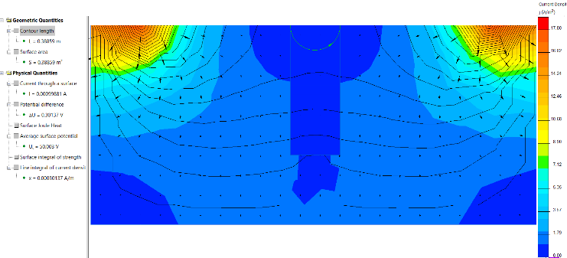
2. 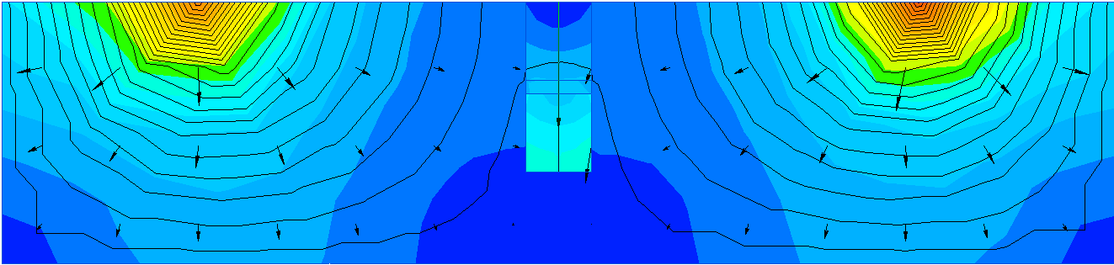

**Fig. 20.** a) By adding a half-a-circle contour within column cross-section, the electric resistivity of the upper part of the column could be calculated; no defect in column b) Straight line contour, with a wider far field; with a discontinuity.

* 1. Schlumberger 4 array for recognizing the distortion of current flow

By examining the contour of either potential and current which are crossing a vertical boundary, the difference between the resistivity of the structure and the soil is recognized. As the contour is perpendicular to that of current flow, it is seen that, if the higher resistivity (i.e, smaller electrical conductivity) of the structure as compared to that of soil medium, the closer current flow is bent toward the normal, or the potential contour moves outward the normal, or closer to the outer edge of the column shaft; by examining a reference point X, the predicted voltage would be lower (Fig. 21b).

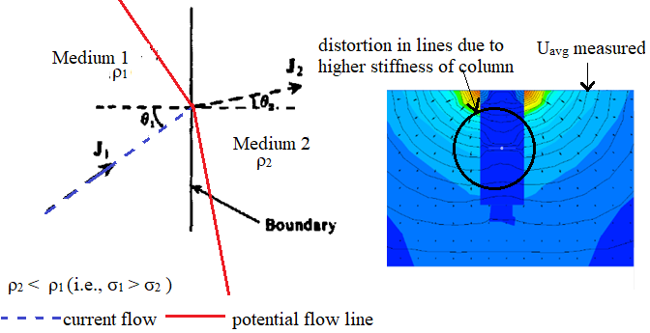

**Fig. 21.** a) Theory on the angle of current flow when crossing two mediums having different electrical resistivity [21]; b) Collect data by reading at a reference point in numerical model.

Two inner voltage electrodes M and N are kept to stay fixed as the outer current electrodes A and B move to vary b (in Fig. 9). Voltage at any reference point could be governed by the numerical model (Fig. 21b) and compared to measurement at site.

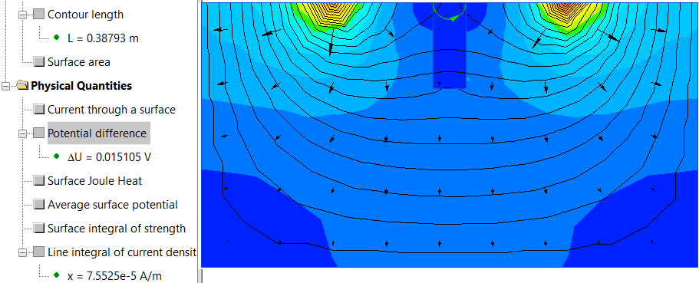

**Fig. 22.** Schlumberger test with c=3a, measuring Voltage difference and calculating the resistivity of column by half a circle contour or line, etc. yields ρ=9714 Ω-m (or σ=0.0001 S/m).

In the numerical model, potential diffenence is ΔU= 0.015105V (Fig. 22) and current flowing thru the contour length is I, or xL=7.55e-5 A/m × 0.38793 m. The apparent resistivity calculated by Schlumberger’s formula is as below:

 (5)

* 1. Predict the strength parameters for soil-cement mixture

It is necessary to predict the humidity, and the strength of the structure, including skin friction and partial tip point bearing at the site. By applying the correlation formula, the coefficient of calibrating concerning the transformation from the apparent to the computed value of ER as studied in subsection 3.2 (i.e., F=6.54), the predicted values of the water content, denoted by w (%), cohesion c (kPa), and angle of internal friction φ are as below [24]:

 (6)

 (7)

 (8)

As such, the strength of SCC could be estimated from the apparent ER (i.e., the measured value of ER together with a calibration coefficient determined by site measurement as in subsection 3.2), exactly for either dry and saturated soil-cement column by applying the correlation between UCS of the dry soil sample and the wet sample [10] and between cohesion and UCS of SCC for wide range of the time of curing (i.e., 3 days, 7 days, 14 days, and 28 days, and UCS, c are in kPa) [25]:

 (9)

 (10)

As results of cohesion of SCC obtained by formula (7), UCS is predicted to be 148.67 kPa by formula (10) [26]. This result could be definitely checked with lab test.

* 1. Predict the bearing capacity of the soil-cement column

A model of SCC on sand is as illustrated in Fig. 23. In the case of Lc/dc=1.5 the plotted curve results in a BC equal 82 kPa (Fig. 23b)

1. 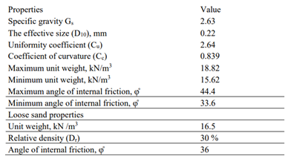
2. 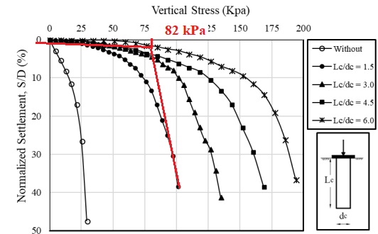

**Fig. 23**. Experimental study on a small scaled model of SCC in sand. A) data of soil in model; b) BC determined by double tangent method is qult=82 kPa (replacement ratio Ar=40.5%) [27].

The bearing capacity (BC) of the SCC could be estimated according to conventional approaches. As in [27], the ultimate load on a column in the model is 0,78 kN for a replacement ratio Ar=40.5% and qult=82 kPa, resulting in a load at overall failure load in the scale model is 0.78 kN.

In the case of discontinuity, where the upper part, of which the length is L and the converted diameter D, the BC could be of material Rscc and the properties of the surrounding soil Rscc,u. The UCS for the column is calculated by the formula (10), being 148.67 kPa. As per Kitazume and Terashi (2013), the bearing capacity of a soil-cement column is [28]:  (11)

And the allowable bearing capacity is

 (12)

in which α is the coefficient regarding the effective width of the column (from 0.8 to 0.9), β relates to working conditions (from 0.8 to 0.9), and γ for strength variability (equals 0,55). The soil bearing capacity of a single SCC under consideration using calculated values of c, UCS, and angle of internal friction φ [29]:

 (13)



In the abovementioned calculation, a reduction factor of 0.8 is applied to the diameter of the SCC, and the ratio Length/diameter of pile is assumed to be 1.3 to estimate the length of the SCC, which equals 3 times the diameter or 0.78m in the model. Many factors, including ratio L/d, the density of sand, etc. in the suggested model should consider further.

1. Discussion
   1. Potential of Model

The model in this paper uses a physical concept instead of a mechanical method to apply to geotechnical engineering. The final target is to estimate the strength of the SCC via the electrical resistivity (ER) or conductivity of soil and column. In general, once the EC of the SCC is determined, the bearing capacity for the structure is predicted. The column is modeled to be a vertical boundary in the plane parallel model (1 m in length) instead of an axisymmetric one, many different arrays could be applied to obtain and check data and calibrate them. A well-calibrated model is proved to be a possible tool for studying the state of materials (i.e., dry, wet, or saturated), calculating the porosity, and diagnosing the mechanical properties of a soil-cement column by using a geophysical concept. There are some useful discussions below:

* The model could be calibrated by several approaches, such as
  + by comparing the resistivity of soil and sub-ground structure to that of water or air (in the numerical model);
  + by comparing it between the forward procedure (i.e., ECs for soil and structure are assigned, voltage and current are measured at points on the groundsurface) and backward one (EC to be calculated with given voltage and current) to ensure the proper value of resistivity assigned to the model;
  + by comparing it to that of site tests with different sizes of the sample (Fig. 11a), using equipment and electronic devices in several different directions, etc..

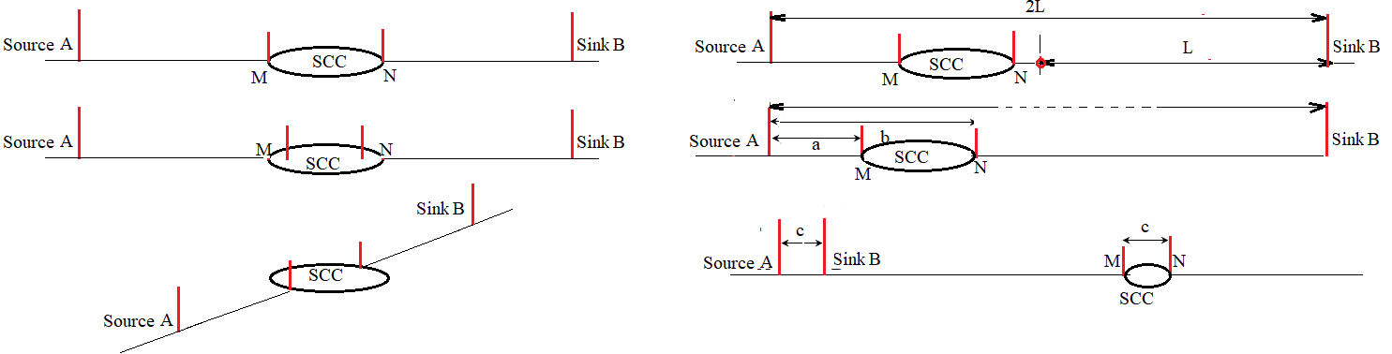

**Fig. 24.** Configuration arrays [26] could be alternatively applicable as measures of calibration.

For having a good predictable model, rigorous steps of calibration are necessarily conducted, both in material and in configuration array as previously described in subsection 2.2. In the Wenner test, equal spacings between electrodes are used, measurement at points could lead to errors due to repeated measurement (i.e, spacing alters). Meanwhile in the Schlumberger test method, with unequal spacing between electrodes without moving the inner electrodes, it could reduce the errors because of no repetition in measurement; in other methods (dipole or pole-pole array as in Fig. 10) which some electrodes are moved to infinity could be conducted with a very far distance. For a very long electrical wire; the approach of the pole-pole array for deep exploration is more practicable. As measuring is only conducted on the ground surface with a wide range of spacings (Fig. 24), the model could develop to carry out with a depth of penetration h in formula (1). This could give the more exact results of ER, providing the contact around the probes is well guaranteed. Outcomes as described in Table 4 could be used to calculate the ER of soil and structure.

* The numerical model as in this article is the first step to understanding how the defects affect the contour map, and alter the value of voltage measured at specified electrodes M and N in some specific arrays. It should be studied before carrying out any test at the site. Some points are recognized as follows:
  + to trace the difference in electric parameters, i.e. voltage and current, resistivity or conductivity...etc for different scenarios of defects in the model;
  + to measure at site what obtained by the numerical model over a broad testing area.
  + to govern the configuration (array, depth of electrodes, etc.) for measurement at the site, to govern the comparison of the calculated and measured values.
* 2D axisymmetric model or 3D one (as in Fig. 13b), declaring a 2D or 3D conduction model should be used to avoid errors in data. The input data assigned to the model are current and resistivity, and results are alternatively conductivity (σ) or resistivity (ρ) of the objectives.
* It is possible to use other approaches such as spectral analysis of surface waves (SAWS) to detect discontinuity (location and severity), then, by using this numerical model with calibrated resistivity to estimate the strength parameters of soil and column (formulas (6) to (10) in the subsection 3.4), the bearing capacity of the column could be predicted at any time during the curing process. As the resistivity changes, the water content changes simultaneously.

The wet or dry state of the soil-cement mixture could be determined by both measurement and the correlation between the ER with the degree of saturation S, and the porosity n as followings:

 (14)

in which, n is porosity, S is the degree of saturation, m equals 1.38 to 2.3; d equals 2 and ρw is the ER of water, 200 – 800 μS/m. Further steps are to check with some prior studied results [23][28].

* Although the values of ERs calculated from this model are of apparent values, the cohesion and UCS (both dry and saturated state) are rather reasonable. Nevertheless, it should use the true ER which equals the apparent ER divided by some factor as postulated by many authors [23][28].
* The increase of the strength or temperature of the hardening process, etc. during curing time could be evaluated by tracing the variation of ER with respect to time.
  1. Quantitative Indicators for a Specific Defects

The relevant procedure is to trace the voltage at the voltage electrodes in association with many configuration arrays and values of current density. By measuring voltage or current at points on the ground surface or small depth of electrode penetration h, it could detect the different images with which, the resistivity (or its inverse, conductivity) is computed.

The image described in Fig. 25 is from data in Table 2, for necking, bulging, and discontinuity, respectively..

1. Necking 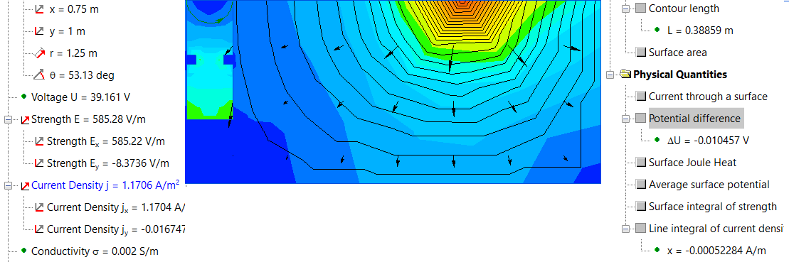
2. Bulging 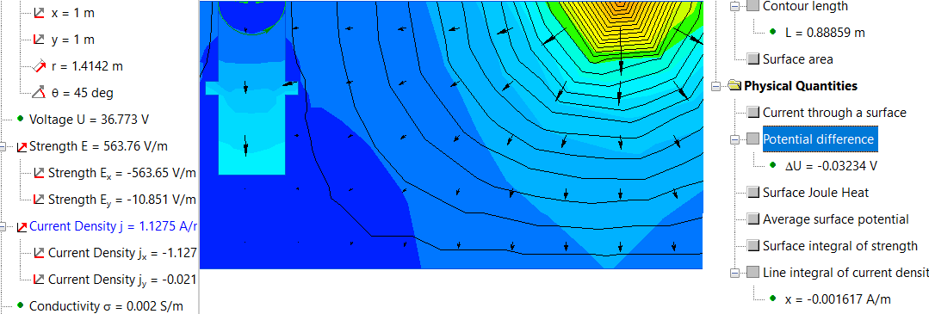
3. 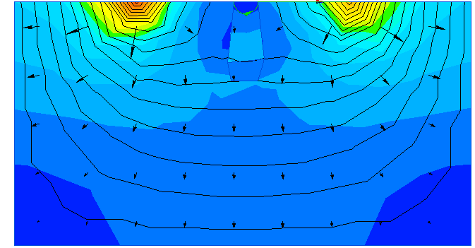
4. 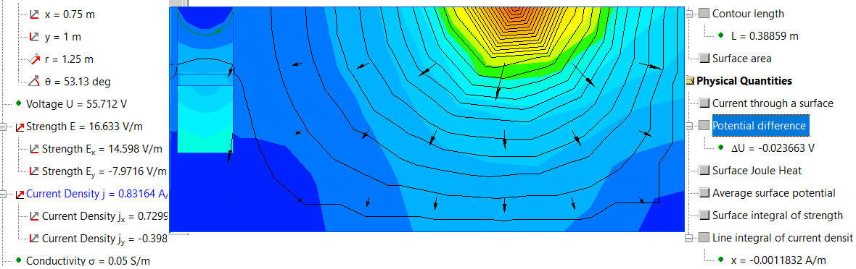

**Fig. 25.** Status of defective SCC: a) Necking; b) and c) Kinds of bulging; and d) Segregation.

*Bulging.* The contour map of voltage is plotted by the software as in Fig. 25c (lower figure). An asymmetric contour could be recognized as the diameter of the structure is sharply changed. This could be diagnosed by measuring at a point apart from the column, conducting in different directions around the columns. Nevertheless, it is rather difficult to relate the change in diameter to the ER, only by measuring at the ground surface, and many studies both in the laboratory or at a site such as the cross-hole method [30][31], etc. Nevertheless, the distortion of the current (i.e., the contour of potential) at positions of the necking and bulging is an important indicator. In the case of segregation in structure, no measurement at the ground surface is possible due to no contour at the breakdown crack found (Fig. 25c).

1. Conclusion

The bearing capacity of a defective semi-rigid structure could be the top priority to be considered. Defects such as bulging, necking, and segregation (i.e., discontinuity) are hard to detect and diagnose the defective status by known methods. As the final target, it is necessary to estimate the bearing capacity of the structure. In the framework of this paper, the model of using physical methods, i.e., applying the electrical resistivity (ER) or its inverse (i.e., electrical conductivity) to geotechnical engineering, proves to be a quantitative method in estimating the strength of a semi-rigid structure like soil-cement columns. The method has several variations that could be used as tools for calibration, together with water or air of known resistivity. Further, the method could be calibrated both in samples mixture in the laboratory, in the numerical model, and in in-situ measurement. Besides, the model of using ER could provide much data for the process of predicting the mechanical and physical properties of the semi-rigid structure, as illustrated in subsection 3.2 with an example of a test in which a convolutional neural network and other algorithms are utilized [22]. The model uses Quickfield to take images of electrical resistivity for the field and to apply it to predict the BC of an SCC in loose sand, as illustrated in this paper. Although the physical method requires electronic devices with high accuracy, earthing system, etc., it should be developed widely and studied deeply when connect to site tests with highly accurate devices to apply to health monitoring for the inhomogeneous and semi-rigid structures like SCC.

References

1. Jiunnren Lai, Chih-Peng Yu and Shu-Tao Liao.: Assessment of the Integrity of Piles by Impedance Log Technique. Journal of Key Engineering Materials, Vol. 321-323, 340-343, Switzerland, <https://doi.org/10.4028/www.scientific.net/KEM321-323.34038>, (2006).
2. Raja Sekhar Madhyannapu, Anand J. Puppala, Soheil Nazarian, and Deren Yuan.: Quality Assessment and Quality Control of Deep Soil Mixing Construction for Stabilizing Expansive Subsoils. Journal of geotechnical and geoenvironmental engineering (ASCE), Vol. 136, No. 1, 119–128, https://doi.org/ 10.1061/(ASCE)GT.1943-5606.0000188, (2010).
3. Tham Hong Duong.: Studying the applicability of non-destructive techniques in diagnosing defects of soil-cement columns. Journal of Science and Technology Development, ISSN 1859-0128, Vol.23 No.4, 808-814, https://doi.org/10.32508/stdj.v23i4.2474 (2020).
4. Hoła J., Bień, J., Sadowski Ł., and K. Schabowicz.: Non-destructive and semi-destructive diagnostics of concrete structures in the assessment of their durability. Bulletin of The Polish Academy of Sciences Technical Sciences, Vol. 63, No. 1, (2015).
5. AbdEl-Rahman Abueladas  and Emad Akawwi.: Ground-penetrating radar inspection of subsurface historical structures at the baptism (El-Maghtas) site, Jordan. Research article, [Volume 9, issue 2](https://gi.copernicus.org/articles/9/issue2.html), Geoscientific Instrumentation Methods and Data System, GI, 9, 491–497, https://doi.org/10.5194/gi-9-491-2020, (2020).
6. Gloria Cosoli, Alessandra Mobili, Francesca Tittarelli, Gian Marco Revel, and Paolo Chiariotti.: Electrical Resistivity and Electrical Impedance Measurement in Mortar and Concrete Elements: A Systematic Review. Journal of Applied Science, Vol. 10, No. 9152, https://doi.org/10.3390/app10249152 (2020).
7. Rodrigo Dias, Simone dos S. Hoefel, Edmundo G. de A. Costa, José A. M. Carrer, and Luiz A. de Lacerda.: Two-Dimensinonal Simulation of The Wenner Method with The Boundary Element Method – Influence of The Layering Discretization . : <https://www.researchgate.net/publication/282253141>, (2001).
8. Farhan Khan.: Reactions in Hydration, <https://constructionhow.com/hydration-of-cement/>, last updated on April 8, 2020.
9. Dian Hastari Agustina1, Adnan Zainorabidin.: Evaluation of resilient modulus and unconfined compressive strength of subgrade. Proceedings of the 4th International Conference on (ICEEDM 2019), E3S Web of Conference 156, 01009, <https://doi.org/10.1051/e3sconf/202015601009>, (2020).
10. B. Vasarhelyi.: Some observations regarding the strength and deformability of sandstones in dry and saturated conditions. Bulletin of Engineering Geology and the Environment, Vol. 62, 245-249, <https://doi.org/10.1007/s10064-002-0186-x>, (2014).
11. Inazumi, S., Shakya, S., Komaki, T., and Nakanishi, Y.: Numerical Analysis on Performance of the Middle-Pressure Jet Grouting Method for Ground Improvement. Geosciences, Vol. 11, No. 313. https://doi.org/ 10.3390/geosciences11080313, 13 pages, (2021).
12. Namita.: Deep Soil Mixing for Ground Improvement. <https://civildigital.com/deep-soil-mixing-for-ground-improvement/>, uploaded on 15 Nov 2017.
13. Federal Highway Administration Design Manual: Deep Mixing for Embankment and Foundation Support Chapter 5. Treated Soil Property Values for Design, Publication Number: FHWA-HRT-13-046, <https://www.fhwa.dot.gov/publications/research/infrastructure/structures/bridge/> 13046/005.cfm, (2013).
14. Jan B. Rhebergen, Henk A. Lensen, Piet B.W. Schweringa, Garciela Rodrıguez Martın, Jan M.H. Hendrickx.: Soil moisture distribution around land mines and the effect on relative permittivity. Article in the Proceedings of SPIE - The International Society for Optical Engineering, <https://doi.org/10.1117/12.479098>, (2002).
15. Franjo Šumanovac, Snježana Dominković Alavanja.: Determination of resolution limits of electrical tomography on the block model in a homogenous environment by means of electrical modelling. Rudarsko-geološko-naftni zbornik, Vol. 19, 47-56, <https://www.researchgate.net/publication/26494055>, Zagreb, (2007).
16. Friedman, S. P., and Seaton, N. A.: Critical path analysis of the relationship between permeability and electrical conductivity of three-dimensional pore networks. Water Resource Res., 34(7), 1703–1710, (1998).
17. Lei Chen, Yan-Jun Du, Song-Yu Liu, and Fei Jin.: Evaluation of Cement Hydration Properties of Cement-Stabilized Lead-Contaminated Soils Using Electrical Resistivity Measurement., Journal of Hazardous, Toxic, and Radioactive Waste, Vol. 15, No. 4, 312-320. (2011).
18. Mohamed Nayel, Boyang Lu, Yu Tian, and Yingzhen Zhao.: Study of Soil Resistivity Measurements in Vertical Two-Layer Soil Model, <https://doi.org/10.1109/APPEEC.2012.6307337>, <https://www.researchgate.net/publication/> 237065657, uploaded 20 May (2014).
19. Mohamed Nayel.: Study Apparent Grounding Resistivity in Vertical-layer Soil, Journal of Electric Power Components and Systems, 42(8), 845-851, http://doi.org/ 10.1080/15325008.2014.896432, (2014).
20. Quickfield User’s Manual. <https://quickfield.com/advanced/wenner_electrodes_array.htm>
21. Levy Abel.: Chapter 8. Resistivity Methods, <https://www.academia.edu/14848914/Chapter_Resistivity_Methods>.
22. Chuan-Sheng Wu, Tian-Qi Hao, Ling-Ling Qi, De-Bing Zhuo, Zhen-Yang Feng, Jian-Qiang Zhang, and Yang-Xia Peng.: Multi-Feature Extraction-Based Defect Recognition of Foundation Pile under Layered Soil Condition Using Convolutional Neural Network. Journal of Applied Science, 12(19), 9840; <https://doi.org/10.3390/app12199840>, (2022).
23. Łukasz Zawadzki, Dorota Wychowaniak, Mariusz Lech.: Electrical resistivity methods for landfill monitoring. Annals of Warsaw University of Life Sciences – SGGW Land Reclamation No 50 (2), 183–193, <https://doi.org/10.2478/sggw-2018-0015>, (2018).
24. Hisyam Jusoh, Syed Baharom Syed Osman.: The Correlation between Resistivity and Soil Properties as an Alternative to Soil Investigation. Indian Journal of Science and Technology, Vol 10(6), https://10.17485/ijst/2017/v10i6/111205, (2017).
25. B. Vasarhelyi.: Some observations regarding the strength and deformability of sandstones in dry and saturated conditions. Article in Bulletin of Engineering Geology and the Environment, 62, 245-249, <https://doi.org/10.1007/s10064-002-0186-x>, (2003).
26. Yu, J.; Mao, Z.; Zhou, J.; Yu, Z.; Liu, X.; Gong, X.: Experimental Study on Engineering Properties of Cemented Soil with High Water Content. Journal of Applied Science, 13, 937. https://doi.org/10.3390/ app13020937, (2023).
27. Mohamed Sakr, Ashraf Nazir, Waseim Azzam, and Faragag A. Aamer.: Model Study of Deep Soil Mixing in Loose Sand. Article for Advances In Construction Techniques in the 15th International Conference on Structural and Geotechnical Engineering, <https://doi.org/10/13140/RG.2.2.14054.68161>, (2019).
28. Pham Van Ngoc, Brett Turner, Jinsong Huang, and Richard Kelly.: Long-term strength of soil-cement columns in coastal areas. Journal of Soil and Foundations, Tokyo 57(4), <https://doi.org/10.1016/j.sandf.2017.04.005>, (2017).
29. Ahmad Safuan A Rashid, Aliff Ridzuan Bunawan, Khairun Nissa Mat Said.: The Deep Mixing Method: Bearing Capacity Studies. Journal of Geotechnical and Geological Engineering, 35(3), <https://doi.org/10.1007/s10706-017-0196-x>, (2017).
30. In-Ky Cho.: Recent Trend in Electrical Resistivity Method. Journal of the Korean Society of Mineral and Energy Resources Engineers, https://doi.org/10.32390/ksmer.2020.57.5.506, 506-526, (2020).
31. R. G. Bearce, M. A. Mooney, and P. Kessouri.: Electrical Resistivity Imaging of Laboratory Soilcrete Column Geometry. Journal of the Geotechnical and Geoenvironmental. Engineering, 142(3), (2016).