A fast numerical model for describing the bond behavior of FRCM reinforced system

Yu Yuan1[yu.yuan@polimi.it] and Gabriele Milani1[gabriele.milani@polimi.it]

1 1 Department of Architecture, Built Environment and Construction Engineering (ABC), Politecnico di Milano, Piazza Leonardo da Vinci 32, 20133 Milan, Italy

**Abstract.** The use of FRCM composites to reinforce building surfaces, particularly masonry structures, is becoming increasingly popular due to the compatibility and reversibility of the materials. The effectiveness of FRCM reinforcement is largely dependent on the bond between FRCM and masonry, which has been commonly investigated by shear tests, and various analytical and numerical models have been developed to reproduce the bond behavior during the tests. However, the existing simplified models often only consider the failure of either the fiber-mortar interface or the mortar-substrate interface, and often ignore the cracking of the mortar. This paper proposes a mathematical model that takes into account both fiber-matrix and matrix-masonry interface failures and mortar matrix damage. The interfacial bond laws are characterized by jagged relationships to reproduce the degradation of the interfacial bond capacity during loading. The constitutive law of mortar is also characterized by the jagged shape to represent the decrease of tensile strength with cracking of the mortar matrix. The debonding problem can be described by an ODE system that can be solved by converting the BVP into an IVP by shooting method, and the solutions can be obtained quickly by a 2D-bisection procedure. The results obtained by the current model are compared with existing experimental data and models, exhibiting a good performance in predicting the global stress-slip curves.

**Keywords:** FRCM strengthening, Shear test, Bond mechanism, Numerical model.

1. Introduction

In recent years, the use of FRCM (Fabric Reinforced Cementitious Matrix) composites in building reinforcement has gained popularity, due to the advantages brought by the replacement of organic matrix into inorganic one compared to Fiber Reinforced Polymer (FRP) composites. The benefits of FRCM composites include higher resistance to UV radiation, better compatibility with masonry material, and reversibility, which is particularly important for the interventions in building heritages. The effectiveness of the externally applied strengthening system heavily relies on the bond between reinforcement and substrate, which is commonly investigated through shear tests. However, unlike FRP (Fiber Reinforced Polymer) composites, the failure modes of FRCM are more complex, which makes modeling and analyzing their behavior a challenging task. As can be observed and summarized in many shear tests, including a series of Round Robin Tests (RRT) [1–4], the failure modes can be characterized into six categories: (a) debonding with cohesive failure of the substrate; (b) debonding at the matrix-substrate interface; (c) debonding at the fiber-matrix interface; (d) fiber slippage inside the matrix; (e) fiber slippage inside the matrix with cracking of the mortar; and (f) tensile failure of the fiber. Some scholars have characterized the shape of the global curve under different failure modes [5, 6]. Generally speaking, the failure modes involved with debonding at the interface (failure modes a, b and c) tend to exhibit brittle failure in the global stress-slip curve; while the failure modes involved with fiber slippage (failure modes d and e) tend to exhibit ductile failure with residual friction. Meanwhile, some experiments have explored the relationship between the failure mode and the maximum bond stress [1]. Usually, the specimens with fiber fracture as the failure mode exhibit higher bond strength, but it is difficult to fully determine the relationship between failure modes and bond strength, because most test results show high discreteness, and many factors (including component properties, manufacturing quality and test conditions) will not only affect the bond strength, but also trigger different failure modes. In this context, a model capable of reproducing the various failure modes in shear tests is certainly of interest, on the one hand, the influence of failure modes on bond strength and behavior of the reinforced system is undeniable; on the other hand, such a model allows us to theoretically explore some phenomena that are difficult to understand via pure experiments.

It is not an easy task to try to consider the various failure modes of the FRCM reinforcement system by means of a simplified model. We can see that the mathematical model commonly used for FRP systems is also tried in the FRCM system, i.e., the reinforcement system subjected to shear is reduced to several components subjected to uniaxial tension, whose interactions are introduced by the zero-thickness interface. Specifically, some researchers consider the FRCM composite as a whole and only consider the damage at the composite-substrate interface [7]; or only consider the damage at the fiber-matrix interface [8–11]; In the study of Grande et al. [12], it is assumed that the support and the inner mortar layer are rigid, the cracking of the outer layer mortar and the fiber-mortar slippage are taken into consideration. While Milani et al. solved the governing equations by numerical methods with the consideration of the failure of the fiber-matrix interface and the cracking of the mortar, but the outer layer of mortar was ignored [13].

In this study, a mathematical model that can consider both fiber-matrix and matrix-masonry interface failures, as well as mortar matrix damage is proposed. Six components, including the fiber textile, two layers of mortar, two fiber-mortar interfaces, and the interface between the matrix and the substrate. The interface stress-slip laws are characterized by jagged shapes, to reproduce the degradation of the interfacial bond capacity during loading. Also, the constitutive law of mortar is assumed to be jagged shape to consider the decrease of tensile strength with cracking of the mortar matrix. With the above relationships and equilibrium conditions, the debonding problem can be described by a second order ordinary differential equations (ODEs) system that can be solved by boundary conditions. To gain explicit solutions, the BVP (Boundary Value Problem) is converted into an IVP (Initial Value Problem) by shooting method, then the solution can be obtained by a two-dimensional bisection procedure. The proposed approach is very attractive for complex nonlinear models as proposed here, furthermore the obtained results are compared with the experimental data and exhibit a good predictive performance.

1. The numerical approach
   1. The mathematical model and the ODE system

The mathematical model is characterized by six components, including: layer A (the outer mortar), layer B (the fiber textile) and layer C (the inner mortar), interface AB (the interface between layers A and B), interface BC (the interface between layers B and C), and zero-thickness interface S (the interface between the inner mortar layer and the substrate). The substrate is not considered in the model, but the bond law of interface S reflects the deformation capacity of the substrate to some extent. We assume uniform material properties and external tensile loads along the width direction. The jagged shape is adopted for the elastic-softening properties of mortar and interfaces, to avoid negative stiffness values which might cause failure in the bisection procedure. The external force acting on the fiber at the rightmost end of the bonded area, and it is assumed that the fiber will remain elastic properties in the whole analysis until the fiber reaches its tensile strength.

Take an infinitesimal part of the composite for analysis, as shown in. The equilibrium conditions for layers A, B and C can be written as follows:

|  |  |
| --- | --- |
|  | () |

in which $t_{A}$ ( $t_{B}$ and $t_{C}$) and $σ_{A}$ ( $σ_{B}$ and $σ_{C}$) represent the thickness and tensile stress of layer A (layer B and C). $τ_{X}$ indicates the shear stress of a certain interface whose name is indicated in the subscript X, which can be expressed by the interfacial stress-slip law:

|  |  |
| --- | --- |
|  | () |

in which $u_{A}$, $u_{B}$ and $u_{C}$ are the displacement of layer A, B and C respestively. $K_{X}^{t-1,x}$ is the stiffness of interface X at calculating step (t-1) and position $x$, it is denoted in this way because we will discretize the entire bond length into multiple (say 50) parts, at each small length ($l_{x}$) we will treat the component properties (mortar modulus, interface stiffnesses) as constants, and to estimate these values from the results (displacements and strains) obtained in last calculating step (t-1).

The constitutive laws of mortar and fiber give:

|  |  |
| --- | --- |
|  | () |

in which $E_{M}^{t-1,x}$ is the elastic modulus of mortar at calculating step (t-1) and position $x$, and $E_{F}$ is the elastic modulus of the fiber. The ODE system can be deduced by combining Equations (1)-(3):

|  |  |
| --- | --- |
|  | () |

* 1. The shooting method and the 2D bisection procedure

The 2nd order ODE system can be solved with the boundary conditions as follow, when all the components’ properties remain elastic along the bond length:

|  |  |
| --- | --- |
|  | () |

in which $u_{B}^{0}$ is the displacement of fiber assigned at the free edge, and it will be increased step by step. However, when the elastic conditions no longer hold, the BVP needs to be converted into a IVP for an explicit solution. As mentioned above, the bond area will be discrete into multiple segment s, each of length $l_{x}$. At the first segment from the free edge, we can assume the initial conditions as in Equation (6). The IVP can be either solved by the analytical approach or an ODE solver as provided in MATLAB. The solutions at $x=l_{x}$ can then be used as the initial conditions for the next segment ($l_{x}≤x≤2l_{x}$). The solutions along the whole bond length can be gained in this approach.

|  |  |
| --- | --- |
|  | () |

in which $u_{A}^{0}$ and $u_{C}^{0}$ will undergo several trials until the values satisfying the boundary conditions at the loading edge ( ${\frac{du_{A}}{dx}|}_{x=L}=0$ and ${\frac{du_{C}}{dx}|}_{x=L}=0$) are found. This method for solving a BVP by reducing it to an IVP is known as the shooting method. In order to improve the efficiency of the trials, the bisection method can often be adopted, which works by repeatedly dividing an interval in half and selecting the subinterval in which a root is guaranteed to exist based on the intermediate value theorem.

If we take three points in the $u_{A}^{0}$- $u_{C}^{0}$ plane ($P_{1}$, $P_{2}$ and $P_{3}$) as shown in Fig. 1(a), three sets of values will map to the ${\frac{du_{A}}{dx}|}_{x=L}$- ${\frac{du_{C}}{dx}|}_{x=L}$ plane ($Q_{1}$, $Q_{2}$ and $Q_{3}$). Whether the zero point is contained within this triangle can be determined by the angle relationship among the three vectors comprised by the zero point and vertices of the triangle. Specifically, if the zero point is inside the triangle, $α_{1}+α_{2}+α_{3}$ should be equal to $2π$; otherwise, $α_{1}+α_{2}+α_{3}$ is equal to 0, as illustrate in Fig. 1 (b) and (c). Each iteration is carried as: divided the original triangle into two sub-divisions by the midpoints at the long edge, and judge which sub-division contains the zero point by the above method. This sub-division will be divided further in the next iteration, until the desired accuracy is obtained.

图示

Fig. 1. Illustration of calculatios for bisection procedure: (a) the three sets of $u_{A}^{0}$ and $u_{C}^{0}$, (b) the situation where the zero point is outside, and (c) inside of the triangle fromed by the corresbonding results.

Since we always determine parameters based on the calculation results of the previous step, the step size $∆u_{B0}$ is crucial. Excessive jump will underestimate the degree of material degradation and thus overestimate the strength of the system. From Fig. 2, it can be observed that fewer steps of 154 (magenta line) will cause slightly higher stress after the elastic stage, while 308 and 616 steps yield results close to each other. In consideration of saving computing power, the results obtained by 308 steps are presented for further analysis.

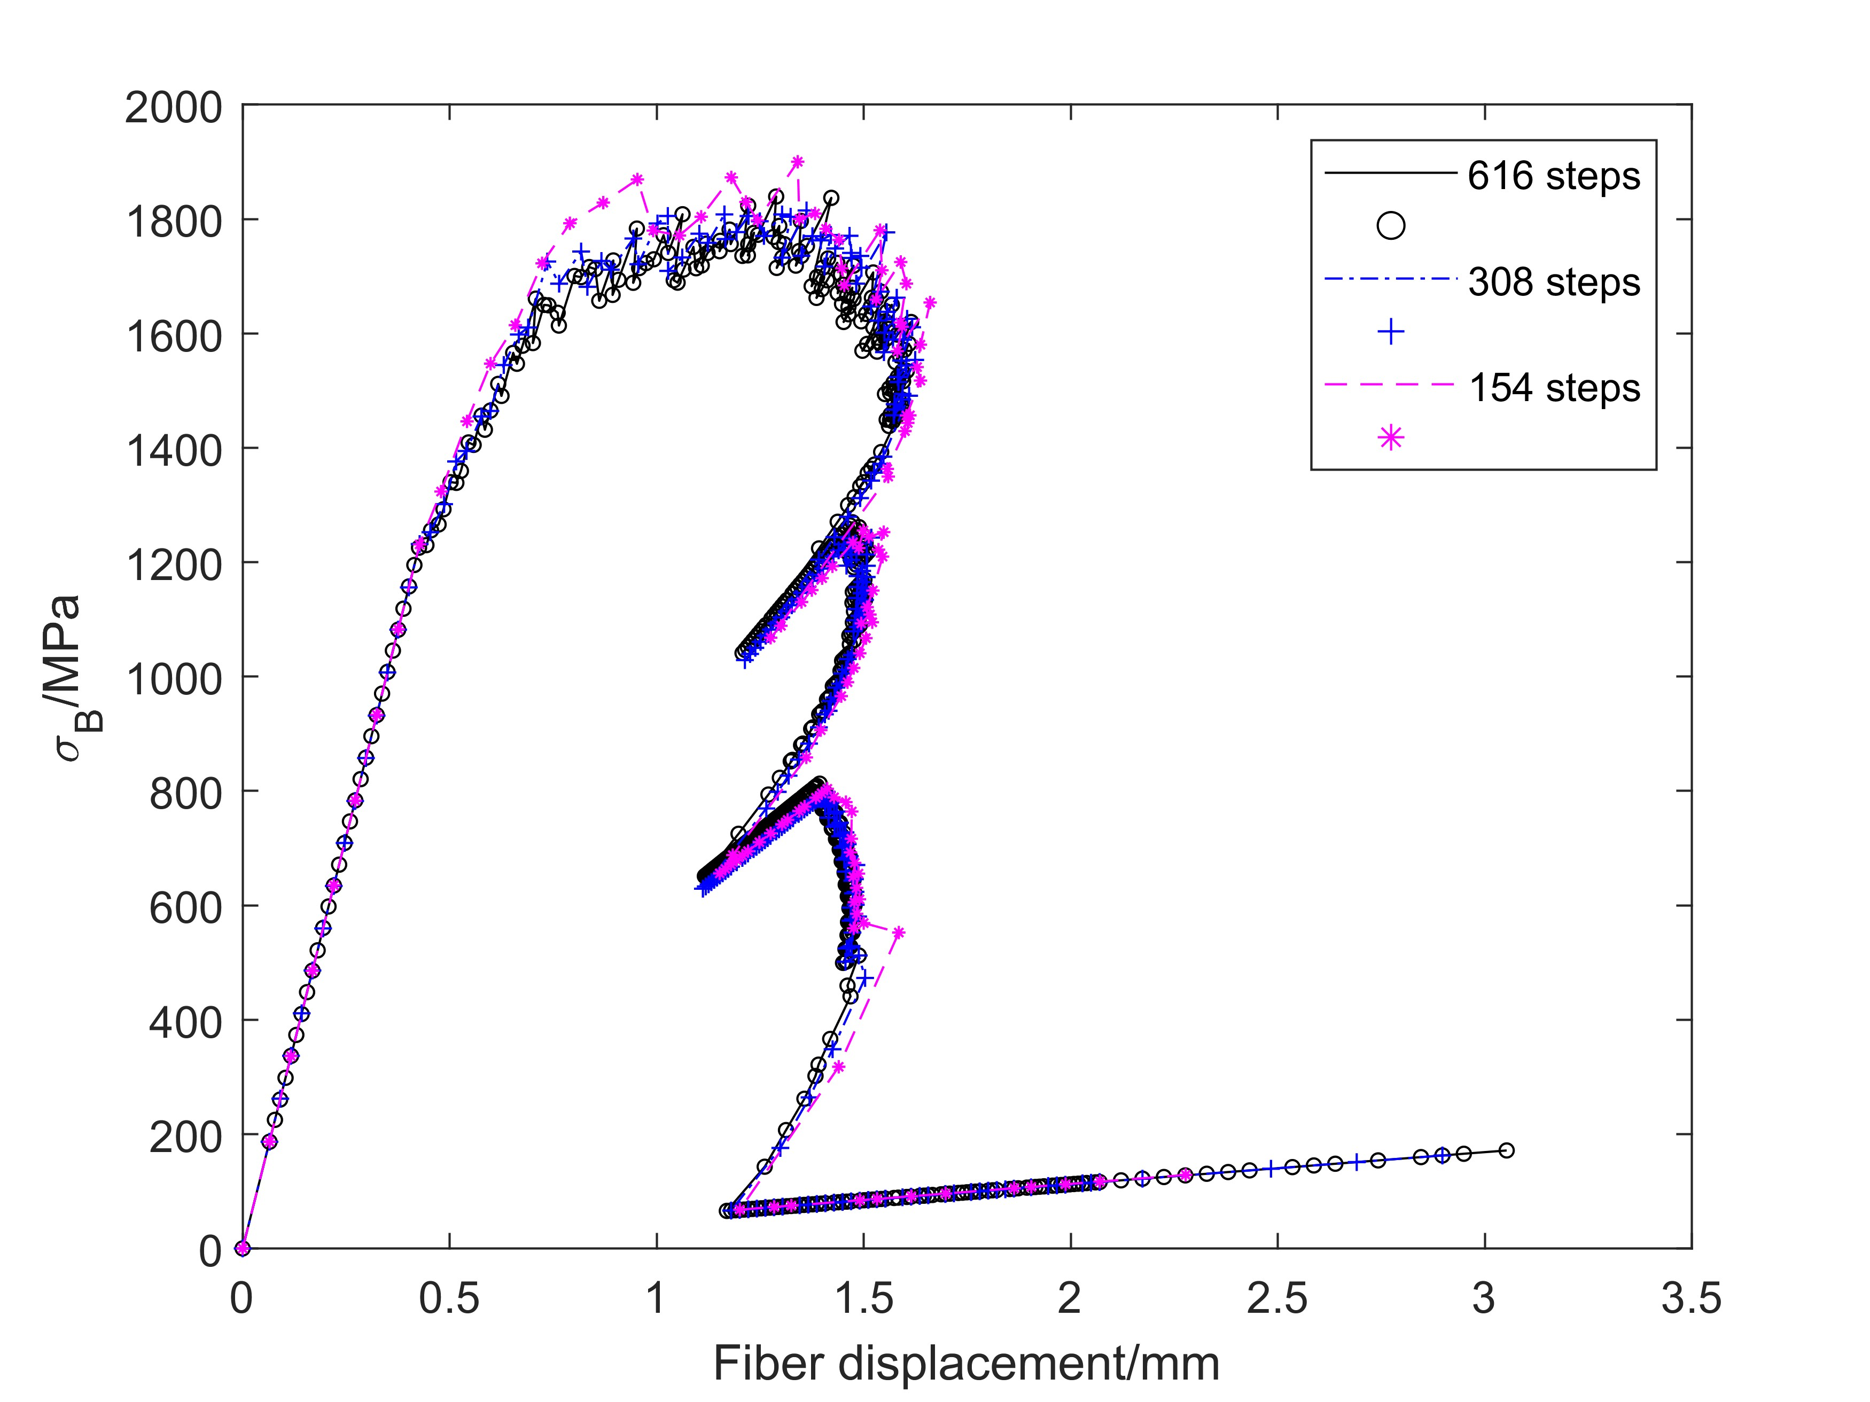

Fig. 2. The globle fiber stress-slip relationships obtained with different step size $∆u_{B0}$.

1. Comparisons with existing approaches

To further validate the current numerical approach and to explore the effect of different assumptions on the bond behavior, two extant models were brought for comparison. One is an analytical model developed by Zou et al. [9] that considers only fiber-mortar interactions; the other is a numerical model developed by Milani et al. [13] that takes into account of the inner mortar layer but not the outer layer. Both models present comparisons with the experimental results in [14]. Parameters close to these two models were also adopted in this paper, as shown in Table 1 and Fig. 3. Two cases will adopt different assumptions for components’ properties, to reproduce results from two existing models separately, as shown Table 2. While the first case will consider the failure of all components analyzed in the model as presented in last section.

**Table 1.** Parameters adopted for the numerical model.

|  |  |  |
| --- | --- | --- |
| Parameter | Symbol and unit | Value |
| Bond length | L [mm] | 330 |
| Bond width | B [mm] | 60 |
| Fiber thickness | $t_{F}$ [mm] | 0.054 |
| Fiber elastic modulus | $E_{F}$ [MPa] | 206000 |
| Mortar layer thickness | $t_{M}$ [mm] | 4 |

**Table 2.** Parameters adopted for the numerical model.

|  |  |  |  |  |
| --- | --- | --- | --- | --- |
| Assumptions | CASE 1 | CASE 2 | CASE 3 | |
| Descriptions | Consider failure of all components in current model. | Only consider fiber-matrix interaction (reproduce the analytical model by Zou et.al [9]). | Ignore the presence of outer mortar layer (reproduce the numerical model by Milani et.al [13]). | |
| Layer B (fiber textile) | Elastic | Elastic | | Elastic |
| Layer A (outer mortar layer) | Elastic-softening (jagged) | Elastic | Elastic | |
| Layer C (inner mortar layer) | Elastic-softening (jagged) | |
| Interface AB | Elastic-softening (jagged) | Elastic-softening (jagged) | Elastic (small stiffness) | |
| Interface BC | Elastic-softening (jagged) | Elastic-softening (jagged) | |
| Interface S | Elastic (large stiffness) | Elastic (large stiffness) | |

Fig. 3. The constitutive law adopted for mortar (a), fiber-matrix interface shear stress-slip relationship (b), and matrix-substrate interface shear stress-slip relationship (c).

Fig. 4. The global fiber stress-slip curves abotained by the current model (a), and by exsiting models and experimental tests provided in [13] (b).

The global fiber stress-slip curves are compared in Fig. 4, and in both sub-figures the cyan-blue curves indicate the models of Zou et.al [9], while the blue curves of Milani et. al [13]. In general, the model is capable of reproducing the range and trend of the global curves for the shear tests of the FRCM bond system. However, some oscillations can be observed in the results due to the jagged shape interface laws that were adopted. Among the three cases, Case 1 shows the lowest strength as expected, since the failure of more components are allowed, reducing the overall strength of the system. Meanwhile, Case 3 shows an obvious larger slip (almost two times) compared to the other two cases, since the constraint provided by the outer mortar layer is ignored, indicating the importance of considering the influence of the upper mortar layer.

1. Conclusions

In this paper, a numerical model for the analysis of FRCM strengthened system subjected to shear test was proposed. The model considers both fiber-matrix and matrix-substrate interface failures, as well as mortar matrix damage, through jagged interfacial bond-slip laws and constitutive laws for mortar. The shooting method and 2D bisection are utilized to gain the numerical solutions, the correctness of this approach has been validated by the analytical solutions when all the components behave as elastic. The proposed model was found to perform well in predicting the global stress-slip curves, as compared to existing experimental data and models. Moreover, the influence of simplifications made under the proposed model was investigated, indicating the importance of taken into account the presence of the outer layer of mortar and the mortar damage. Further investigations could be carried out to investigate the influence of individual components, as well as to consider different shapes of material laws. Additionally, the model's flexibility and fast solution method open the possibility to consider more complex situations, such as presence of mortar joints and initial defects. Overall, this study provides a foundation for future research and development of more advanced and accurate models for analyzing the FRCM strengthened system.

References

1. Carozzi, F.G., Bellini, A., D’Antino, T., de Felice, G., Focacci, F., Hojdys, Ł., Laghi, L., Lanoye, E., Micelli, F., Panizza, M., Poggi, C.: Experimental investigation of tensile and bond properties of Carbon-FRCM composites for strengthening masonry elements. Compos B Eng. 128, 100–119 (2017). https://doi.org/10.1016/j.compositesb.2017.06.018.

2. Leone, M., Aiello, M.A., Balsamo, A., Carozzi, F.G., Ceroni, F., Corradi, M., Gams, M., Garbin, E., Gattesco, N., Krajewski, P., Mazzotti, C., Oliveira, D., Papanicolaou, C., Ranocchiai, G., Roscini, F., Saenger, D.: Glass fabric reinforced cementitious matrix: Tensile properties and bond performance on masonry substrate. Compos B Eng. 127, 196–214 (2017). https://doi.org/10.1016/j.compositesb.2017.06.028.

3. Caggegi, C., Carozzi, F.G., De Santis, S., Fabbrocino, F., Focacci, F., Hojdys, Ł., Lanoye, E., Zuccarino, L.: Experimental analysis on tensile and bond properties of PBO and aramid fabric reinforced cementitious matrix for strengthening masonry structures. Compos B Eng. 127, 175–195 (2017). https://doi.org/10.1016/j.compositesb.2017.05.048.

4. Bellini, A., Aiello, M.A., Bencardino, F., de Carvalho Bello, C.B., Castori, G., Cecchi, A., Ceroni, F., Corradi, M., D’Antino, T., De Santis, S., Fagone, M., de Felice, G., Leone, M., Lignola, G.P., Napoli, A., Nisticò, M., Poggi, C., Prota, A., Ranocchiai, G., Realfonzo, R., Sacco, E., Mazzotti, C.: Influence of different set-up parameters on the bond behavior of FRCM composites. Constr Build Mater. 308, (2021). https://doi.org/10.1016/j.conbuildmat.2021.124964.

5. De Santis, S., Carozzi, F.G., de Felice, G., Poggi, C.: Test methods for Textile Reinforced Mortar systems. Compos B Eng. 127, 121–132 (2017). https://doi.org/10.1016/j.compositesb.2017.03.016.

6. Carozzi, F.G., Arboleda, D., Poggi, C., Nanni, A.: Direct Shear Bond Tests of Fabric-Reinforced Cementitious Matrix Materials. Journal of Composites for Construction. 24, (2020). https://doi.org/10.1061/(ASCE)CC.1943-5614.0000991.

7. D’Ambrisi, A., Feo, L., Focacci, F.: Bond-slip relations for PBO-FRCM materials externally bonded to concrete. Compos B Eng. 43, 2938–2949 (2012). https://doi.org/10.1016/j.compositesb.2012.06.002.

8. Carozzi, F.G., Colombi, P., Fava, G., Poggi, C.: A cohesive interface crack model for the matrix–textile debonding in FRCM composites. Compos Struct. 143, 230–241 (2016). https://doi.org/10.1016/j.compstruct.2016.02.019.

9. Zou, X., Sneed, L.H., D’Antino, T.: Full-range behavior of fiber reinforced cementitious matrix (FRCM)-concrete joints using a trilinear bond-slip relationship. Compos Struct. 239, (2020). https://doi.org/10.1016/j.compstruct.2020.112024.

10. Carozzi, F.G., Milani, G., Poggi, C.: Mechanical properties and numerical modeling of Fabric Reinforced Cementitious Matrix (FRCM) systems for strengthening of masonry structures. Compos Struct. 107, 711–725 (2014). https://doi.org/10.1016/j.compstruct.2013.08.026.

11. Grande, E., Milani, G.: Procedure for the numerical characterization of the local bond behavior of FRCM. Compos Struct. 258, (2021). https://doi.org/10.1016/j.compstruct.2020.113404.

12. Grande, E., Imbimbo, M., Sacco, E.: Numerical investigation on the bond behavior of FRCM strengthening systems. Compos B Eng. 145, 240–251 (2018). https://doi.org/10.1016/j.compositesb.2018.03.010.

13. Milani, G., Grande, E.: Simple bisection procedure in quickly convergent explicit ODE solver to numerically analyze FRCM strengthening systems. Compos B Eng. 199, (2020). https://doi.org/10.1016/j.compositesb.2020.108322.

14. Carloni, C., D’Antino, T., Sneed, L.H., Pellegrino, C.: Role of the Matrix Layers in the Stress-Transfer Mechanism of FRCM Composites Bonded to a Concrete Substrate. J Eng Mech. 141, (2015). https://doi.org/10.1061/(ASCE)EM.1943-7889.0000883.