Electrical resistivity-based approach to characterize moisture content field in raw earth

Tuan Anh NGUYEN 1, Minh Dung PHAM 2,  
Wael HAFSA 3, Nicolas ANGELLIER 4, Laurent ULMET 4 and Frédéric DUBOIS 4

1 STASD Research Group, Ho Chi Minh City University of Transport, Vietnam

2 Mientrung University of Civil Engineering, Vietnam

3 Aix-Marseille University, CNRS IUSTI UMR 7343, France

4 Civil Engineering Laboratory, Diagnostic and Sustainability (GC2D), University of Limoges, France

phamminhdung@muce.edu.vn

**Abstract.** As a part of the trend to use sustainable and environmentally friendly construction materials, raw earth has long been confirmed to be suitable to meet these challenges. As a hygroscopic material, like wood, its mechanical and physical properties are highly dependent on moisture content and the surrounding environment. This paper aims to evaluate moisture content distribution in raw earth bricks varying from the outer surface to the center of the material. The electrical resistivity method is used to perform the cartography of moisture content at required locations. An experimental equipment based on geophysical devices is developed to inject an electric current into the material by using an optimized multiplexing technique. Furthermore, an electrical-thermal analogy is employed to build diffusion models. A numerical inversion is also used to optimize experimental results and the transition law between electrical resistivity and moisture content is established.

**Keywords:** Moisture monitoring, Electrical resistivity measurements, Hygroscopic material, Inverse analysis

1. Introduction

In response to current environmental challenges, the civil engineering sector is exploring solutions that prioritize the use of natural materials requiring minimal transformation and transportation. One solution is the use of materials such as wood and raw earth. These materials have been used in the past and have stood the test of time, making them a promising option for sustainable construction.

The response to climate challenges is also based on controlling the lifespan of structures by deploying maintenance strategies based on a whole approach to inspection and monitoring of structures. Wood and raw earth are two materials that are distinguished by their hygroscopicity. This results in a characteristic mechanical behavior associating viscoelasticity or visco-plasticity with a hygroscopic coupling generating shrinkage-swelling effects. Due to the material anisotropy of these materials, water variations can induce pathologies such as, for example, water shrinkage cracks [1, 2].

Raw earth is one of the oldest natural building materials favored by humans since prehistoric times. Currently, one-third of the world's population lives in earthen dwellings, whether it be rammed earth, adobe bricks, compressed blocks… Raw earth is a sustainable and eco-friendly material for construction. Its production has a low energy when compared to other materials such as concrete or steel. In addition, raw earth is biodegradable and can be easily recycled, which reduces its environmental impact.

One of the techniques developed in industrialized countries includes extruded bricks and compressed earth bricks (CEB). The extrusion manufacturing method presents itself as a compelling alternative owing to its production speed and repeatability. Analogous to other construction materials derived from raw earth, extruded bricks have hygroscopic properties, meaning it can absorb and release moisture from its surrounding environment. As the primary material used is raw earth, bricks have high hygroscopicity and can easily absorb moisture from the environment.

The hygroscopic properties of extruded bricks have both advantages and disadvantages. On the one hand, it can regulate indoor humidity levels, resulting in a healthier and more comfortable living environment. On the other hand, excessive moisture absorption can decrease brick's mechanical strength, causing damage such as cracking and deformation. To ensure the quality and longevity of structures made from raw earth, various solutions for moisture content monitoring have been proposed.

The double weighing methods only allow to have an overall average value of the humidity in each section [3]. The impedance method provides more specific information on the temporal evolution of humidity but without having the spatial dimension of the phenomenon. The techniques used are generally limited to studying the humidity close to the surface of the elements to be monitored [4, 5]. The psychrometric method consists of deploying a network of hygrothermal sensors to deduce the temporal and spatial evolution of humidity. However, this method requires intervention during the construction phase by implanting cavities in the sections that will accommodate these sensors [6].

As part of the non-destructive approach to studying structures, non-intrusive methods are being sought to characterize moisture distribution within materials. In this context, several technologies can be used. Ultrasonic methods make it possible to correlate wave propagation velocities with elasticity properties, themselves corrected for internal humidity in the hygroscopic range. The implementation of this technique is more appropriate for specific measurements during periodic inspection missions. Moreover, the determination of the 2D moisture field requires duplicating the propagation paths to reconstruct a complete field [7]. The same applies to Ground Penetrating Radar methods using electromagnetic waves [8].

An alternative to these techniques is borrowed from geophysical characterization methods like resistive tomography. This method, based on the deployment of a network of resistive quadrupoles, makes it possible, using an inverse analysis algorithm, to achieve a spatial map of the resistivity of the medium, and this, correlated with a map of the internal humidity. Geophysical applications assume, on the one hand, a distribution of quadrupoles on the free surface dictated by the topography of the medium and, on the other hand, a semi-infinite conductive medium. The existing tools integrate a measuring head associated with a programmable multiplexed system, which makes it a good development basis for our problem. It remains to adapt the approaches to a finite medium characterized by the periphery of the structural elements which also represents a set of surfaces allowing a multitude of deployment of quadrupoles thus multiplying the shape and the distribution of the lines of current. Thus, the spatial distribution of the quadrupoles makes it possible to seek a compromise between precision of the measurement and depth of investigation, and this, in relation to the techniques of inverse analysis [9].

This article aims to explore the use of electrical resistivity measurement as a non-invasive method for measuring moisture content in earthen materials.

Hydrous diffusion is presented mathematically by the fundamental Fick-type laws and the properties that characterize them. The measurement of the moisture content is based on the application of resistive methods. Thus, it is necessary to master the laws of electrical behavior in the transient and permanent domain to study the variations of electrical resistivity correlated with the properties of hygroscopic materials dependent on humidity. Currently, the electrical method is widely used for monitoring buildings or civil engineering structures. The reference of several research applying this method at the laboratory scale and in-situ made it possible to fix the main lines of the scientific orientation in this work.

Regarding the study of water diffusion, the electrical resistivity tomography method is now developed. This method provides a more quantitative and rigorous spatial picture of electrical resistivity data such as apparent resistivity and induced polarization. Based on current injections and potential measurements, typical configurations of quadrupoles are defined. Their choice depends on the concordance of each configuration with respect to the geometry and the perimeter of the studied sample.

The analogy between electrical and thermal behavior makes it possible to develop a modeling strategy for electrical conduction. Taking as reference the electrical tomography work developed for geotechnical prospecting, a finite element model of a simple quadrupole on the surface of a semi-infinite medium is developed. Current injections by nodes and by non-point electrodes will be more specifically studied. The design of the electrode mesh guarantees the continuity of the studied domain as well as the optimization of the mesh and the calculation time. Secondly, a finite medium and the influence of its boundaries, in accordance with the geometries of raw earth samples equipped with electrodes and conditioned at constant humidity were studied. The results obtained by the modeling and the associated multiplexing are confronted with the experimental measurements carried out by a Syscal Junior resistivity meter, whose basic and advanced characteristics are studied. This multiplexing, which is based on a succession of 24 quadrupoles, is carried out at different moisture contents. Through the method of least squares, applied to the comparison of modeled and experimental data, the relationship between resistivity and homogeneous moisture content is determined. Finally, a first experimental strapping protocol is developed. The finite element model and the integrated multiplexing are adapted to this new electrode configuration.

1. Principle and theoretical background of the electrical resistivity method

Just like Fick's law, Ohm's law is a “phenomenological” law. This means that it is not a physical law, but a mathematical relationship verified using well-established assumptions and approximating conditions. These two laws translate that the effects (current density or mass flux density) are proportional to the cause (gradient of potential or particle density).

**Table 1** summarizes the analogies between Fick's and Ohm's laws. They correspond to a spontaneous evolution of the medium which tends towards an equilibrium by minimizing the gradients, and this, in accordance with the second principle of thermodynamics:

**Table 1.** Analogies between Fick's and Ohm's Laws [9]

|  |  |
| --- | --- |
| **Fick's law** | **Ohm's law** |
| Particle density vector $\vec{\text{ω}}$ | Electric current density vector $\vec{\text{j}}$ |
| Particle density c | Potential V |
| Diffusion coefficient D | Electrical conductivity σ |
| $$\vec{\text{ω}}\text{=-D}\vec{\text{grad}}\text{c}$$ | $$\vec{\text{j}}\text{=-σ}\vec{\text{grad}}\text{V}$$ |

For the circulation of direct current in a semi-infinite medium such as the ground, the resistivity is the capacity of a medium to oppose the passage of an electric current. The potential of any point M (**Fig. 1**):

|  |  |
| --- | --- |
|  | () |

**Fig. 1.** Current electrode on the surface of a homogeneous soil

With n current sources, the potential at point M is then:

|  |  |
| --- | --- |
|  | () |

In geophysics, a direct current is injected into the ground to study the distribution of potential and deduce the distribution of resistivity in the subsurface. While a homogeneous and isotropic medium corresponds to the true resistivity, this is not the case for a heterogeneous medium. In this case, the concept of apparent resistivity is used.

The apparent resistivity is the ratio of the potential measured in the medium to that calculated theoretically under the same conditions (same geometry of the electrodes, same intensity of injected current) on a homogeneous ground of unit resistivity.

Practically, the measurement of the apparent resistivity ρapp (Ωm) is carried out on the surface, from two electrodes A and B called injection electrodes to which an electric current of intensity IAB (mA) is injected into it. The potential difference ∆VMN (mV) is measured between the two other electrodes M and N, called potential electrodes.

From equation (1), the potentials at electrodes M and N are defined according to the following:

|  |  |
| --- | --- |
|  | () |

The potential difference is deduced following:

|  |  |
| --- | --- |
|  | () |

The apparent resistivity is determined according to the ratio between potential difference and intensity of the injected current and corrected by a geometric factor K:

|  |  |
| --- | --- |
|  | () |

With

|  |  |
| --- | --- |
|  | () |

Depending on the respective position of the potential measurement electrodes and the current injection electrodes, several network configurations can be defined. The Wenner, Wenner-Schlumberger, dipole-dipole pole-pole or pole-dipole configurations are the most commonly used (**Table 2**). Depending on the network configuration, the geometric factor K differs [10].

**Table 2.** Examples of 2D in-line electrodes array configurations, and 3D electrode device [10]

|  |  |  |  |  |
| --- | --- | --- | --- | --- |
| **Configuration** | | | **Electrodes array** | **K** |
| 2D | Wenner | α |  | 2πa |
| β |  | 6πa |
| γ |  | 3πa |
| Wenner - Schlumberger |  |  | πn(n+1)a |
| Dipole-Dipole |  |  | πn(n+1)(n+2)a |
| Pole-Pole |  |  | 2πa |
| Pole- Dipole | Forward |  | 2πn(n+1)a |
| Reserved |  |
| 3D | Square |  |  | $$\frac{\text{2}\text{π}\text{a}}{\text{2-}\sqrt{\text{2}}}$$ |

According to Palacky's (1987) works, the resistivity values of common terrestrial mineral materials generally range from 0.01 Ωm to 100 Ωm [11]. The higher electrical conductivity observed in clay soils compared to coarse-textured soils is attributed to the presence of electric charges located at the surface of clay particles. This phenomenon can be explained by the significant specific surface area of clay soils [12 - 15]

The electrical current in soils is of electrolytic origin and is based on the movement of ions in interstitial water. Hence, it is more significant in the presence of dissolved salts. Consequently, the electrical current is dependent on the quantity of water present in the pores and its ionic composition. The electrical conductivity of the solution is assumed to remain constant. This assumption enables any variation in electrical conductivity to be correlated with a variation in moisture content [14, 17].

Samouelian & al. (2005) synthesized experimental results from McCarter (1984) and Michot & al. (2001) (**Fig. 2**), linking electrical resistivity and moisture content. Similarly, Fukue & al. (1999) and Cosenza & al. (2006) established the variation of the resistivity according to the moisture content of two types of soil (**Fig. 3**). In all cases, an increase in moisture content is associated with a decrease in soil electrical resistivity. Furthermore, at low moisture content levels, the relationship between moisture content and electrical resistivity follows an exponential function.

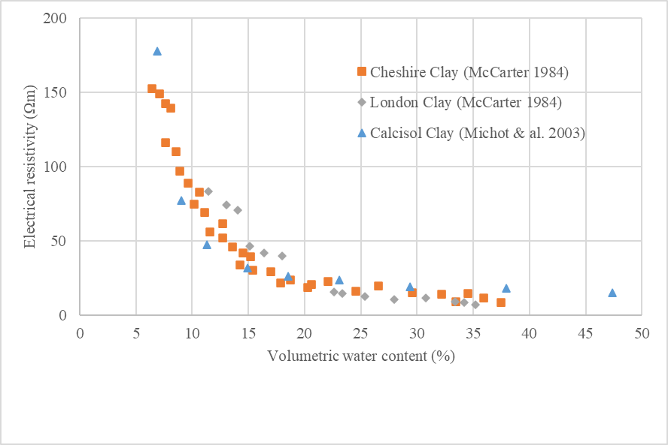

**Fig. 2.** Relationship between Volumetric Moisture Content and Electrical Resistivity for Different Soil Types [10, 18, 19]

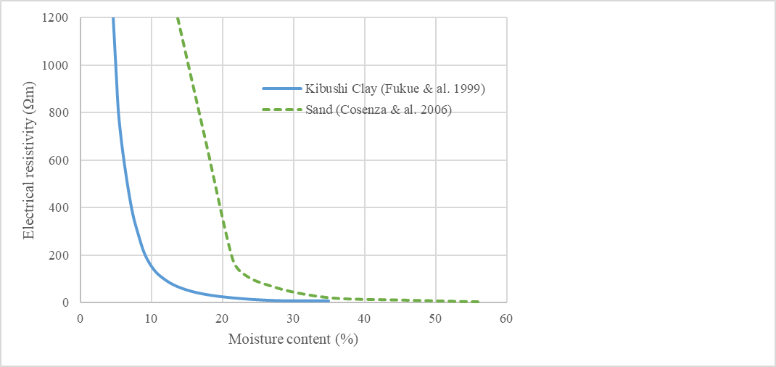

**Fig. 3.** Relationship between moisture content and electrical resistivity for two types of soils [14, 20]

1. Experimental Protocol
   1. Material

Bricks in this study comes from a brick factory in the Southwest of France and, are formed by vacuum extrusion and have dimensions of 22.5×11×5 cm3. A degree of anisotropy related to the orientation of the clay slabs is created by this extrusion process. This causes the hydric, thermal and mechanical properties to differ in two different directions: perpendicular and parallel to extrusion.

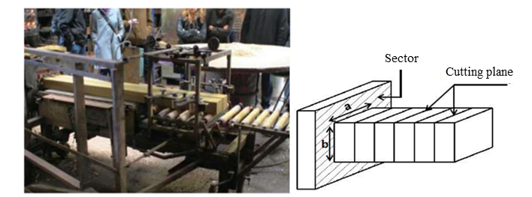

**Fig. 4.** Brick shaping, direction of extrusion and cutting plan

The physical and chemical properties of bricks previously characterized [1, 21] are listed below. The chemical composition is determined by chemical analysis from X-ray fluorescence data. The mass percentages of brick oxide are reported in **Table 3**, as well as the loss on ignition corresponding to the loss of mass of the samples after calcination at 1050°C

**Table 3.** Chemical compositions of mixtures used in brick fabrication (%)

|  |  |  |  |  |  |  |  |  |  |  |
| --- | --- | --- | --- | --- | --- | --- | --- | --- | --- | --- |
| SiO2 | Al2O3 | CaO | Fe2O3 | MgO | K2O | TiO2 | Na2O | P2O3 | Loss on ignition at 1050°C | Total |
| 47,2 | 13,6 | 13,0 | 5,6 | 2,3 | 2,3 | 0,7 | 0,3 | 0,1 | 15,6 | 100 |

The brick is observed and analyzed by a scanning electron microscope down to the nanometric scale which shows a fairly dense heterogeneous organization of the grains (**Fig. 5**) thanks to the manufacture under vacuum. The density of 2200 kg/m3 is quite comparable to that of terracotta and heavy solid concrete, which are respectively 2100 kg/m3 and 2300 kg/m3.

**Fig. 5.** Morphology and size of brick clay particles

The plasticity is defined in terms of the Atterberg limits and the plasticity index. **Table 4** reports the values of the indicators which show the average brick plasticity.

**Table 4.** Atterberg limits and plasticity index at 400 μm

|  |  |  |
| --- | --- | --- |
| Liquid limit WL (%) | Plasticity limit WP (%) | Plasticity index IP (%) |
| 42,9 | 20,0 | 22,9 |

The VBS methylene blue value determines the total ion exchange surface between the clay fraction and the methylene blue molecules. The specific surface area, characterizing the shrinkage/swelling phenomena and the absorption capacity, is obtained from methylene blue and mercury porosimeter tests, **Table 5**

**Table 5.** Specific surfaces obtained by different techniques

|  |  |
| --- | --- |
| Specific surfaces – VBS (m2/g) | Specific surfaces - Porosimeter (m2/g) |
| 11 | 10 |

The differential volume porosity and the cumulative percentage of brick sizes are shown in **Fig. 6**. The total porosity is 20.8%.

**Fig. 6.** Pore size distributions

The particle size curve, presented in **Fig. 7**, shows good gradation and a high proportion of fine particles. With a silt fraction of 42.8%, clays of 46.6% and sand of 10.6%, the brick is classified according to Taylor's triangular chart, each vertex of which represents one of the three elements: clay (< 2μm), silt (2 ÷ 50μm) and sand (>50μm), **Fig. 8**

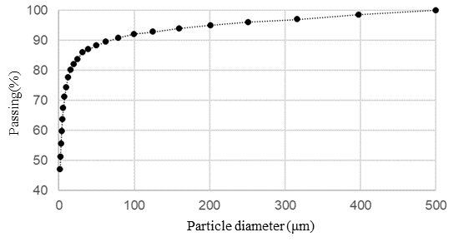

**Fig. 7.** Particle size curve

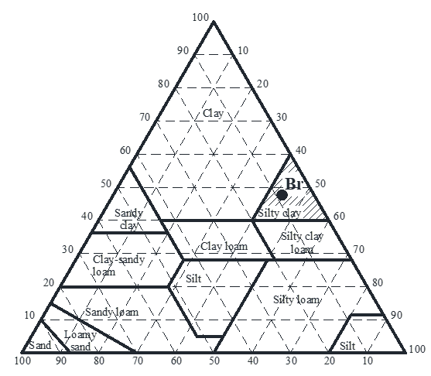

**Fig. 8.** Taylor's triangular chart

* 1. Experimental equipment

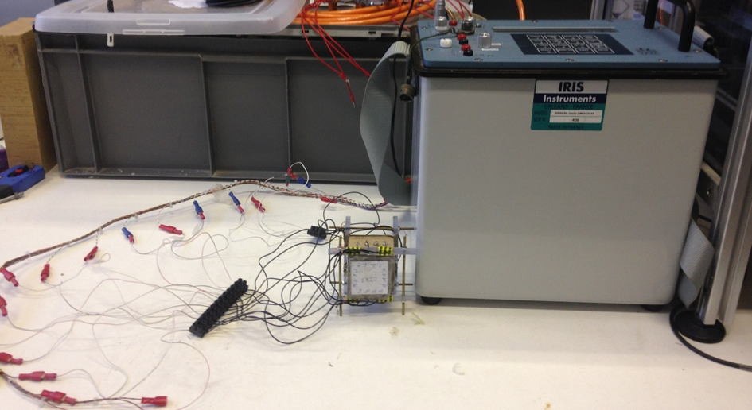

**Fig. 9.** Syscal Junior Switch-48

The resistivity meter, used in this study, is a Syscal Junior Switch-48, consisting of a multiplexing system that can control up to 48 electrodes (2 pairs of 24 electrodes) and a 100W power source. Its principle is to transmit a current of intensity I via two injection electrodes (A and B) and to measure a potential difference VMN between two other electrodes (M and N) in order to obtain a field of resistivity [22].

The resistivity meter can be connected to 4 electrodes for “four-point measurements” (2 injection electrodes and 2 reception electrodes) or to multiple electrodes for use in multi-electrode mode through the multiplexer.

For materials with high electrical resistance, the current intensity that can be injected becomes very low, even for a maximum voltage of 400V. This intensity approaches the resolution value of the ohmmeter in the standard configuration of the Syscal Junior device. The accuracy of the current measurement becomes problematic. At our request, the manufacturer installed a current divider module to reduce the injection range from 1250mA to 50mA, while improving the resolution from 10μA to 0.4μA. In 50mA mode, the intensity must therefore be divided by 25. Nguyen (2014) and Hafsa & al. (2021) also used this device to perform measurements of the resistivity of wood materials [23, 24].

The large-sized electrodes used in geophysics for resistivity measurements in a semi-infinite medium are not suitable for the scale of the samples studied in this work, which have a finite size of a few centimeters. For this reason, specific cables and miniature electrodes were manufactured.

The electrodes are now modeled according to their actual geometry. In this study, two types of electrodes are considered:

### In-depth electrodes

They consist of an infinitely conductive cylinder which penetrates from the free surface of the material and is in contact with it on the lower base and lateral surface. The electrodes were produced by casting a molten alloy consisting of 99.3% tin (Sn) and 0.7% copper (Cu) into pre-drilled spaces, enabling electrical cable connections, **Fig. 10**

**Fig. 10.** In-depth electrodes

### Surface electrodes

They consist of an infinitely conductive cylinder, whose base is in contact with the material surface.

The assembly uses a support equipped with nails and springs. The surface contact electrode is a 0.25cm diameter steel nail head, connected via an electrical pod. To ensure the contact between the electrodes and the surface of the sample, a spring system, a plastic reaction plate and a nut ensuring the tightening are used, **Fig. 11**

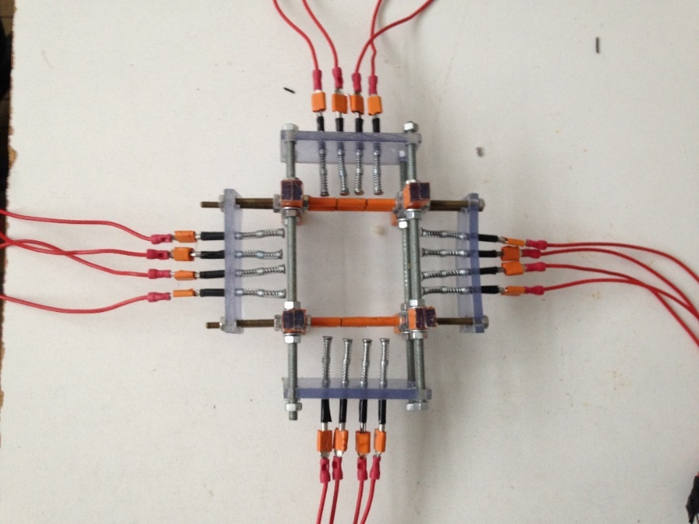

**Fig. 11.** Composition of surface electrode support and complete assembly

* 1. Electrical Measurement

### Four-point measurements

Four-point measurements is carried out with 1 specimen named Standard made from a brick with the dimensions of $\text{50×40×40 }{\text{mm}}^{\text{3}}$. In this experiment, the in-depth electrodes were used with a spacing of 10 mm between them, a radius of 2 mm, and a depth of insertion of 5 mm.

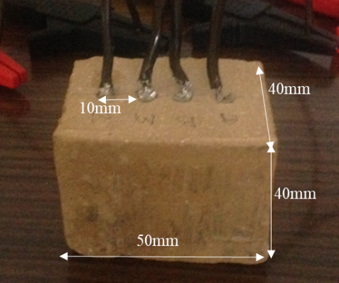

**Fig. 12.** Standard raw earth block and 4 electrodes disposition

Standard block was placed in a desiccator during the desorption phase. The initial relative humidity was maintained at 100% RH and gradually reduced to 70%RH, 60%RH, 50%RH, 40%RH and 20%RH. The desiccator is an apparatus used to create an environment of specific relative humidity and temperature, depending on the amount of water and salt present.

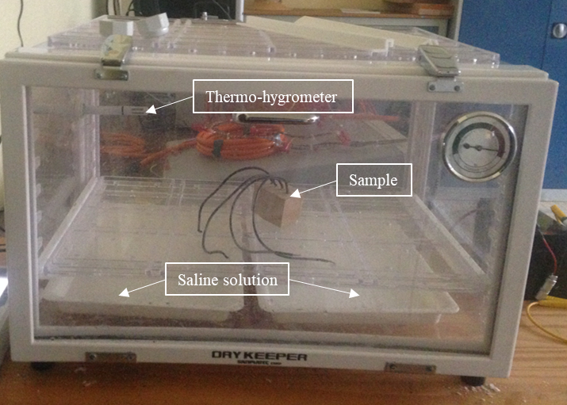

**Fig. 13.** Desiccator for sample conditioning

By using 4 electrodes of standard mode, it is possible to create up to 24 quadrupoles as shown in **Fig. 14**.

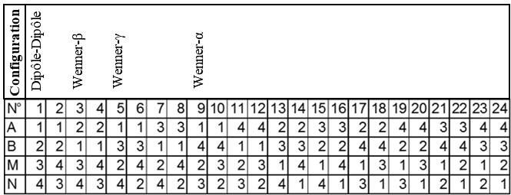

**Fig. 14.** 24 quadrupoles

### Multiplexed quadrupoles measurements

Two cubes A and B, with dimensions $\text{50×50×50 }{\text{mm}}^{\text{3}}$, are taken from the brick [1]. The location of cubes is shown in **Fig. 15**.

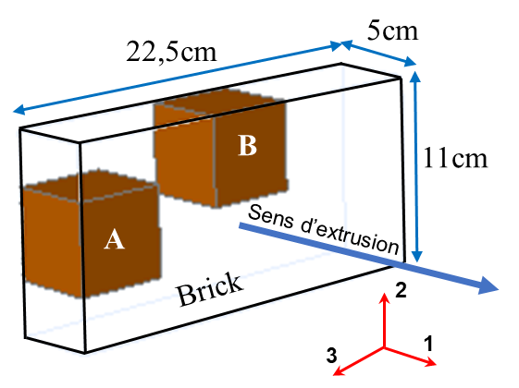

**Fig. 15.** Locations of cube samples in the brick

16 tin electrodes are inserted around the perimeter of a plane of symmetry of the sample with a spacing of 1cm, a depth of 0.3cm and a radius of 0.15cm. Due to the non-lasting contact between the metal electrodes and the raw earth, a frame is prepared to ensure the maintenance of the cables during measurements, **Fig. 16**.

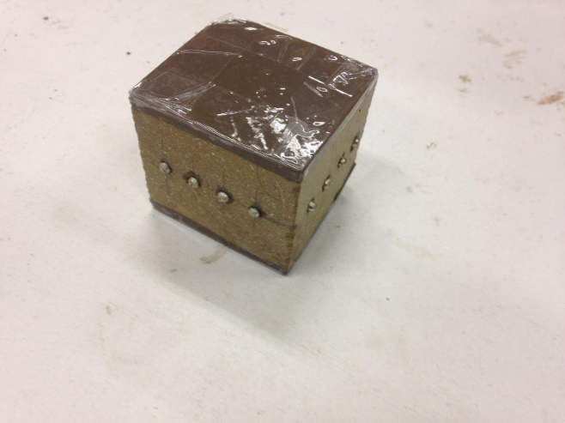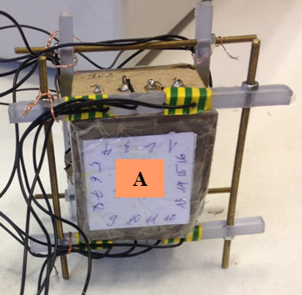

**Fig. 16.** Experimental set-up by belting in-depth electrodes

The assembly in **Fig. 11** was used for surface electrodes. The position of the electrodes corresponds to those placed in depth, **Fig. 17**

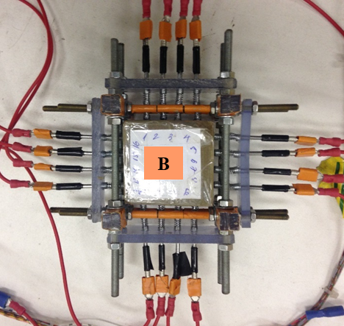

**Fig. 17.** Experimental set-up by belting surface electrodes

Cubes with in-depth electrodes A1, A2, A3 (**Fig. 16**) are placed under ambient conditions close to 40%RH. After having noted the relative humidity of the atmosphere, their moisture content was determined by weighing their dry mass.

Cube A1 with in-depth electrodes (**Fig. 16**) and cube B1 with surface electrodes (**Fig. 17**) are placed in a climatic chamber at 70% relative humidity until their mass stabilizes. After stabilization and measurement sequences, the moisture content is also deduced by weighing their dry mass. The values are also reported in.**Table 6**

**Table 6.** Moisture content values

|  |  |  |  |  |  |
| --- | --- | --- | --- | --- | --- |
|  | **Ambient** | | | **70% RH** | |
|  | A1 | A2 | A3 | A1 | B1 |
| w(%) | 2.50 | 2.53 | 2.96 | 3.99 | 4.07 |

A sequence of 136 quadrupoles is programmed. Even if the duplicate quadrupoles have been avoided, the classification in ascending order of the theoretical ratios makes it easy to identify families of identical quadrupoles, and this, due to the symmetry of the device.

The first series of quadrupoles consists of deploying dipole-dipole type configurations with different pitches around the perimeter of the section, in the same way as one would do online for geotechnical prospecting. A second type of quadrupole consists of crossing the sample by the current lines and measuring the potential difference along a parallel line, **Fig. 18**.

|  |  |  |  |  |
| --- | --- | --- | --- | --- |
|  |  |  | |  |
| Dipole-dipole type quadrupoles | | | |
|  | |  | |
| Transverse quadrupoles | | | |

**Fig. 18.** Some examples of quadrupoles

Under these conditions, the two injection modes (50mA and 1250mA) of the resistivity-meter are used. To avoid the influence of induced polarization, the injection time is always fixed at 2000ms.

1. Numeric Model

Generalized Ohm's Law and Fourier's law present a clear analogy between electrical conduction behavior and steady-state heat transfer **Table 7**. It is on this observation that the modeling of the electric current diffusion process is based by applying the heat transfer tools implemented in the code to the finite elements Cast3M.

**Table 7.** Electrical and thermal analogy [22]

|  |  |
| --- | --- |
| **Thermal** | **Electric** |
| Fourier's law $\vec{\text{ψ}}\text{=-}{\text{λ}}_{\text{T}}.\vec{\text{grad}}\text{T}$ | Generalized Ohm's Law $\vec{\text{j}}\text{=-σ}\vec{\text{grad}}\text{V}$ |
| Thermal conductivity: ${\text{λ}}_{\text{T}} \left[\text{W.}{\text{m}}^{\text{-1}}\text{.}{\text{K}}^{\text{-1}}\right]$ | Electrical conductivity: $\text{σ}\left[\text{S.}{\text{m}}^{\text{-1}}\right]$ |
| Temperature: $\text{T}\left[\text{K}\right]$ | Potential: $\text{V}\left[\text{V}\right]$ |
| Heat flux density: $\text{ψ}\left[\text{W.}{\text{m}}^{\text{-2}}\right]$ | Current density: $\text{J}\left[\text{A.}{\text{m}}^{\text{-2}}\right]$ |
| Thermal resistance: ${\text{R}}_{\text{T}}\left[\text{K.}{\text{W}}^{\text{-1}}\right]$ | Electric resistance: $\text{R}\left[\text{Ω}\right]$ |
| Thermal conductance: $\text{UA}\left[\text{W.}{\text{K}}^{\text{-1}}\right]$ | Electrical conductance: $\text{G}\left[\text{S}\right]$ |
| Heat flux: $\text{ϕ}\left[\text{W}\right]$ | Intensity: $\text{I}\left[\text{A}\right]$ |

The modeling of all the configurations is carried out according to the real dimensions of the sample and the electrodes.

For modelling the Standard block, the discretization technique is the extrusion of the surface mesh.

|  |  |
| --- | --- |
| Electrodes modelling |  |

**Fig. 19.** Mesh by surface extrusion of block $\text{50×40×40 }{\text{mm}}^{\text{3}}$

For cube with in-depth electrodes, the total mesh (sample and electrodes) is recommended because the solution by extrusion is not applicable. Due to the symmetry, it suffices to mesh only half of the domain limited by the cross-section passing through the plane of the electrodes. These are arranged around this section. Parallelepipedal elements are therefore more relevant. The numbering of the electrodes is the same for the two configurations as indicated in **Fig. 20**

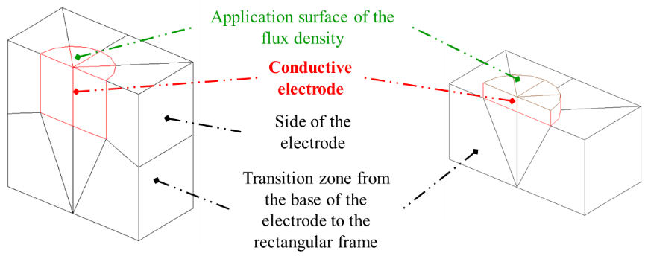

Electrodes modelling

|  |  |
| --- | --- |
| Diagram  Description automatically generated  In-depth electrodes | Diagram  Description automatically generated  Surface electrodes |

**Fig. 20.** Mesh of the raw earth cube in belting and numbering of the electrodes

For a given uniform resistivity field ρ=1Ωm, ∆VMN, IAB and ∆VMN⁄IAB are calculated by following the sequence of measurements made to identify the actual resistivity value of the material.

1. Results and Discussion
   1. Four-point measurements

The curves of the ratio ∆VMN  IAB for the 24 quadrupoles (**Fig. 14**) are plotted for the experimental data of 50mA mode and 1250mA mode compared with modeling values in **Fig. 21**.

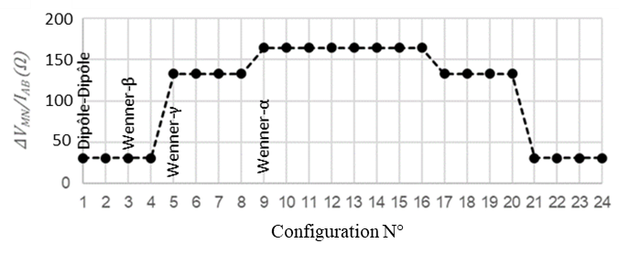

**Fig. 21.** Modeling values of ∆VMN⁄IAB of 24 quadrupoles

The value of the homogeneous resistivity of the numerical model is modified in order to shift the curve of the ratio ∆VMN⁄IAB of modeling so that it tends towards the experimental curves (**Fig. 22**).

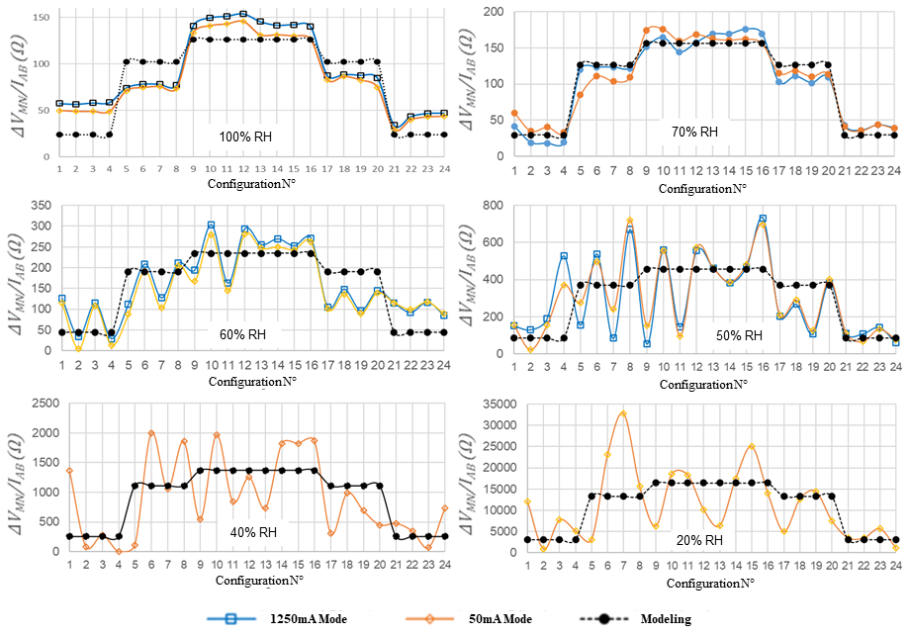

**Fig. 22.** Apparent resistances to RH differences of 2 modes (1250mA/50mA) and modeling

For the relative humidities 100%RH and 70%RH these curves can be almost superimposed and the modelling values can be shifted to get closer to them. From 60%RH and 50%RH, the experimental curves are no longer stable and can no longer be superimposed with the modelling. Finally, beyond RH40%, the 1250mA mode cannot even be used to measure ∆VMN⁄IAB.

The homogeneous apparent resistivity of all the quadrupoles is deduced according to the following equation:

|  |  |
| --- | --- |
|  | () |

* ρnum = 1Ωm: resistivity of the numerical model;
* Inum =1A: current injected into the numerical model;
* ∆Vnum: potential difference calculated by the numerical model;
* ∆Vexp: potential difference measured by the resistivity-meter;
* Iexp: current measured by the resistivity-meter.

Theoretically, for a given relative humidity, the resistance values should be the same regardless of the type of quadrupole. Nevertheless, we find that only the dipole-dipole configuration leads to stable and robust results over the entire range of moisture content explored. The function of the homogeneous resistivity of the dipole-dipole with respect to the relative humidity is presented in logarithm scale in **Fig. 23**. There is a rapid increase in the resistivity of the raw earth when the material is in an environment increasingly drier.

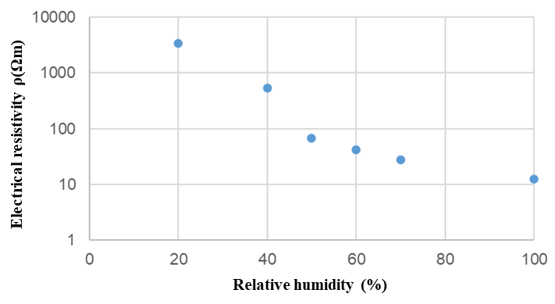

**Fig. 23.** Logarithm electrical resistivity Vs. relative humidity for the dipole-dipole quadrupoles in the Standard 4-electrodes block

The transition law is found by establishing the variation of electrical resistivity as a function of moisture content, **Fig. 24**. The lower the moisture content, the more strongly the electrical resistivity increases, satisfying the general variation of resistivity as seen in literature.

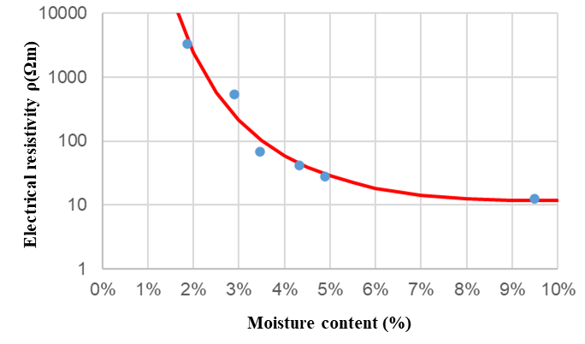

**Fig. 24.** Relationship between logarithm electrical resistivity and moisture content of the Dipole-Dipole Quadrupole for the Standard 4-Electrode Block

An exponential function thus makes it possible to interpolate the measurement points and responds to the following expression:

|  |  |
| --- | --- |
|  | () |

* 1. Multiplexed quadrupoles measurements

An uniform field of unit resistivity is applied to the model. The modeled values of ∆VMN, IAB and ∆VMN ⁄ IAB are calculated by following the sequence of measurements applied to identify the actual resistivity value of the material.

All the measured and modeled values of the ratio ∆VMN⁄IAB are recorded for comparison and processing. To better see the difference between these two series of values, the quadrupoles are classified according to the increase in the modeled values of the ratio ∆VMN ⁄ IAB (**Fig. 25**). **Fig. 26** presents the results obtained for cube A1 in the atmosphere.

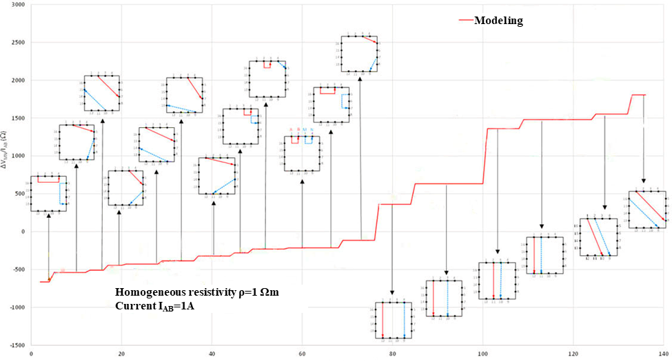

**Fig. 25.** The modeling values of the increased ratio ∆VMN⁄IAB

**Fig. 26.** Comparison between experimental and numerical results of the cube A1 in the atmosphere

In addition, it appeared that certain points very far from the cloud were systematically associated with the use of the same electrode (n°15) and this for the different cubes, which leads one to think that the malfunction comes from the strand of the beam cables itself. All quadrupoles involving an electrode connected to this strand were therefore eliminated (**Fig. 27**)

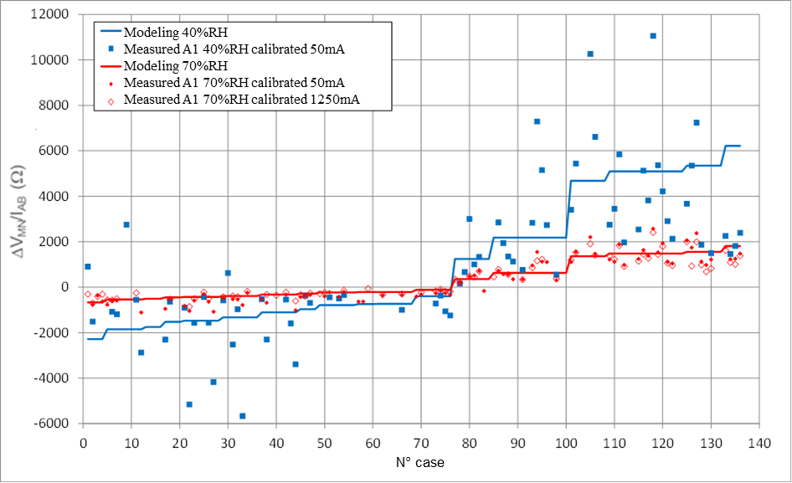

**Fig. 27.** Comparison of multiplexing results on cubes for different moisture contents

The deviations of the ratio ∆VMN ⁄ IAB between the measured and modeled data are calculated, which makes it possible to establish the objective function in the sense of least squares. The homogeneous resistivity of the belting cube is identified by minimizing this function by the **Excel Solver**.

The resistivity values determined as a function of the moisture content are presented in **Table 8**.

**Table 8.** Determined resistivity values

|  |  |  |  |  |  |
| --- | --- | --- | --- | --- | --- |
|  | **Ambient** | | | **70% RH** | |
|  | A1 | A2 | A3 | A1 | B1 |
| w(%) | 2.50 | 2.53 | 2.96 | 3.99 | 4.07 |
| ρ(Ωm) | 228.6 | 277.4 | 182.7 | 51.1 | 62.3 |

Therefore, the graph defining the transition law expressed by the equation (8) in **Fig. 24** can be completed.

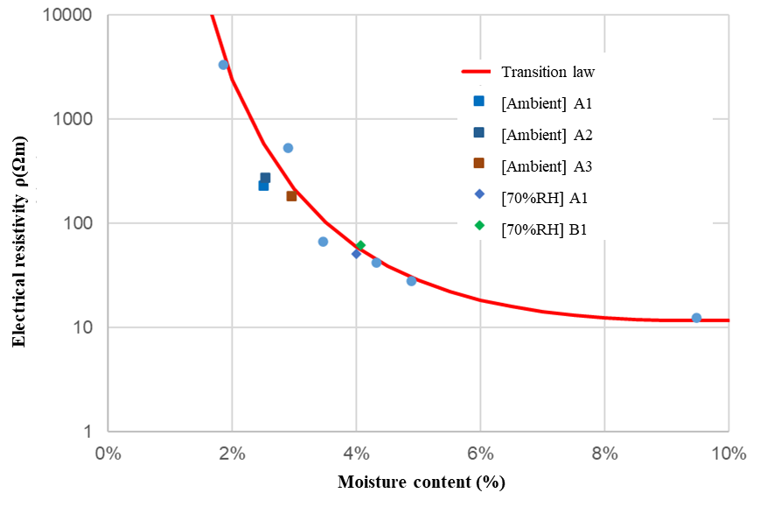

**Fig. 28.** Experimental points on the transition law curve

Based on the data presented in **Fig. 28** it can be inferred that the newly obtained data points align well with the transition law, which is characterized by an exponential function with a clear 'knee' between 2% and 8% humidity. This strengthens the overall evidence supporting the applicability of the transition law.

1. Conclusion and perspectives

The numerical inversion algorithm used in this study relies on two main components: cross-measurements of humidity and a direct calculation of apparent resistivity based on quadrupole approach by using finite elements.

A comprehensive resulting in a robust and convergent strategy for discretizing the injection electrodes and simulating quadrupole alignments in both a homogeneous semi-infinite medium and a belting approach.

Using the optimized Syscal Junior resistivity meter and its multiplexer, the first measurements on raw earth were performed in a controlled environment.

The initial results showed good agreement between the numerical calculation and measurements for moisture contents above 2%, corresponding to environments with a humidity of 40%RH or higher. An Excel solver algorithm was used to optimize the model-measurement agreement for this application. However, the measurement quickly reached its physical limits below this humidity level.

A second study using the belting technique was used to optimize the current lines whose length can also be a physical limit in the measurement of the apparent resistivity. Nonetheless, the study successfully identified an exponential transition law between resistivity and moisture content.

While a homogeneous moisture content state is necessary to calibrate the measurement chain and digital model, monitoring structures requires adapting the approach to transient regimes with heterogeneous moisture content distribution and resistivity fields. In this case, the optimization algorithm based on homogeneous scalar resistivity needs to be replaced with an inverse analysis approach that can integrate both homogeneous and heterogeneous resistivity fields.

References

1. Laou, L. (2017). Evaluation du comportement mécanique sous sollicitations thermohydriques d’un mur multimatériaux (bois, terre crue, liants minéraux) lors de sa construction et de son utilisation. PhD Thesis. University of Limoges.
2. Asal A. (2021). Building with Earth – Sustainable Stabilization and Additive Manufacturing for Rammed Earth Construction. Bachelorthesis. HTWG Konstanz - University of Applied Sciences.
3. Smith, J. C., & Augarde, C. (2014). Optimum water content tests for earthen construction materials. Proceedings of the Institution of Civil Engineers - Construction Materials, 167(2), 114–123. doi:10.1680/coma.12.00040
4. Hoła, J., Matkowski, Z., Schabowicz, K., Sikora, J., Nita, K., & Wójtowicz, S. (2012). Identification of moisture content in brick walls by means of impedance tomography. COMPEL - The International Journal for Computation and Mathematics in Electrical and Electronic Engineering, 31(6), 1774–1792. doi: 10.1108/03321641211267119
5. Hoła, A., Matkowski, Z., & Hoła, J. (2017). Analysis of the Moisture Content of Masonry Walls in Historical Buildings Using the Basement of a Medieval Town Hall as an Example. Procedia Engineering, 172, 363–368. doi: 10.1016/j.proeng.2017.02.041
6. Zhang, W., Ma, H., & Yang, S. (2016). An Inexpensive, Stable, and Accurate Relative Humidity Measurement Method for Challenging Environments. Sensors, 16(3), 398. doi: 10.3390/s16030398
7. Bernat-Maso, E., Teneva, E., Escrig, C., & Gil, L. (2017). Ultrasound transmission method to assess raw earthen materials. Construction and Building Materials, 156, 555–564. doi: 10.1016/j.conbuildmat.2017.09.012
8. MD.E.1: Determination of moisture distribution and level using radar in masonry built with regular units. (2005). Materials and Structures, 38(2), 283–288. doi:10.1007/bf02479354
9. Pham M. D. (2022) Approche Résistive pour l’Evaluation des Champs Hydriques dans les Matériaux Hygroscopiques. Theses. Université de Limoges.
10. Samouëlian, A., Cousin, I., Tabbagh, A., Bruand, A., & Richard, G. (2005). Electrical resistivity survey in soil science: a review. Soil and Tillage Research, 83(2), 173–193. doi: 10.1016/j.still.2004.10.004
11. Palacky, G. J. (1987). Clay mapping using electromagnetic methods. First Break, 5(8).
12. Russell, E. J. F., & Barker, R. D. (2010). Electrical properties of clay in relation to moisture loss. Near Surface Geophysics, 8(2), 173–180. doi:10.3997/1873-0604.2010001
13. Shevnin, V., Mousatov, A., Ryjov, A., & Delgado-Rodriquez, O. (2007). Estimation of clay content in soil based on resistivity modelling and laboratory measurements. Geophysical Prospecting, 55(2), 265–275. doi:10.1111/j.1365-2478.2007.00599.x
14. Fukue, M., Minato, T., Horibe, H., & Taya, N. (1999). The micro-structures of clay given by resistivity measurements. Engineering Geology, 54(1-2), 43–53. doi: 10.1016/s0013-7952(99)00060-5
15. Waxman, M. H., & Smits, L. J. M. (1968). Electrical Conductivities in Oil-Bearing Shaly Sands. Society of Petroleum Engineers Journal, 8(02), 107–122. doi:10.2118/1863-a
16. Noborio, K. (2001). Measurement of soil water content and electrical conductivity by time domain reflectometry: a review. Computers and Electronics in Agriculture, 31(3), 213–237. doi: 10.1016/s0168-1699(00)00184-8
17. Bhatt, S., & Jain, P. K. (2014). Correlation between electrical resistivity and water content of sand–a statistical approach. Am. Int. J. Res. Sci. Technol. Eng. Math, 6(2), 115-121.
18. McCarter, W. J. (1984). The electrical resistivity characteristics of compacted clays. Géotechnique, 34(2), 263–267. doi: 10.1680/geot.1984.34.2.263
19. Michot, D., Dorigny, A., & Benderitter, Y. (2001). Mise en évidence par résistivité électrique des écoulements préférentiels et de l’assèchement par le maı̈s d’un CALCISOL de Beauce irrigué. Comptes Rendus de l’Académie Des Sciences - Series IIA - Earth and Planetary Science, 332(1), 29–36. doi: 10.1016/s1251-8050(00)01498-1
20. Cosenza, P., Marmet, E., Rejiba, F., Jun Cui, Y., Tabbagh, A., & Charlery, Y. (2006). Correlations between geotechnical and electrical data: A case study at Garchy in France. Journal of Applied Geophysics, 60(3-4), 165–178. doi: 10.1016/j.jappgeo.2006.02.003
21. Laou, L., Aubert, J. E., Yotte, S., Maillard, P., & Ulmet, L. (2021). Hygroscopic and mechanical behaviour of earth bricks. Materials and Structures/Materiaux Et Constructions, 54(3) doi:10.1617/s11527-021-01701-1
22. SYSCAL SWITCH (V 11.5++) (2005). Résistivimètre à commutation de tension automatique et à commutation d’électrodes intégrée (IRIS INSTRUMENTS)
23. Nguyen, T.A. (2014). Approches expérimentales et numériques pour l’étude des transferts hygroscopiques dans le bois. PhD Thesis. University of Limoges.
24. Hafsa, W., Angellier, N., Takarli, M., & Pop, O. (2021). A mixed experimental–numerical electrical resistivity-based method for moisture content assessment in wood tested using the example of Douglas fir. Wood Science and Technology, 55, 697-718. https://doi.org/10.1007/s00226-021-01281-x