Nonlinear ANN Modeling for Predicting Ultimate Strength of CFST Columns

Tran-Trung Nguyen1,2, Phu-Cuong Nguyen1*

1 Advanced Structural Engineering Laboratory, Department of Structural Engineering, Faculty of Civil Engineering, Ho Chi Minh City Open University, Ho Chi Minh City, Vietnam

2 Department of Architectural Engineering, Faculty of Architecture, Van Lang University, Ho Chi Minh City, Vietnam  
cuong.pn@ou.edu.vn ; henycuong@gmail.com

**Abstract.** Artificial Neuron Network (ANN) applications are growing strongly in many scientific fields. Especially in the field of structural engineering, ANN has been used for solving many problems, from prediction to classification problems. The datasets performed in those problems are preserved with the original data; general information is normalized if processed. In addition, the structure of the ANN applied is mostly multiple layers of perceptrons (MLPs) without giving precise information as to why MLPs are needed. This study as a contribution is clear to the above problems using ANN. The problem is the ultimate strength prediction problem of the CFST circular columns with a data set of 663 samples, including 6 continuous variables features. The ANN prediction model for the critical intensity of the above column type considers two more issues that have not been clarified, namely i). Does the algorithm used, StandardScaler and MinMaxScaler, for data normalization affect the results of the predictive model? ii). How do ANN structures have only one perceptron layer (Linear ANN - LANN) and ANN structures have multiple perceptron layers (Nonlinear ANN - NANN) with an equal number of units and does the different number of units affect the predicted problem above?

**Keywords:** Nonlinear ANN, CFST Column, Multiple Layers of Perceptron, Ultimate Strength, Normalization Algorithm.

1. Introduction

CFST columns are part of structural building-bearing systems [1]. From material qualities to column cross-section area, the CFST column's ultimate strength is the most important.

Each country's design guidelines can anticipate CFST columns' final strength. FEM corrects column critical strength formulae. [2] offered a new limited concrete softening regime and new ABAQUS constitutive model parameters. The research [3] exploited local buckling effects from steel tube defects and residual stress to anticipate CFSBC ultimate loads. Ansys Workbench's integrated Ansys DesignXplorer addressed the study's problem [4]. Academics and industry can design CFST columns easily using the parameters' compressive strength equations. A modified finite element model predicted CFST behavior and strength under axial compression [5]. Development improved the concrete-damaged plasticity model's stress-strain relationship. Many experiments validate the revised model. The outer circular steel tube lost horizontal tensile strength and successfully restricted the inner square CFST [6]. Superposition predicts limited square CFST compressive strength. Theoretical expectations match test data. FEM works. Simulation software still uses single data, which increases time with more data. Challenge material model parameters affect time and results. This leads to new methods and popularizes AI.

Computer science is quickly developing artificial intelligence (AI). AI uses ML and DL. Technology, science, and society use them. Analyze and Design ML/DL Structural Buildings [7,8]. [9,10] used ML to study short circular columns CFST bearing capacity issues. This research focuses on DL-related studies because of their popularity. The current study by Pham et al. [11, 12] employed the ANN model to construct an edge-smoothed FEM employing higher-order shear deformation theory to evaluate auxetic honeycomb sandwich plate vibration. ANN model research for CFST column strength prediction is [13]. Most datasets are raw, and the ANN model is MLP-based; however, studies have proved its efficacy and power in prediction.

This study tackles two ANN model challenges for circular column ultimate strength prediction utilizing 663 samples with 6 characteristics [2] to determine i). SS/MS data normalization; ii). LANN and NANN structures with equal and variable units.

1. Analytics overview

This research included data from prior studies [2, 3, 12]. Fig.1 shows data details.

|  |  |
| --- | --- |
| **a)** | **b)** |

**Fig. 1** Analytical data information: a). Indicators related to statistics; b). Check for missing values

Figure 1 displays 663 CFST short-circular column samples. Column specifications include diameter (D_cm), steel shell thickness (t_cm), and length (L_cm). Steel shell strength and concrete strength are material strength characteristics. The experiment's column critical compressive strength is the final characteristic.

1. StandardScaler vs. MinMaxScaler

In section 2, data is described. Data visualization simplifies. Predictive models need data uniformity, particularly in section 3. To demonstrate the differences between the two data normalization techniques discussed in this section, we utilize a box plot, as shown in Fig. 2, to identify features with the most outliers.

SS and MS Algorithms build prediction models before scaling training data. Outliers are highest for t_cm and Ntest_kN. Most samples compress ultimate strength (Ntest_kN) to [0, 1.25] and [0, 1]. Exceptions (some samples have an ultimate strength of greater than 40000 kN) (some samples have an ultimate strength of more than 40000 kN). Pre-processing may improve some applications. Marginal outliers affect pre-processing procedures.

Without a mean, SS normalizes data. Outliers change mean and standard deviation. Both the converted steel shell thickness (t_cm) and transformed ultimate strength features have data in the [-1.5, 5] range. Each feature has different outlier magnitudes. Hence SS cannot balance anomalous feature scales. MS rescales the data to [0, 1]. All inliers fall within [0, 0.25].

1. ANN architectures

Deep Learning neural networks mimic the brain to solve complex data-driven problems. Many layers of artificial neurons analyze the input to create the desired output: voice recognition, human identification, healthcare, and marketing using ANNs. Neural Network neurons mimic brain activity.

This research employs one perceptron layer (Linear ANN - LANN) and many perceptrons (Nonlinear ANN - NANN) with equal and different numbers of units, denoted by NANN1 and NANN2, respectively. The dataset is 80% training and 20% test. Fig. 3 shows the analysis of ANN models.

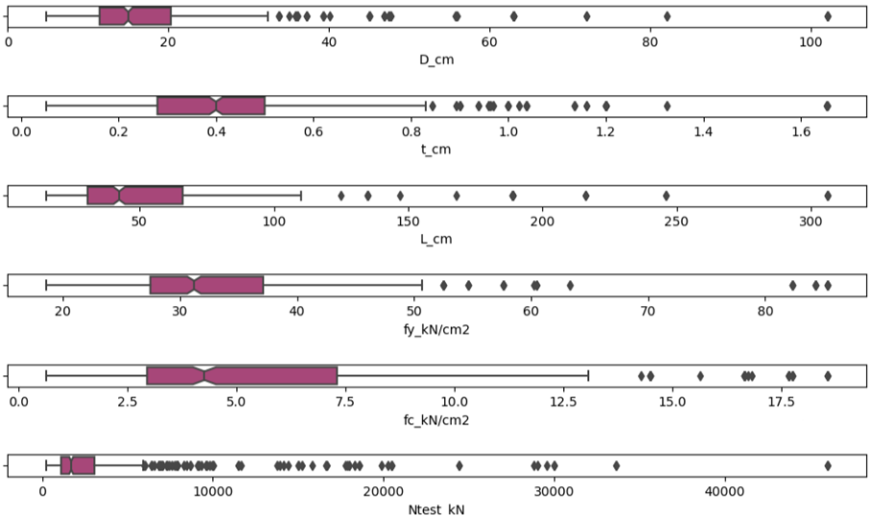

**Fig. 2** Show outliers of features using a box chart



**Fig. 3** The ANN models considered in this study

1. Results and Discussion

We got the convergence results of the SS and MS methods, corresponding to the ANN models, presented in Fig. 4. 20% of short circular CFST Columns' in the test dataset (133 observed samples) are present in Tables 1 and 2. The LANN model is unsuitable for prediction. Use additional models from the research [16].

The MS method has performed well for NANN1 models with 1, 3, and 5 hidden layers and even better for NANN2 models with 5 hidden layers in Fig. 3 and Table 2.

Table 1 shows that the SS approach for data normalization in the issue of estimating the critical strength of CFST columns using ANN models yields too big error outcomes.

|  |
| --- |
| **a)** |
|  |
| **b)** |
|  |

**Fig. 4** Effect of SS and MS Algorithms on Convergence of ANN Models

|  |  |  |  |  |  |  |  |  |  |  |  |
| --- | --- | --- | --- | --- | --- | --- | --- | --- | --- | --- | --- |
| **#** | **Ntest**  **(kN)** | **LANN** | **Err**  **%** | **NANN1**  **1hl** | **Err**  **%** | **NANN1**  **3hls** | **Err**  **%** | **NANN1**  **5hls** | **Err**  **%** | **NANN2**  **5hls** | **Err**  **%** |
| 1 | 920 | 0.8 | 99.9 | 91.0 | 90.1 | 0.2 | 100.0 | -0.2 | 100.0 | -0.2 | 100.0 |
| 2 | 2158 | 27.1 | 98.7 | 192.3 | 91.1 | 1467.7 | 31.9 | -0.2 | 100.0 | -0.2 | 100.0 |
| 3 | 355 | -27.0 | 107.6 | 91.0 | 74.4 | 0.2 | 100.0 | -0.2 | 100.1 | -0.2 | 100.0 |
| 4 | 1763 | 21.8 | 98.8 | 91.0 | 94.8 | 0.2 | 100.0 | -0.2 | 100.0 | -0.2 | 100.0 |
| … | ... | ... | ... | ... | ... | ... | ... | ... | ... | ... | ... |
| 130 | 1118 | -8.6 | 100.8 | 91.0 | 91.9 | 0.2 | 100.0 | -0.2 | 100.0 | -0.2 | 100.0 |
| 131 | 2044 | 1.0 | 99.9 | 91.0 | 95.6 | 1557.3 | 23.8 | -0.2 | 100.0 | -0.2 | 100.0 |
| 132 | 2592 | 1.5 | 99.9 | 947.7 | 63.4 | 897.2 | 65.4 | -0.2 | 100.0 | -0.2 | 100.0 |
| 133 | 1117 | -9.0 | 100.8 | 91.0 | 91.9 | 0.2 | 100.0 | -0.2 | 100.0 | -0.2 | 100.0 |

**Table 1** CFST ultimate strength is predicted from ANN models using SS Algorithm

**Table 2** CFST ultimate strength is predicted from ANN models using MS Algorithm

|  |  |  |  |  |  |  |  |  |  |  |  |
| --- | --- | --- | --- | --- | --- | --- | --- | --- | --- | --- | --- |
| **#** | **Ntest**  **(kN)** | **LANN** | **Err**  **%** | **NANN1**  **1hl** | **Err**  **%** | **NANN1**  **3hls** | **Err**  **%** | **NANN1**  **5hls** | **Err**  **%** | **NANN2**  **5hls** | **Err**  **%** |
| 1 | 920 | 28.1 | 96.9 | 507.1 | 44.9 | 1037.8 | 12.8 | 958.8 | 4.2 | 877.8 | 4.6 |
| 2 | 2158 | 32.6 | 98.5 | 2715.3 | 25.8 | 2127.4 | 1.42 | 2194.6 | 1.7 | 2294.9 | 6.4 |
| 3 | 355 | 23.5 | 93.4 | 182.4 | 48.8 | 211.1 | 40.7 | 301.1 | 15.4 | 322.2 | 9.5 |
| 4 | 1763 | 30.8 | 98.3 | 1478.3 | 16.2 | 1595.3 | 9.6 | 1567.3 | 11.1 | 1701.5 | 3.5 |
| … | ... | ... | ... | ... | ... | ... | ... | ... | ... | ... | ... |
| 130 | 1118 | 26.5 | 97.6 | 792.0 | 29.2 | 1241.2 | 11.0 | 1090.2 | 2.5 | 1072.7 | 4.1 |
| 131 | 2044 | 27.7 | 98.6 | 2142.5 | 4.8 | 1803.7 | 11.8 | 1753.8 | 14.2 | 1823.9 | 10.8 |
| 132 | 2592 | 28.1 | 98.9 | 2344.4 | 9.6 | 2204.2 | 15.0 | 2150.2 | 17.0 | 2035.5 | 21.5 |
| 133 | 1117 | 26.3 | 97.7 | 566.5 | 49.3 | 845.5 | 24.3 | 814.5 | 27.1 | 859.8 | 23.0 |

1. Conclusion

This work has considerably affected critical strength prediction findings of short circular CFST columns utilizing two prominent data normalization techniques, SS and MS. The MS method predicts CFST column critical strength well. When adding hidden units and layers, the ANN model for the issue specified with the NANN2 structure performs better.

**Acknowledgments** The authors gratefully acknowledge the financial support from the Scientific Research Fund of Van Lang University, Vietnam. The authors gratefully acknowledge the financial support granted by the Scientific Research Fund of the Ministry of Education and Training (MOET), Vietnam, under the grant No. B2023–MBS–03.

References

1. Wang X, Fan F, Lai J (2022) Strength behavior of circular concrete-filled steel tube stub columns under axial compression: A review. Construction and Building Materials, 322.
2. Pham D-D Nguyen P-C (2020) Finite Element Modelling for Axially Loaded Concrete-Filled Steel Circular Tubes. Springer Singapore. in CIGOS 2019, Innovation for Sustainable Infrastructure: 75-80.
3. Pham D-D, Nguyen P-C, Nguyen D-L, Le H-A (2020) Simulation of Concrete-Filled Steel Box Columns. Springer Singapore. in ICSCEA 2019: 359-366.
4. Nguyen T-T, Nguyen P-C, Tran VT, Pham D-D, Benabou L (2021) Reliability analysis of concrete-filled steel tube columns under axial compression. in AIP Conference Proceedings. AIP Publishing LLC. 060017.
5. Nguyen PC, Pham DD, Tran TT, Nghia-Nguyen T (2021) Modified Numerical Modeling of Axially Loaded Concrete-Filled Steel Circular-Tube Columns. Engineering, Technology & Applied Science Research, 11 (3): 7094-7099.
6. Zhang S, Li X, Chen X, Chen J (2022) Behavior of circular-steel-tube-confined square CFST short columns under axial compression. Journal of Building Engineering, 51.
7. Hong T, Wang Z, Luo X, Zhang W (2020) State-of-the-art on research and applications of machine learning in the building life cycle. Energy and Buildings, 212.
8. Zhang L et al. (2021) A review of machine learning in building load prediction. Applied Energy, 285.
9. Faridmehr I Nehdi ML (2022) Predicting axial load capacity of CFST columns using machine learning. Structural Concrete, 23 (3): 1642-1658.
10. Nguyen T-T Nguyen P-C (2023) K-Fold Cross-Validation Technique for Predicting Ultimate Compressive Strength of Circular CFST Columns. Springer Nature Singapore. in ICSCEA 2021: 867-874.
11. Pham Q-H, Nguyen P-C, Tran TT (2022) Free vibration response of auxetic honeycomb sandwich plates using an improved higher-order ES-MITC3 element and artificial neural network. Thin-Walled Structures, 175.
12. Pham Q-H, Tran TT, Nguyen P-C (2023) Nonlocal free vibration of functionally graded porous nanoplates using higher-order isogeometric analysis and ANN prediction. Alexandria Engineering Journal, 66 651-667.
13. Arokiaprakash A Selvan SS (2022) Application of Random Forest and Multi-layer Perceptron ANNS in Estimating the Axial Compression Capacity of Concrete-Filled Steel Tubes. Iranian Journal of Science and Technology, Transactions of Civil Engineering, 46 (6): 4111-4130.