Improving Labor Productivity of Concrete Construction of Townhouse Columns by Discrete Event Simulation

Phong Thanh Nguyen1,2*, Phat Huynh Kim3,4

1 Professional Knowledge & Project Management Research Team (K2P), Ho Chi Minh City Open University, Vietnam

2 Department of Project Management, Faculty of Civil Engineering, Ho Chi Minh City Open University, Vietnam*.*

3 Department of Construction Engineering and Management, Faculty of Civil Engineering,

Ho Chi Minh City University of Technology (HCMUT), 268 Ly Thuong Kiet, District 10, Ho Chi Minh City, Vietnam.

4 Vietnam National University Ho Chi Minh City, Linh Trung Ward, Thu Duc District, Ho Chi Minh City, Vietnam.

phong.nt@ou.edu.vn

**Abstract.** Construction is one of the industries with a long history and the largest scope in the world. In Vietnam, despite experiencing the Covid-19 pandemic, the market demand for townhouse construction is forecasted to still have a high growth rate because most of them are self-built houses and are less sensitive to short-term changes in the economic environment. There are many researches and solutions proposed to improve labor productivity, reduce costs or shorten the project schedule. However, it is very difficult to satisfy all three factors at the same time. To solve this problem, the simulation approach is considered one of the most effective methods. Using Stroboscope simulation, this study records the actual construction time of the column workers at the construction site, thereby calculating the probability distributions and modeling the implementation process. The research results will help construction managers observe and evaluate potential conflicts or problems, such as resource allocation, number of workers, etc., and then make effective solutions to reduce construction time and increase labor productivity.

**Keywords:** Discrete Event Simulation; Probability Distribution; Townhouses; Crystal Ball; Stroboscope.

1. Introduction

Currently, the supply and consumption of townhouses in Ho Chi Minh City and surrounding areas are both higher than the previous period. For example, in the first six months of 2021, the market supply is 1,908 apartments and the consumption is 1,483 apartments while in the first 6 months of 2022, the market supply is 5,145 apartments and the consumption is 3,848 apartments (increased by 269,65% and 259.47% respectively) [1]. This proves that the demand for housing, especially in the townhouse segment in Vietnam is very high. On the other hand, in general, construction contractors in Vietnam are mostly small and medium-sized enterprises with low technical skills and specialization. Therefore, the research and improvement of labor productivity is a solution that not only accelerates construction speed but also balances revenue and budget, increasing competitiveness in the market [2]. Although, there are many different methods to improve and enhance labor productivity. This study used the Stroboscope simulation method because it could analyze and evaluate the reasonableness in the arrangement of workers and resource allocation based on the simulation of discrete events through the calculated probability distribution functions based on the actual construction time of workers at the construction site. Then, it will simulate the concrete pouring of the column because this is an important component in the construction work. On the other hand, in the construction of townhouses, the column cross-section is usually constant so the proposed methods can be widely applied in other works. The research results will contribute to providing solutions to help construction enterprises arrange and allocate resources reasonably to reduce construction time, contributing to increasing labor productivity.

1. Research Background

There are many studies on improving labor productivity using discrete event simulation in construction management worldwide [2-7]. For example, Martinez, et al. [8] introduced the Stroboscope as a programming language for construction process simulation. The programming language provides access to the state of the simulation and the properties of resources. It allows the creation of realistic models that can make utilization, consumption, and production of resources stochastic; perform dynamic resource allocations; characterize resources created at runtime by combining other resources; and make dynamic decisions regarding the sequence of operations. Martinez and Ioannou [9] presented an overview of the Stroboscope and illustrates how it can be used to model a complex example taken from classic simulation literature. The study analyzed an airplane service center to illustrate the capabilities of the language, not the operations of an airplane service facility. Complex and realistic problems such as the example presented can be modeled, analyzed, and optimized quite easily, Ioannou and Martinez [10] used the Stroboscope simulation system to compare two alternative construction methods for rock tunneling. The probability of choosing the less expensive construction method based on a single run increases from 55% to 96%, the variance of the difference in cost decreases by two orders of magnitude, and the 95% confidence interval for the expected difference in cost given by 4,000 independent pairs is given by only sevenmatched pairs.

Ioannou and Martinez [11] mentioned the disadvantage that decision-makers often do not have the training nor the time to check the validity of simulation models prepared by others and thus have little confidence in the results. The study proposed an “Animation technique” that can be used to verify, debug and validate simulation models. The study presented a simulation model for the movement of people inside a building served by a single elevator with fairly complex control logic that was verified using Stroboscope and Proof Animation. Panas and Pantouvakis [12]used discrete event simulation to model the installation of 34 submersible well foundations and then determined a progress curve to compare with reality. The simulation model evaluation results are close to reality when the difference was very small. Messinella [13] used a stroboscope simulation application of tunneling by blasting method, applied in the Deo Ca project (a mountain in central of Vietnam). The model has optimized the layout of the excavator line - the soil transport vehicle and the working time of the loader because this is the stage that takes up a large amount of time in the whole cycle.

1. Research Methodology

The research process consists of five steps as shown in Figure 1 as follow:

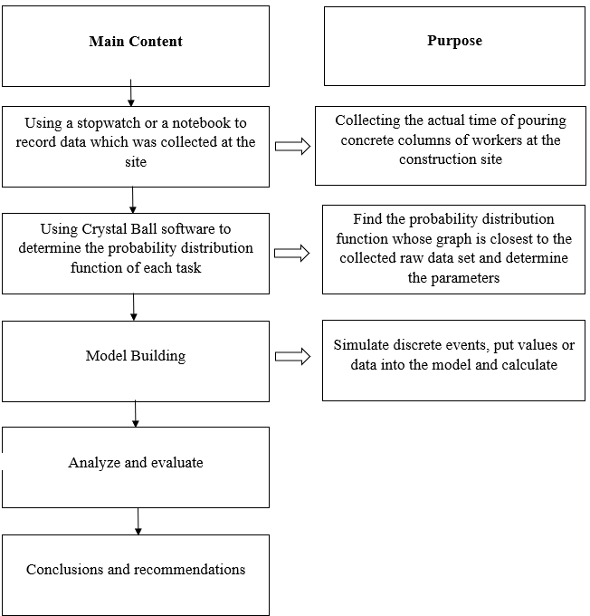

Fig 1. Research process

**Step 1**. **Collect actual data on site**:Data is collected using a stopwatch combined with a logbook to record the actual time a worker completes a job during the concreting process. This is considered the most important step, in deciding the success or failure of the simulation model. If the data set is not collected correctly, it will affect the model structure, and distort the distributions, which leads to the manager making wrong decisions. Therefore, data collection requires concentration, care, meticulousness, accuracy and objectivity. The collection of data must ensure that all steps follow the concrete pouring process specified in Vietnamese Standard TCVN 4453:1995. [10], including (1) formwork processing; (2) steel rebar processing; (3) formwork transportation; (4) steel transportation; (5) installation of steel; (6) installation of formwork; (7) support formwork; (8) testing and acceptance; (9) concrete work; (10) concrete transportation; (11) Concreting; (12) concrete lagoon; and (13) formwork removal work.

**Step 2. Determine the distribution function:** Using Crystal Ball software, we will find different probability distribution functions corresponding to each set of collected data representing each task. The probability distribution functions will be ordered from highest to lowest, that is, the functions will first have the distribution closest to the data set and then descend. Therefore, we usually only use the first probability distribution functions and define their values as the value max; min; mean.

**Step 3. Model building:** The model was built in Stroboscope must ensure all the tasks listed in Step 1, and assign the values found in Step 2 to each task. For each task, we assign a variable number of workers performing that task.

**Step 4. Analyze and evaluate:** After carefully checking the model (number of jobs; values, etc.), we proceed to run the simulation and analyze the results.

**Step 5. Conclusions and recommendations:** This study proposed the results that need to be improved to increase labor productivity, including: (i) total construction time to pour concrete; (ii) total waiting time; (iii) a total number of workers; and (iv) labor costs.

1. Research Results

The study was carried out on individual townhouses and construction sites in Ho Chi Minh City. The construction project has a scale of 01 ground floor, 02 floors, and 01 terrace, with a construction area of 4 x 23.3 (m2). Using Stroboscope software to build a simulation model of column concrete pouring. The model adds the probability that the concrete compactor is damaged with the value P = 0.15 (in 20 times of concrete compaction, the machine fails 03 times, probability = 3/20 = 0.15). With the initial default number of workers performing the job at 1, the total construction time is 4.7 (hours), and the total waiting time is 7.8 (hours). Therefore, in order to optimize the construction time, we proceed to increase the number of workers according to the principle that if the number of workers increases, the construction time will decrease, that is, the increase of workers is effective. However, it should be noted that the cost should not exceed the contractor's budget. This iterative method will execute until the optimal number of workers performing each task is determined.

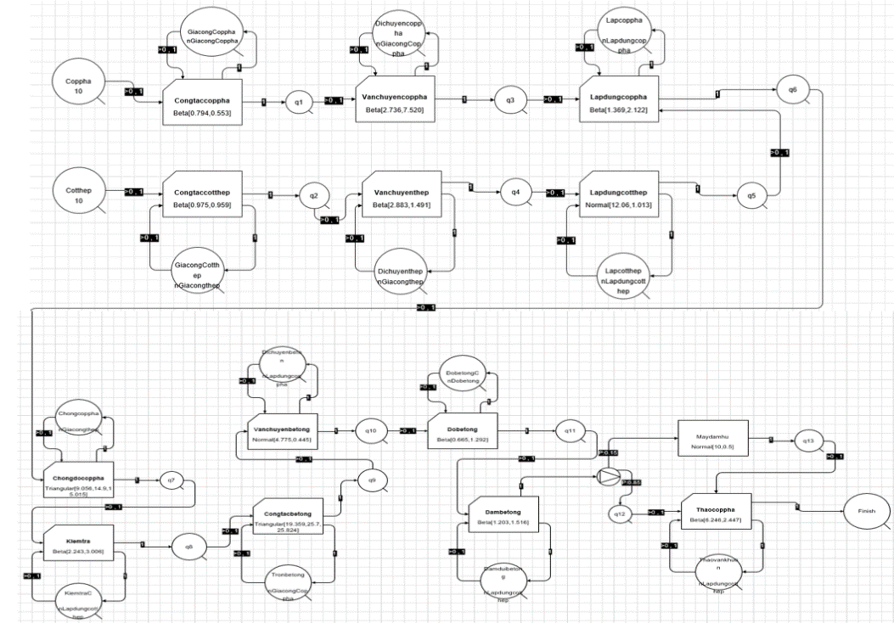

Fig 2. Simulation model

The number of workers calculated in Table 1 is understood as the number of people in a team. For example, the team of workers processing formwork is: 03 people, and the team of workers processing steel is: 02 people. In the simulation, the processing of formwork is performed by a team of workers processing the formwork. with the constraint of 01 workers processing 01 formwork sheet. Therefore, the number of workers performing the task is always lower or equal to the worker team has been optimized from the simulation. In the simulation, the human factor is the decisive factor (affecting the probability distribution function) so in case that the same construction area or the same work (concreting work), two different construction teams will give us two different probability distribution functions.

Table 1. Summary table of simulation results

|  |  |  |  |  |  |  |  |
| --- | --- | --- | --- | --- | --- | --- | --- |
| **Casse**  **Content** | **Case 1** | **Case 2** | **Case 3** | **Case 4** | **Case 5** | **Case 6** | **Case 7** |
| Number of workers processing formwork | 1 | 2 | 3 | 4 | 3 | 3 | 3 |
| Number of workers processing steel | 1 | 1 | 1 | 1 | 2 | 2 | 2 |
| Number of workers installing formwork | 1 | 1 | 1 | 1 | 1 | 1 | 1 |
| Number of workers installing steel | 1 | 1 | 1 | 1 | 1 | 2 | 2 |
| Number of workers pouring concrete | 1 | 1 | 1 | 1 | 1 | 2 | 3 |
| **Total number of workers** | 5 | 6 | 7 | 8 | 8 | 10 | 11 |
| **Total construction time** | 4,69 | 2,96 | 2,87 | 2,95 | 2,64 | 2,09 | 2,23 |
| **Total waiting time** | 7,79 | 5,52 | 6,03 | 6,55 | 6,09 | 4,99 | 5,52 |
| **Labor costs (milion VND)** | 2 | 2,4 | 2,8 | 3,2 | 3,2 | 4 | 4,4 |

**\*** Note: 1 USD ≈ 23.000 VND

1. Conclusion

This paper applied the Stroboscope to simulate concrete construction of townhouse columns. The simulation model is built by observing and recording the actual construction time of workers at the construction site. There are many factors affecting the working process of workers such as: weather, working environment, etc.. The study's findings will help construction companies set up and distribute resources more efficiently, which will shorten construction times and boost worker productivity.

**Acknowledgment**

The authors would like to thank Dr. Viet Thanh Nguyen, Industrial University of Ho Chi Minh City; Assoc, Prof. Dr. Sy Tien Do, Ho Chi Minh City University of Technology (HCMUT), and the Professional Knowledge & Project Management Research Team (K2P), Ho Chi Minh City Open University, Vietnam for supporting this research.

References

[1] D. J. S. Company, "Report on housing real estate market in Ho Chi Minh City and surrounding areas in the first 6 months of the year 2022," 2022.

[2] W. Yi and A. P. Chan, "Critical review of labor productivity research in construction journals," *J. Manage. Eng.,* vol. 30, no. 2, pp. 214-225, 2014.

[3] R. Jin, J. Zuo, and J. Hong, "Scientometric review of articles published in ASCE’s journal of construction engineering and management from 2000 to 2018," *J. Constr. Eng. Manage.-ASCE,* vol. 145, no. 8, p. 06019001, 2019.

[4] A. Alvanchi, R. Azimi, S. Lee, S. M. AbouRizk, and P. Zubick, "Off-site construction planning using discrete event simulation," *Journal of Architectural Engineering,* vol. 18, no. 2, pp. 114-122, 2012.

[5] K. P. Kisi, N. Mani, E. M. Rojas, and E. Terence Foster, "A case study on estimating optimal labor productivity," in *Construction Research Congress 2016*, 2016, pp. 1762-1771.

[6] J. Louis, P. Dunston, and J. Martinez, "Automating construction operations using discrete event simulation models," in *Construction Research Congress 2014: Construction in a Global Network*, 2014, pp. 1043-1052.

[7] H. Alzraiee, O. Moselhi, and T. Zayed, "A hybrid framework for modeling construction operations using discrete event simulation and system dynamics," in *Construction Research Congress 2012: Construction Challenges in a Flat World*, 2012, pp. 1063-1073.

[8] J. Martinez, P. G. Ioannou, and R. I. Carr, "State and resource-based construction process simulation," in *Computing in civil engineering*, 1994: ASCE, pp. 177-184.

[9] J. C. Martinez and P. G. Ioannou, "General purpose simulation with stroboscope," in *Proceedings of Winter Simulation Conference*, 1994: IEEE, pp. 1159-1166.

[10] P. G. Ioannou and J. Martinez, "Evaluation of alternative construction processes using simulation," in *Construction Congress*, 1995: ASCE, pp. 440-447.

[11] P. G. Ioannou and J. Martinez, "Animation of complex construction simulation models," in *Computing in Civil Engineering*, 1996: ASCE, pp. 620-626.

[12] A. Panas and J.-P. Pantouvakis, "Simulation-based concrete truck-mixers fleet size determination for on-site batch plant operation," *Procedia-Social and Behavioral Sciences,* vol. 74, pp. 459-467, 2013.

[13] M. Messinella, "Models for the analysis of tunnelling construction processses," University of Twente, 2010.