Preserving Urban Heritage in the Industry 4.0

*Nguyen* Nguyen Thi Hanh1 and *Trang* Nguyen Thi Nhu2

1 Faculty of Architecture-Interior Design-Applied Arts, Nguyen Tat Thanh University, Vietnam.

2 Department of Architecture, Hanoi Architectural University, Vietnam.

**Abstract.** Urban heritage in Vietnam has never entered such an unpredictable period as now. The 4th Industrial Revolution has brought countless opportunities as well as challenges to all industries and all aspects of the country. It has such a large and multifaceted global economic impact that it is difficult to separate one particular impact from the next. Indeed, all the major macro variables one can think of - GDP, investment, consumption, employment, trade, inflation, etc. - will be affected [1]. The conservation industry in general and urban heritage conservation, in particular, are no exception to this influence. The article applies methods including field surveys, learns typical experiences from failures in urban heritage conservation in Ho Chi Minh City, Nam Dinh, and Da Lat, as well as synthesis and analysis in order to draw solutions to preserve urban heritage in the era of Industry 4.0 that has been and is taking place. Thereby, the study establishes the vision and direction for heritage and historic cities.

**Keywords:** Urban heritage, Industry 4.0, Heritage city.

# Introduction

## Background and Research Interest

### *Challenges for Urban Heritage Today*

#### Vietnamese cities are losing their identity

Vietnam's urban areas through the development periods have fostered many different identities: Hanoi is an urban area with thousands of years of history; Ho Chi Minh City is dynamic and modern, once compared to the “Pearl of the Far East”; Hue is the last Citadel with ancient architectural monuments on the banks of the Perfume River; Da Lat is a poetic foggy highland city; Hoi An is an ancient town with Japanese and Chinese architectural styles...

The worrying thing is that many of the cities mentioned above are gradually losing their own identity, to move towards a common “pattern” that is quite similar, even willing to trade off the gradual loss of historical and environmental values. has been accumulated for hundreds, even thousands of years, to prioritize development. As an inevitable consequence of that spontaneous and unsustainable development, all cities are Development in Vietnam is paying a heavy price with rapidly increasing flooding, traffic jams, and environmental pollution [2].

#### There is no specific conservation law for Urban Heritage

After 20 years of the Law on Cultural Heritage being promulgated (since 2001) and more than 10 years of revision, this system of legal documents has gradually revealed a number of limitations and inadequacies. The ongoing reality in the field of heritage requires urgent amendments and supplements to the Law on Cultural Heritage in order to catch up with social movements and changes, adjust obstacles, and create a legal corridor. favorable management for activities to protect and promote the heritage value of the national culture. Especially, for regulations that are not feasible, or are no longer consistent with reality, and need to be amended or abolished such as in the field of relics, intangible cultural heritage, management of relics, antiquities, national treasures, and museums.

#### Preparing documents on Urban Heritage is slow and inconsistent

In large cities in Vietnam, such as Hanoi and Ho Chi Minh City, many precious ancient architectural works associated with history have not been classified as monuments, so protection against the encroachment of the development process urban is extremely difficult. The research stage, surveying the current status, and studying the relic records is not done correctly, or is overlooked. Heritage assessment is also inadequate. Meanwhile, completing the records to rank the monument is not easy, even in many places, both the people and the government avoid and refuse to cooperate in the inventory and assessment of the monument.

Sharing the same problem with Ho Chi Minh City is Da Lat, the city is oriented to become a heritage city but there are many ancient villas that are disappearing rapidly. In May 2020, the authors surveyed the current status of Da Lat’s urban architectural heritage and found that the number of heritages was deformed, degraded, and at risk of disappearing quite a lot, the decline in the Urban Architectural Heritage Fund leads to a decrease in the attractiveness of the city [3].

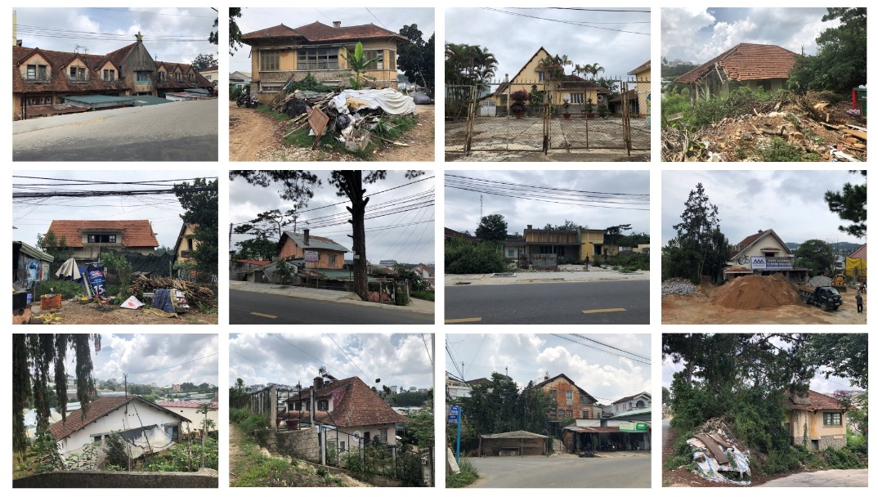

**Fig. 1.** Da Lat people demolish and renovate their French-style villas before the city is officially recognized as a heritage city. Source: author's survey in May 2020.

Many Da Lat people do not want the villa they own to be listed on the Heritage list because they fear that they will not have full rights to their property in the future.

#### Community awareness about urban heritage conservation is not high

The awareness of the Vietnamese people in general and people living in urban areas or areas with architectural heritage that needs to be preserved is still not high, which is a problem that the media and experts warn a lot, but the situation improvement is still very slow. The community still has many misconceptions about heritage conservation:

- “Conservation costs a lot of money but brings little value”.

- “Preservation of heritage means that there is no land left for development”.

- “Economic development must be prioritized”.

- “Old cities are no longer suitable for contemporary lifestyles”.

- “Preservation of Heritage is simply preserving the architectural heritage itself, without regard to the surrounding context”.

### *Case studies from lost urban heritage*

#### Case Study 1: Ba Son shipyard

From the land that used to be the first shipyard of Lord Nguyen, it is now planned into a dense neighborhood of high-rise towers, blocking the wind and the view from the city towards the port and the Saigon River. Ho Chi Minh City (formerly known as Saigon) is gradually losing its heritage value that formed the primitive industrial regime of the busiest city in Asia [4].

|  |  |
| --- | --- |
|  |  |
| **Fig. 2.** An aerial reconnaissance photograph was taken in advance of the 1944-1945 Allied bombing campaign. Source: [4] | **Fig. 4.** Ba Son Shipyard before being demolished in 2014. Source: Alexandre Garel |
|  |  |
| **Fig. 3.** Ba Son shipyard image was taken by satellite in 2000 Source: Google map | **Fig. 5.** Ba Son after being demolished and rebuilt in 2019. Source: Zing. vn |

Today, the overall vision of Saigon is a city with a high population density with a large number of buildings. When the new building is built, it will drown its history under its roots. In the narrow urban space, there are only ancient buildings and small historical sites. At the end of the old urban area, Ba Son seems to be the most favorable location and also the brightest point of Saigon's history.

#### Case Study 2: Historic Church of Bui Chu

Bui Chu Church - Nam Dinh province is the birthplace of Vietnamese Catholicism. Built in 1881-1885 and existed for more than 135 years, it has experienced many events in Bui Chu parish in particular and this diocese in general. That is, it should be recognized as a heritage site and preserved as is. Unfortunately, it was dismantled in 2019 after a lot of efforts to protect the monument from the community and experts [5].

Bui Chu Church was built at the same time as the Hanoi Cathedral, and exists to this day almost intact, with very thick bearing brick walls and a strong wooden frame and column system. It was built with a structure like a traditional village house that we often see in the North of Vietnam. In addition, the pattern of doors, windows, and details of this church is taken in the style of churches in Spain and Europe.

|  |  |
| --- | --- |
|  |  |
| **Fig. 6.** Bui Chu, three months before was demolished in August 2019. Source: Nguyen Phu Duc | **Fig. 7.** Bui Chu, has been demolished on 1/8/2019 - 135 years of history converted into dust. Source: [Nguoidothi.net.vn](https://nguoidothi.net.vn/) |

Bui Chu Church is just a typical case that the online community knows, behind it are hundreds of other ancient churches in the North that are in the same situation. Previously, Tra Co church - Quang Ninh province was also dismantled and renewed in 2017.

#### Case Study 3: Mayor Palace Hill, Hoa Binh center, Da Lat

In addition to Hanoi, Saigon, and other cities in Vietnam, Da Lat is a rare case in the world formed from vacant land. This highland city is a methodical result of planning, landscape to architecture. The work was designed by two famous foreign architects at that time, Ernest Hébrard and Pineau, and some prestigious Vietnamese architects such as Ngo Viet Thu and Huynh Kim Mang.

With those special values, the historical center of Da Lat should be preserved by retaining as much as possible of the original, green spaces that have been narrowed. This is a humane and sustainable way of behavior that shows the civilized level of the city. Hoa Binh area is a Vietnamese center established by the French government in the beginning, including 3 main areas: Market, Shophouse, and Mayor Palace Hill. The Governor's Palace is located in the highest area of the center of Da Lat and is one of the first constructions built. Understanding the values and characteristics of those areas is imperative for architects to capture the core values of the city [6].

|  |
| --- |
|  |
| **Fig. 9.** Mayor Palace Hill, Hoa Binh Center, 1955 and 2019. Source: [7] |

## Literature Review

### *Urban Heritage and Heritage Urban*

The concept of urban heritage was proposed for the first time by Giovannoni in 1931. “Urban Heritage includes materials, prestigious or not, cities and groups of the traditional and preindustrial nineteenth century, and tends to encompass more broadly all highly structured urban materials” [8].

The definition of “urban heritage” that comes to the mind of most urban planners and managers is usually “monuments”, i.e. churches, temples, all sorts of religious buildings, palaces, castles, fortresses, historic city walls and gates, and other types of institutional buildings (e.g. of education, science, administration, or other social purposes). This interpretation often excludes historic residential areas and historic city centers which equally represent the urban heritage. In addition, there may even be intangible elements of urban heritage, such as customs and beliefs, which play a role in the articulation of space use and the built environment [9].

Along with Urban Heritage, the concept of a Heritage Urban or Historic City has not been included in legal documents and has not been unified and clear. Perhaps, Professor Hoang Dao Kinh was the first to fully introduce the concept of Heritage Urban: “The heritage urban is a typical historical whole, a product of urban civilization, combined with organic elements of material and spiritual, architecture and culture, in harmony with nature, is the starting point that governs everything” [10].

### *Industrial Revolution 4.0 and its Impact on urban heritage*

The first concept that we need to understand is Industry 4.0, also known as IIoT (Industrial Internet of Things - application of Internet of Things technology to production). Professor Klaus Schwab, Founder and Executive Chairman of the World Economic Forum, is convinced that we are at the beginning of a revolution that is fundamentally changing the way we live, work, and have relationships with each other, which he explores in his new book: The Fourth Industrial Revolution [1].

The fourth industrial revolution will have a monumental impact on the global economy, so vast and multifaceted that it makes it hard to disentangle one particular effect from the next. Indeed, all the big macro variables one can think of - GDP, investment, consumption, employment, trade, inflation, and so on - will be affected [1].

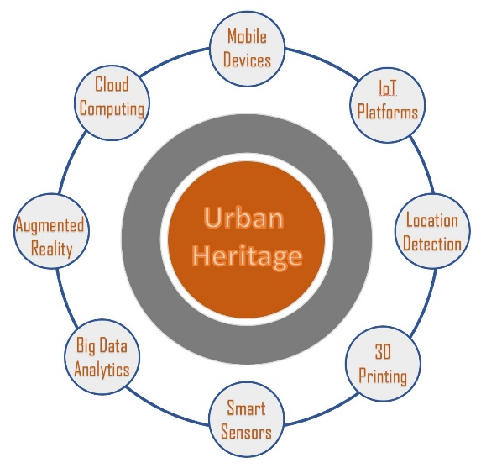

**Fig. 11.** The 4th Industrial Revolution's impact on Urban Heritage. Source: authors

It can be said that the Fourth Industrial Revolution brings numerous advantages and difficulties to the conservation of urban heritage in particular and all industries across the country in general.

On the difficult side, in the era of Industry 4.0, urban heritage as well as other cultural heritages is facing the threat of disappearing at a faster rate, when the community believes that digitizing all physical and intangible heritage is enough to provide the user experience. However, the authors stress that no digital experience can replace the physical experience.

On the contrary, technologies born in the 4.0 revolution will promote a very clear effect in preserving and promoting the value of traditional cultural heritage. Technology supports conservation professionals in digitizing heritage to be preserved, storing digitized documents in unlimited quantities with Cloud Computing, and sharing data with Big Data. Digitization makes it easier to restore lost or deformed heritage to its original state, saving conservationists from having to race with the weather in the field as before. In addition, Smart Sensor chips and IoT platforms support viewers to experience heritage spaces with Augmented Reality technology. There are countless experiences that 4.0 technology can support for the conservation industry.

### *Urban identity*

When commenting on cities, people often talk about identity. Like, this city is big, wide, and modern but has no identity. The town is small but has a lot of character. So what is urban identity? In simple terms, urban identity is the sum total of many attributes expressed through tangible objects and intangible culture, of which the most basic attributes are landscape features, natural topography, places, and places. urban creation. Identity is the factor that guides the economic development of each city, especially in urban areas with historical elements.

The city has an identity that often exploits tourism and economic development well. Conversely, uncontrolled tourism development can cause many cities to gradually lose their identity. Losing identity is losing its own character, losing its difference to make its mark, and creating its own attraction compared to all other cities. Without their own identity, all cities would become versions of the same. Therefore, it is necessary to preserve the cultural identity along with the unique historical memory of each city [6].

### *Cities for People*

This concept originated with Dr. Jan Gehl through his inspirational book “Cities for People”. Based on visual observations, statistics, analysis, and a special interest in studying the lives of typical urban dwellers worldwide, Jan makes an enlightening observation: “The city’s greatest attraction is People…the importance of life and activity as an urban attraction. People gather where things are happening and spontaneously seek the presence of other people” [11]. Since then, Jan has come up with a humanistic urban model with four core points: Lively, Safe, Sustainable, and Healthy.

After all, the human factor is the central nucleus, making the reference system for the entire urban planning and construction today and tomorrow. Cities for people, is the urban philosophy, the spirit that permeates the excellent research work of Jan Gehl.

# Research Methods

This article applies the following main methods: (1) Physical field surveys to explore some areas with many precious urban heritages such as Hanoi, Ho Chi Minh City, Nam Dinh, and Da Lat; (2) Document research and data checking; (3) Synthesize and analysis to draw solutions to preserve urban heritage in the era of Industry 4.0 that has been and is taking place.

# Solutions for preserving Urban Heritage in Industry 4.0

Currently, in Vietnam, historic cities are facing many challenges because they carry many heritages but still have to serve the expectations of local economic development in the era of industrial revolution 4.0 with too many variables and difficulties. measure. The most basic solution is based on the reality of each locality, however, the common problem still needs to be implemented synchronously with the following solutions:

## Impact on all stakeholders

There are 4 objects involved in the urban development process and decisive influence on the destiny of the heritage: Government, Investors, Professionals/Experts; and Community.

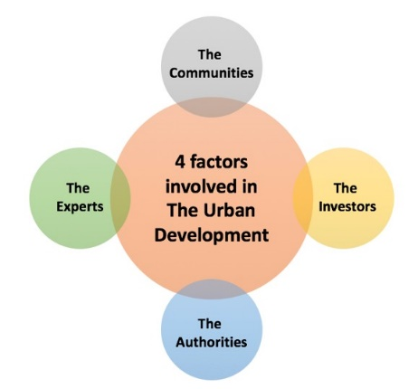

**Fig. 12.** Four factors involved in urban development. Source: [12]

In the trend of Urban Development in the Industrial Age 4.0, this is the right time for Experts to actively and more actively participate in urban life, analyze, debate, and participate in consultation works. deeper for the Government. It is even necessary for Professionals who require an advisory role when Authorities carry out conservation projects. It is time for the authorities at all levels to re-recognize their roles and responsibilities in protecting and preserving the urban heritage, which is the common value of the city, the country, the current urban residents, and the future.

It is necessary to strengthen heritage education for all classes and ages in communities living with heritage in particular and throughout Vietnam in general [3]. Technology 4.0, if it knows how to exploit, will become an extremely effective tool to support communication and heritage education.

## Comprehensive planning with multidisciplinary thinking

At present, specific urban areas with big heritage systems such as Ho Chi Minh City, Hanoi, and Da Lat... have never had heritage planning drawings integrated into the city master plan. We are currently only looking at heritage as independent entities but we do not have a more general perspective to combine intangible values with tangible desires to find a balanced solution. In Vietnam, planning is often “behind”, planning is usually based on projects, so general plannings have a lack of vision or failure.

Planning is to promote the wisdom of experts and must have multidisciplinary thinking. The difference between each city is based on its specific characteristics so cannot follow other urban models. Planners must do full research on the city and the region, and at the same time decisions must listen to comments from domestic and foreign experts to create a sustainable plan for the future.

## Standardize the assessment of Urban Heritage

The Vietnamese heritage conservation industry does not yet have an optimal and complete set of tools for identifying and classifying Heritage in order to identify appropriate conservation methods in order to maximize the advantages of the heritage and bring value. value in urban development.

|  |  |
| --- | --- |
|  |  |
| Conservation potential of Hoa Binh Central Area before being deformed | Conservation potential of Hoa Binh Central Area nowadays |
| **Fig. 13.** Conservation Potential Analysis. Source: [13]  In order to balance the need for heritage conservation with the need for urban development, the finalization and standardization of this toolkit should be on the table of stakeholders. It is recommended to use Nahoum Cohen's assessment tool for the conservation of urban and architectural heritage with 5 criteria: (1) Characteristics and Boundaries; (2) Site and Feeling; (3) Ratio and Connection; (4)Architectural styles and Features, and (5) Materials and Construction Methods.  Experts need to make a rating table with the above 5 criteria, each rating from 0-20% (potential for conservation). A heritage work meets the criteria for conservation when it has a total rating of 50% or more [13]. | |

## Building a set of criteria for urban heritage

Around the world, people recognize the need to preserve heritage with a view: Preserving authentic value, originality, authenticity, and accuracy. The more we respect the history, the more we appreciate the authenticity and uniqueness of heritage. Because the attraction of a heritage city is the cultural depth and historical length reflected in each remaining architectural and urban landscape [14].

Therefore, it is necessary to have a set of criteria for an urban potential to become a heritage city to preserve the characteristics that it already has and fill in the missing and weak features.

In the era of Industry 4.0, it is necessary to add criteria for applying technological innovations to heritage protection. If a city knows how to exploit technology properly, it will exploit the economic potential of heritage and have a better chance of being preserved sustainably.

## Digitizing data for heritage conservation

Today, science and technology have become effective tools in the story of preserving culture and natural heritage. The journey of preserving natural heritage in the 4.0 era has only just begun, but significant strides have been made. In particular, heritage digitization plays an important role in preserving cultural and historical values, contributing to preserving and preserving the originality of heritage in order to introduce and promote it to the community at home and abroad.

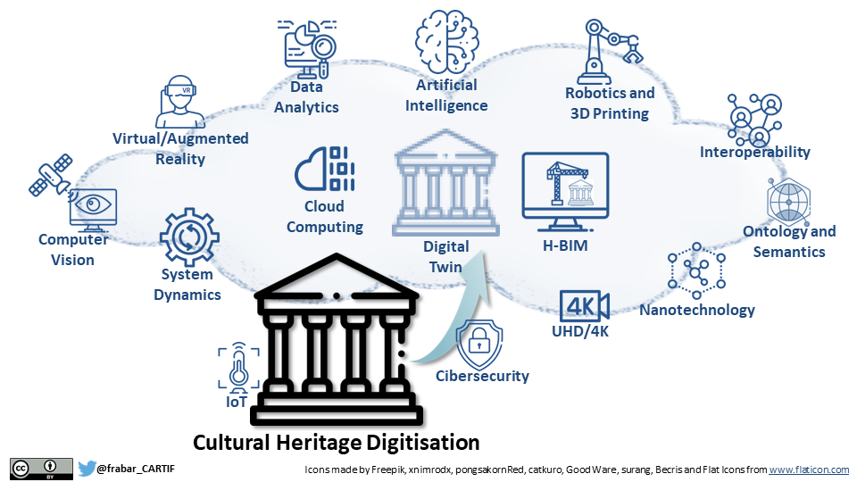

**Fig. 13.** Technologies for the Digitalization of Urban Heritage. Source: CARTIF

# Conclusion

In Vietnam today, the Industrial Revolution 4.0 brings countless opportunities and challenges in the conservation of urban heritage. In one respect, technology offers the most advanced conservation techniques, making heritage conservation quick and efficient. On the other hand, technology is closely related to the speed of urban modernization, which is an indirect or direct agent that causes urban and architectural heritages to be destroyed or lost forever.

The article applies methods including field survey, the study of typical case studies from failures in urban heritage conservation in HCMC, Nam Dinh, and Da Lat, as well as synthesis and analysis. to draw solutions to preserve urban heritage in the context of Industry 4.0. Thereby, the study establishes the vision and direction for heritage and historic cities.

# References

|  |  |
| --- | --- |
| [1] | K. Schwab, The Fourth Industrial Revolution, Switzerland: World Economic Forum, 2016. |
| [2] | Ngo Viet Nam Son, "Preserve, restore and develop the diverse identities of Vietnam's urban areas – A case study of Binh Duong province," *Architecture Magazine of Vietnam Association of Architects,* vol. Dec 2018. |
| [3] | N. T. N. Trang, "Da Lat architecture conservation with the heritage education approach," *Vietnam Journal of Construction,* vol. 11/2021, pp. 65-69. |
| [4] | Tim Doling, "Tim Doling's Heritage portal," 2015. [Online]. Available: https://www.historicvietnam.com/ba-son-shipyard/. [Accessed 12 4 2023]. |
| [5] | R. C. Paddock, "The New York Times webpage," 22 July 2020. [Online]. Available: Demolition of Historic Vietnam Cathedral Is Underway. |
| [6] | N. T. H. Nguyen, "Measures that need to apply to identify and protect urban heritage," *Construction, and Urban Magazine,* vol. August 2019. |
| [7] | N. T. H. Nguyen, "Dalat planning: Is today's choice the achievement or consequence for tomorrow?," *Architecture Magazine of Vietnam Association of Architects online,* 2019. |
| [8] | G. Giovannoni, Vecchie città ed edilizia nuova, Torino: Unione Tipografico Editrice Torinese, 1931. |
| [9] | Florian Steinberg, "Conservation and Rehabilitation of Urban Heritage in Developing Countries," in *Habitat International*, 1996. |
| [10] | H. D. Kinh, “Hue - heritage city, developed in continuity,” *Urban Planning Magazine,* vol. 5/2011. |
| [11] | Jan Gehl, Cities For People, Island Press, 2010. |
| [12] | N. T. H. Nguyen, "Heritage conservation in the context of smart urban development," *Architecture Magazine of Vietnam Association of Architects,* no. Oct 2018. |
| [13] | K. T. Hung, "The potential and conservational orientation of the Hoa Binh center area - Dalat," *Architecture Magazine of Vietnam Association of Architects,* no. No 11, 2019. |
| [14] | N. T. H. Nguyen, "Maximum conservation of originality: The best way to behave with the heritage," *Architecture Magazine of Vietnam Association of Architects,* no. June 2019. |