A Solution to Measure Wave overtopping on an Offshore Emerged Island

Trung Dung Nguyen1*, Cao Tri Mai1, Quang Tao Nguyen1, Van Bau Nguyen1,

Duc Dat Ho1, Manh Thai Do2, Quang Hai Luu3, Ngoc Thao Nguyen3 ,

Hao Nguyen4, Van Hung Ha4 and Quang Cuong Dinh1,4

1 Faculty of Coastal and Offshore Engineering, Hanoi University of Civil Engineering

2 Army Corps of Engineers, Vietnam

3 Center for Literature, Vietnam

4 Institute of Construction for Offshore Engineering, Hanoi University of Civil Engineering

*Corresponding author: dungnt4@huce.edu.vn

**Abstract.** Due to climate change, rising water levels lead to more frequent wave overtopping the shore protection dyke. Causing flooding, affecting the works behind the dyke and people's lives. In addition to the standard wave overtopping calculation solutions, according to the numerical and physical models, the solution to measure the wave overtopping in the actual situation is the most objective and accurate solution. But this is also a more expensive solution, requiring the tester to learn and prepare more carefully. Currently, in Vietnam, there are few studies and published solutions to measure wave overtopping waves in practice. In the world, the Eurtop2018 standard also mentions the CLASH project to measure overflow waves at the port of Ostia, Italy, a coastal port. But when measuring wave overtopping on emerged islands far from the shore, with more difficult measurement conditions, a different measurement method is required than when measuring inshore. In this study, the authors give the measurement solution, the results of measuring the wave overtopping on an offshore island in the Truong Sa archipelago, Vietnam and the notes when measuring the wave overtopping on the offshore emerged island. The study material will be useful as a reference for survey teams to measure nearshore and offshore wave overtopping.

**Keywords:** Wave overtopping, the offshore emerged island, Real solution to measure wave overtopping, overtopping discharges.

1. Introduction

Currently, coastal areas and islands are interested and invested in economic development, port services as well as entertainment purposes. On the other hand, due to climate change, water level rise causes wave overtopping over sea dykes with more frequency, causing flooding, affecting safety, people's lives as well as economic development services. Therefore, the problem of determining the wave overtopping over the dike is of great interest to scientists and engineers. Today, there are three methods to determine the overtopping discharges: the experimental method is to use the formula to calculate and the formulas are drawn from many physical modeling experiments, the numerical model method is to use the using mathematical model and plan to measure the actual wave overtopping. Up to now, the formulas for calculating waves over the dike have been developed quite complete for all types of dike geometries and have taken into account many different influencing factors in the EurOtop 2018 Standard[1]. But for some complex dike cross-sections, the terrain in front of the dike has a steep slope that is not mentioned in the standard, we have to build a physical model, a mathematical model to calculate or measure the discharge. overflow in reality. Compared with the methods of calculating the flow of overflow waves, the method of measuring the flow of overflow waves in fact gives more accurate results.

Within the research project CLASH (Crest Level Assessment of coastal Structures by full-scale monitoring, neural network prediction and Hazard analysis on permissible wave overtopping, 2002–2004, funded by the European Commission), field measurements on wave overtopping are carried out at three different locations in Europe: a vertical seawall with rubble mound toe protection at Samphire Hoe, United Kingdom[2], a rock armored rubble mound breakwater in shallow water at Ostia, Italy[3], and a rubble mound breakwater armored with grooved (Antifer) cubes at Zeebrugge, Belgium[4].

Franco 2004's research arranged a 2mx4mx2m steel tank (width x length x height) right behind the top wall of the dike and pressure sensors at the bottom of the tank to measure the amount of water, the machine was connected to a computer. The hydrometer is also placed in the harbor tank, the measurement lasts for a long time. The results measured a set of flow metrics over the spillway for a storm in October 2003 and some sensors malfunctioned due to wet electrical connections.

Research by Troch 2004 arranged 2mx7.4mx2m concrete tanks (width x length x height) right behind the dike and pressure sensor at the bottom of the tank. The results also measured a set of wave overtopping data sets whose dyke roofs were reinforced with flattened Grooved cubes 25T at the port of Zeebrugge, Belgium.

The above studies show that the measuring device is quite large, cumbersome, difficult to move, complicated, and has a long measuring scale. For the measurement of wave overtopping on offshore islands, there is a lack of electricity and a lack of available materials. The application of the above measurement method is very difficult.

Therefore, the authors used wooden planks, tarpaulins, nails, screws to make flumes to collect overflow water and tanks for overflowing water. Wave overtopping measuring devices can be moved to locations with wave overtopping. In front of the dike, there is a wave parameter meter.

1. Research Methods
   1. Theoretical basis of wave overtopping measuremen

Wave overtopping is the amount of water that is pushed over the top of the dyke due to the kinetic energy of the waves while the dyke crest is still above sea level. The time- overtopping discharge average, also known as the average overtopping discharge q, is the average overtopping discharge in a unit of time. The average overtopping discharge is the overtopping discharge taken per meter length of the dyke and has the unit of m3/s/m or l/s/m (actually the unit average overtopping discharge)[5]

The amount of waves that spill over the top of the dyke is collected into the storage chamber behind the structure, which is pumped out and measured by specialized volumetric devices. The formula to calculate the overtopping discharge [6]:

*q= $\frac{V_{ovt}}{l_{d}.T_{ovt}}$ (l/s/m)* (1)

Where: Vovt(l) : is the total volume of wave overtopping measured in the time period Tovt (s) and through the flume width ld (m).

* 1. Preparation of measuring equipment::

Wave measuring device

Using specialized equipment for measuring waves and tides TWR - 2050.

|  |  |
| --- | --- |
|  |  |
|  | |

**Fig. 1.** Image of the device TWR - 2050.

**Table 1.** Specifications of the device TWR -2050.

|  |  |  |  |
| --- | --- | --- | --- |
| **Equipment specifications - TWR 2050** | | | |
| Wattage | QTY 2,3V CR123A cells | | | |
| Data transmission | RS-232/485; logged box, cable, or transmitter | | | |
| Download speed | ~115,000 samples/minute | | | |
| Size | 265mm x 38mm | | | |
| Weight | 364g dry; 70g in water | | | |
| **\* Depth Sensor** | | **\* Temperature Sensor** | | |
| Limit | 10/25/60/100m (dBar) | Limit | -5oC – 35oC | |
| Accuracy | ± 0.05% full range | Accuracy | ±0.002oC | |
| Resolution | <0.001% full range | Resolution | <0.00005oC | |
|  |  | Time does not change | <3 second | |

Overtopping discharge measuring equipment

Due to the measurement off the offshore island in the Truong Sa archipelago, the authors prepared 2 sets of equipment for measuring the overtopping discharge. Each set including 01 overtopping flume, 01 overtopping tank, and volumetric devices (including graduated 100 liter bucket and 2.5 liter graduated shift).

The structure of the overtopping flumes consists of wooden planks joined together through wooden bars as shown in Figure 2.

|  |  |
| --- | --- |
|  |  |
|  |  |

**Fig. 2.** Image of plan, section and material statistics of the overtopping flume.

The structure of the overtopping tank consists of wooden slats joined together to form a frame and a canvas to store water as shown in Figure 3.

|  |  |  |
| --- | --- | --- |
|  |  | |
|  | |  |

**Fig. 3.** Image of a overtopping tank.

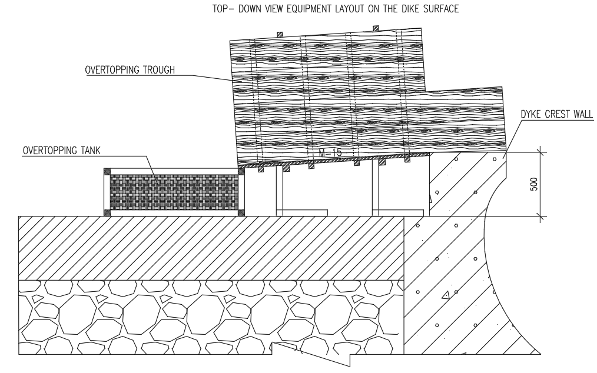

**Fig. 4.** Image of equipment layout on the dike surface.

In addition, there are additional equipment for manufacturing overtopping flume and overtopping tank:

|  |  |  |  |  |  |  |  |  |
| --- | --- | --- | --- | --- | --- | --- | --- | --- |
| **Order** | **Device name** | **Unit** | **Quantity** |  | **Order** | **Device name** | **Unit** | **Quantity** |
| 1 | Battery drill | pcs | 1 |  | 11 | Eraser | pcs | 3 |
| 2 | Saw | pcs | 2 |  | 12 | Marker pens | pcs | 2 |
| 3 | screw 5,7 | kg | 2 |  | 13 | Ballpoint pens, notebooks | pcs | 2 |
| 4 | Nail 5,7 | kg | 2 |  | 14 | Knife | pcs | 2 |
| 5 | Hammer | pcs | 2 |  | 15 | Electrical outlet 5m | pcs | 1 |
| 6 | Ruler m | pcs | 1 |  | 16 | pliers | pcs | 1 |
| 7 | Tibon glue | box | 3 |  | 17 | screw hatch 8 | pcs | 30 |
| 8 | Glue Guns | pcs | 1 |  | 18 | tarpaulin scissors | pcs | 1 |
| 9 | Tarpaulin | m2 | 30 |  | 19 | 4 hole corner ke | pcs | 20 |
| 10 | Adhesive Tape | pcs | 2 |  | 20 | countersink 4,5 | pcs | 10 |

Some pictures of manufacturing and transporting equipment from Hanoi to Cam Ranh.

|  |  |
| --- | --- |
|  |  |

**Fig. 5.** Image of manufacturing and transporting equipment from Hanoi to Cam Ranh

Pictures of crafting off the island

|  |  |
| --- | --- |
|  |  |

**Fig. 6.** Image of preparing and releasing the wave meter

|  |  |
| --- | --- |
|  |  |

**Fig. 7.** Image of making overtopping tank and overtopping tanks on the island.

1. Measurement results
   1. Measuring area, measuring cross-section:

The measurement area is an island of Truong Sa island of Vietnam, nearly 500km from Cam Ranh Bay, Khanh Hoa province, Vietnam.

The section at the measurement site has a vertical wall structure, combined with a sloped roof with a slope of 1:4, the top wall has a wave nose, and a radius of curvature of 500mm. Top elevation +4.3m, bottom elevation in front of dike -2.7m (baseline) as shown in Figure 8. Actual image in Figure 9.

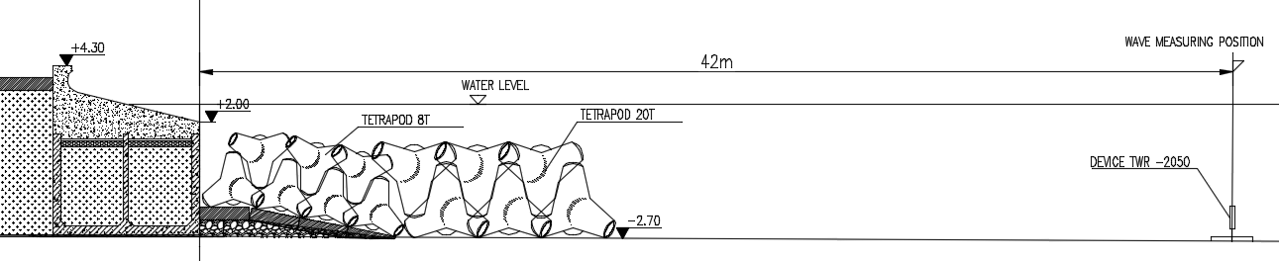

**Fig. 8.** Image of dike section and arrangement of measuring equipment

|  |  |
| --- | --- |
|  |  |

**Fig. 9.** Actual image of measuring position.

* 1. Changes and problems during measurement:

A overtopping flume and overtopping tank are designed as soon as there is an overflow. The overtopping flume is mounted on the wall of the dyke and the overtopping tank as showin Figure 10.

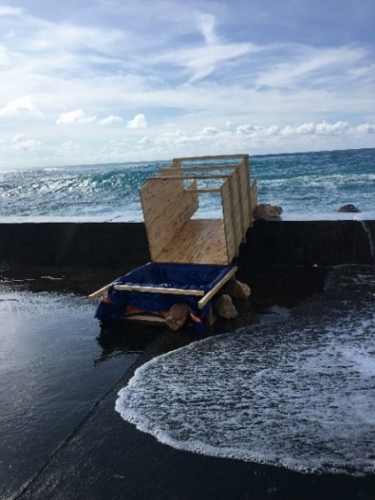

**Fig. 10.** Image of overtopping tank and overtopping tanks.

The overtopping flume is often unstable due to oblique waves impacting on the flume wall as shown in Figure 11. The research team has cut the flume wall to put it on the dyke crest wall, reduced the height of the flume wall and arranged more supports as in the original design to keep the receiver stable. Add ice on the stand and overtopping tank to increase stability as shown in Figure 12

|  |  |
| --- | --- |
| **Fig. 11.** Image of the position of oblique waves impacting on the overtopping flume | **Fig. 12.** The image of the new overtopping flume plan |

During the measurement, the overtopping flume was broken due to the large wave hitting the dyke crest wall, creating a large amount of water that shot up and then fell, a very large amount of water fell from above creating a strong force to break the bottom plate of the overtopping flume. The process of wave impact on overtopping flume and damage is shown in Figure 13.

|  |  |
| --- | --- |
|  |  |
|  |  |
|  |  |
|  |  |

**Fig. 13.** Image the process of wave impact on the overtopping flume and damage to the overtopping flume

The authors increase the stiffness of the bottom plate of the overtopping flume by reinforcing wooden ribs, mica panels on the face and supporting legs as shown in Figure 14.

|  |  |
| --- | --- |
|  |  |

**Fig. 14.** Image of reinforcement of the overtopping flume and overtopping tank

* 1. Measurement results::

Wave data, at the continuous measurement location, include the following factors: Hs significant wave height, H1/10 wave height, Hmax wave height, and main wave direction. According to statistics collected during the first phase of the survey, which was 6 days (from May 2, 2022 to May 8, 2022), the time step was 5 minutes with the measuring position TWR2. The results of processing and analysis give some statistical characteristics of waves in Table 2.13 as follows:

**Table 2.** The largest wave parameters of the measuring station

|  |  |  |  |  |  |  |  |
| --- | --- | --- | --- | --- | --- | --- | --- |
| **Measurement location** | **Date** | **Tp**  **(s)** | **Hm0**  **(m)** | **H10 (m)** | **Hmax (m)** | **Hmean (m)** | **The biggest wave direction** |
| Measuring position TWR2 | 04/5/202 | 7.93 | 2.73 | 3.71 | 4.74 | 1.64 | NE-N |

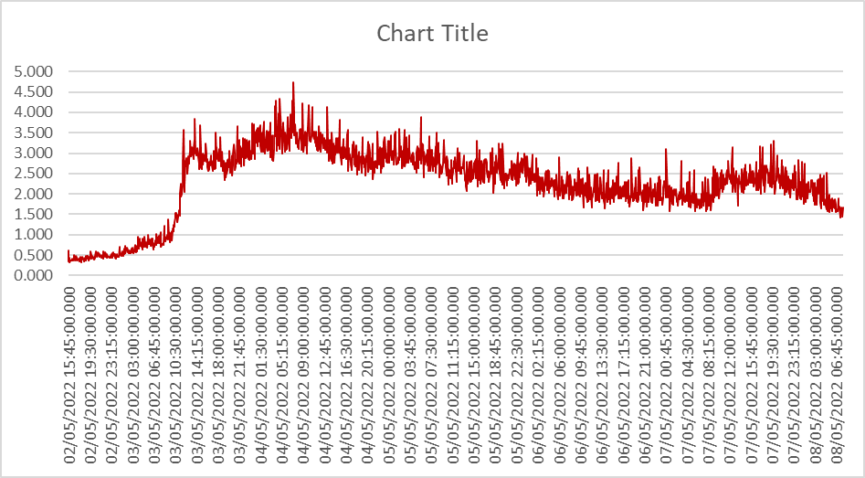

**Fig. 15.** Variable maximum wave height at measuring position TWR2

The measurement results show that the overtopping discharge is quite large, especially from May 3, 2022 to May 6, 2022.

**Table 3.** Result table of overtopping discharge

|  |  |  |  |  |  |
| --- | --- | --- | --- | --- | --- |
| Order | Measurement date | Measurement start time | Measurement end time | Total measurement time  (hour) | Overtopping discharge  (liter) |
| 1 | 03/05/2022 | 14h55 | 15h55 | 1 | 290 |
| 2 | 04/05/2022 | 15h30 | 16h30 | 1 | 740 |
| 3 | 05/05/2022 | 15h55 | 16h55 | 1 | 320 |
| 4 | 06/05/2022 | 7h50 | 8h50 | 1 | 445 |
| 5 | 06/05/2022 | 8h50 | 10h | 1.167 | 590 |
| 6 | 06/05/2022 | 10h | 10h50 | 0.833 | 410 |
| 7 | 06/05/2022 | 10h50 | 11h15 | 0.417 | 350 |

|  |  |
| --- | --- |
|  |  |

**Fig. 18.** Overtopping discharge measurement image.

1. Conclusion

The authors have described the actual process of measuring the overtopping waves, giving a feasible, mobile and flexible solution suitable for measuring the overflow on emerged islands far from the shore. The set of actual measured results can be used as data for calibration and comparison with mathematical and physical models.

Acknowledgements:

This research is funded by Hanoi University of Civil Engineering (HUCE) under grant number 05-2023/KHXD-TĐ. The authors would like to express their sincere thanks for their support and provide some results of subproject DDTB11.4-GĐ3 for this paper.

References

1. EurOtop Manual-Final (2nd Edition, Dec 2018).
2. Pullen, T., Allsop, N.W.H., Bruce, T., Geeraerts, J., 2004. Violent wave overtopping: clash field measurements at Samphire Hoe. Proceedings of Proc. Conf. Coastal Structures ’03, Portland. A.A. Balkema, Rotterdam. In press.
3. Franco, L., Bellotti, L., Briganti, G., De Rouck, R., Geeraerts, J.,2004. Field measurement of wave overtopping at Ostia yacht harbour breakwater. Proceedings of Proc. Conf. Coastal Structures ’03, Portland. A.A. Balkema, Rotterdam. In press.
4. Peter Trocha,*, Jimmy Geeraertsa, Bjorn Van de Wallea, Julien De Roucka, Luc Van Dammeb, William Allsopc, Leopoldo Francod,. Full-scale wave overtopping measurements on the Zeebrugge rubble mound breakwater. Coastal Engineering 51 (2004) 609 – 628
5. Trung Dung Nguyen, Xuan Tinh Nguyen. Studying the suitable dike section to reduce the flow of overflow waves by Bouss2D model for Gia Loc- Van Chan dike section, Cat Hai district- Hai Phong. Journal of Construction Science and Technology, No. 28/03-2016: 104–111
6. Van Dung Nguyen, Xuan Roanh Le, Quang Tuan Thieu. Study on the effect of nose sneeze on flow. Journal of science, technology, irrigation and environment - No. 50 (September 2015):127-132.