Damage detection in beam-like structures via frequency response function

Tran-De-Nhat Truong1,2, Tan-Phu Vo1,2, Hoang-Tang Phan1,2, Thanh-Cao Le1,2,3, and Duc-Duy Ho1,2*

1Faculty of Civil Engineering, Ho Chi Minh City University of Technology (HCMUT), Ho Chi Minh City, Vietnam

2Vietnam National University Ho Chi Minh City, Ho Chi Minh City, Vietnam

3Faculty of Civil Engineering, Nha Trang University, Nha Trang, Vietnam

*Corresponding author: [hoducduy@hcmut.edu.vn](mailto:hoducduy@hcmut.edu.vn)

**Abstract.** In this paper, a method is developed to detect the damage’s occurrence and location in beams using frequency response function (FRF). This method is applied to a steel beam whose damage is created by reducing the bending stiffness of the beam’s element. Additionally, this study is conducted in three steps of structural health monitoring. Firstly, FRF data is collected in undamaged and damaged states. Secondly, the occurrence of the damage is evaluated by the correlation coefficient of the FRF. Finally, a frequency response function-based index (FRFBI), which is used for detecting the damaged location, is proposed from the results of vibration analysis for the beam simulated by ANSYS software. This study indicates that the FRF-based damage detection method gives the results with high accuracy in both the occurrence and location of the damage.

**Keywords:** Beam-like structures,Damage detection, Frequency response function, Structural health monitoring, Vibration.

1. Introduction

Beam-like structures are common in civil infrastructures. Due to the beam’s important roles, the development of new damage identification methods is necessary. Over the years, many researchers have developed various beam structural health monitoring methods. Especially, detecting the damage in beams using the frequency response function has received more attention. In the past, Özgüven [1] showed how to develop the method using the frequency response function to re-analyze the structure after the model was modified the feature parameters, which are expressed as mass matrix, stiffness matrix and resistance matrix. FRF data was theoretically calculated or experimentally measured for the modified structure. The author indicated that the results have a clear change when the parameters are modified. Thereafter, Ting et al. [2] presented the method to improve the sensitivity of FRF data. Overall, the basic idea of this method is to evaluate the amplitude of the frequency response function by comparing the theoretical value and the measured value.

Sampaio et al. [3] proposed the frequency response function curvature method to detect the damage location by collecting numerical data through the simply supported beam. De Roeck et al. [4] proposed the finite element method (FEM) and the FRF components of dynamic methods to identify the model-based damage. Besides, Lin et al. [5] discussed updating the damping coefficient for the structure and solving the complex problem of collecting the FRF data on the model that used the damping coefficient or without the damping coefficient. Afterward, Yan et al. [6] proposed the global vibration-based structural method to detect the damage by comparing the FRF shapes and other vibration parameters of the bridge structure. Liu et al. [7] proved using the imaginary part and normalization of the FRF shapes to localize the damage location before comparing them. Furthermore, Nuno [8] proposed the frequency response function curvature-based index to detect the damage severity of the bridge’s horizontal beams in Sweden under the certain condition. Mondal et al. [9] proposed the frequency response function curvature method at frequencies adjacent to natural frequencies to detect the damage location and considered the effect of random noise on the simply supported aluminum beam. Afterward, Esfandiari et al. [10] showed that the method avoided errors in analysis by using FRF data instead of free vibration data, especially when adjacent modes were extracted. Kumar and Reddy [11] proposed the new formula to make the frequency response function curvature smoother and applied it to identify the location and level of the damage in the beam. Murali [12] used the FADC index to identify the damage’s occurrence and severity in the structure by calculating the amplitude, the drift, and the shape of the FRF-based changes. Oskoui et al. [13], Zhou et al. [14], and Locke and colleagues [15] presented issues in the structure that should be regularly checked to detect the potential damage due to overload, environmental impacts, fatigue, and dynamic effects. Esfandiari et al. [16] proposed the model-updating method, which is used for identifying the location and level of the damage, based on the new sensitivity algorithm by observing the fluctuations of the FRF principal components. Kildashti et al. [17] monitored each span of the bridge and detected the damage's location and severity by optimizing the vehicle's characteristics. Recently, Zhan et al. [18] integrated the frequency response function and model updating to identify the location and level of the damage in the simply supported steel beam. Jalali and Rideout [19] used frequency response function (FRF)-based inverse dynamic substructuring and FRF-based model updating to detect, locate, and quantify the damage of the global structure.

Various studies have been conducted to minimize these errors and the complexity of the FRF data. However, not only the measurement process is complex and requires high accuracy but also the convergence of the calculation process is still slow. Considering the conditions mentioned above, this paper presents a method that is simple and uses only FRF data to detect the damage’s occurrence and location. Additionally, this study is conducted in three steps of structural health monitoring. Firstly, FRF data is collected in undamaged and damaged states. Secondly, the occurrence of the damage is evaluated by the correlation coefficient of the FRF. Finally, a frequency response function-based index (FRFBI), which is used for detecting the damaged location, is proposed from the results of vibration analysis for the beam simulated by ANSYS software. Especially, the frequency response function curvature method is applied to increase the sensitivity of the FRF data. A simply supported steel beam is selected for the study.

1. Frequency response function-based damage detection

The paper mainly adopts the damage detection method in beam-like structures via frequency response function and has two advantages. Firstly, using only FRF data to detect both the occurrence and location of the damage. Secondly, mathematical formulations are simple and effective. Consequently, the damage’s occurrence and location can be determined. This study includes three aspects, namely, the correlation coefficient of the FRF, the frequency response function-based index (FRFBI) and the damage threshold.

* 1. The correlation coefficient of FRF

Damage causes changes in structural parameters (such as mass, damping and stiffness), which lead to a change in the vibration response of the structure. With these changes, Kim et al. [20] identified the occurrence of the damage via the correlation coefficient of power spectral densities (CC of PSDs). In the same way, the correlation coefficient of the FRF (CC of FRF), which is used for early warning of the damage’s occurrence, is proposed. **Fig. 1** illustrates mathematical symbols in detail. The correlation coefficient of the FRF is expressed as shown in Equation :



where  and  are FRF at the *j*th node in undamaged and damaged states of the beam, respectively.  is the mean value of the FRF at the *j*th node corresponding to the *i*th frequency in undamaged and damaged states.  and  are the standard deviation of the FRF at the *j*th node at the *i*th frequency o in undamaged and damaged states.

* 1. Frequency response function-based index (FRFBI)

As mentioned above, to increase the sensitivity, the FRF data is applied with the second-order central difference formula through Equation and Equation in undamaged and damaged states, respectively:





whereis the distance between the measurement node *j*+1 and *j*-1.

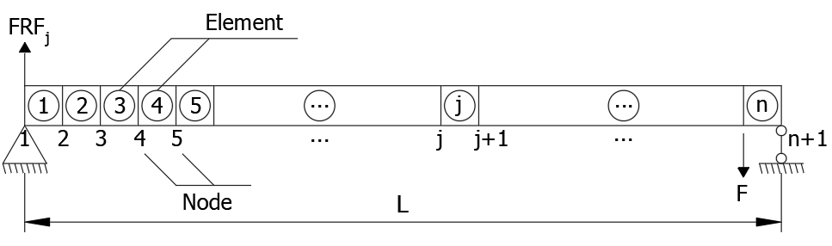

**Fig. 1.** A simply supported beam.

Damage directly affects the stiffness of the beam and leads to change in the FRF at that location. The frequency response function-based index (FRFBI) is proposed to identify the damage's location in beams. FRFBI is expressed as shown in Equation



where  is the deviation of the frequency response function.  is the mean deviation.  is the standard deviation. Afterward, the damage location is determined by normalizing the FRFBI index and is expressed as shown in Equation :



where  is the normalized index.  and  are the mean value and standard deviation of , respectively.

* 1. Proposed damage threshold

The identification of the damage zone in beams is based on the damage index after normalization. In the damage index graph of the whole beam, many damage elements have relatively large damage indexes compared to the others, and some elements aren’t damaged but they have the damage indexes that are greater than "0". Therefore, the damage threshold, which is calculated as a percentage of the largest damage index in beams, is proposed to identify the damage zones, as follows:

* + - : The *j*th node is considered damaged;
    - : The *j*th node is considered undamaged.

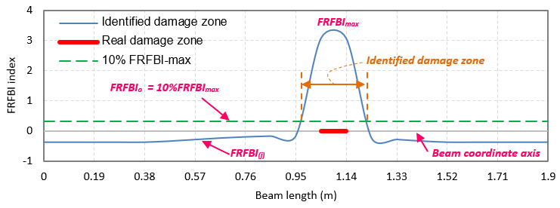

**Fig. 2.** Damage threshold, illustration: .

In this study,  is the threshold, which is used for detecting the zone of the damage (where  is the largest value of the damage index), Illustrated as shown **Fig. 2**.

1. Numerical verification
   1. Beam model

A simply supported beam shown in **Fig. 3** is used for verifying this study. The span of the simply supported beam is 1900 mm. The thickness and width are 20 mm and 150 mm, respectively. The material of the beam is steel with elastic modulus and density of MPa and 7850 kg/m3, respectively. The beam is evenly divided into 20 elemental structures and 21 nodes. To effectively stimulate the vibration of the bridge and reduce noise in the low-order mode of the simply supported beam, an impact load was applied on the 15th node. The damage was created by reducing the bending stiffness of the beam elements using three damage case scenarios listed in **Table 1.** The beam’s damage index is denoted by DI. 

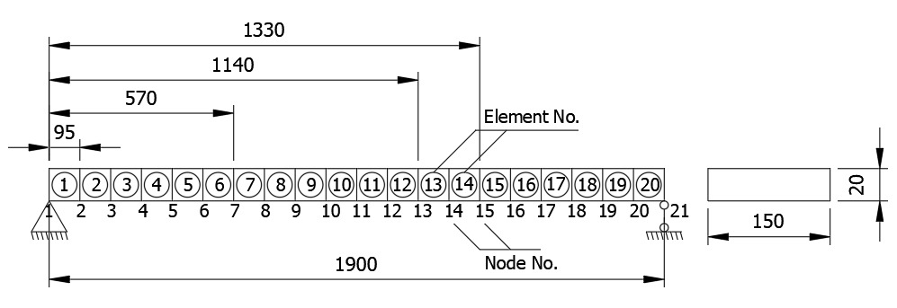

**Fig. 3.** Finite element model of the simply supported steel beam.

**Table 1.** Damage cases for the simply supported steel beam.

|  |  |  |
| --- | --- | --- |
| **Damage cases** | **Damage elements** | **DI** |
| Case 0 | 0 | 0 |
| Case 1 | No. 12 | 0.3 |
| Case 2 | No.6 | 0.1 |
| Case 3 | No.6, No. 12 | 0.5, 0.5 |

* 1. Natural frequency

To check the accuracy of the simulation, the natural frequencies of the intact beam are compared with the results calculated from the analytic theory [21]. The comparison results are presented in **Table 2**. In addition, with each different damage case, the natural frequency peaks have deviation and are shown in **Fig. 4**.

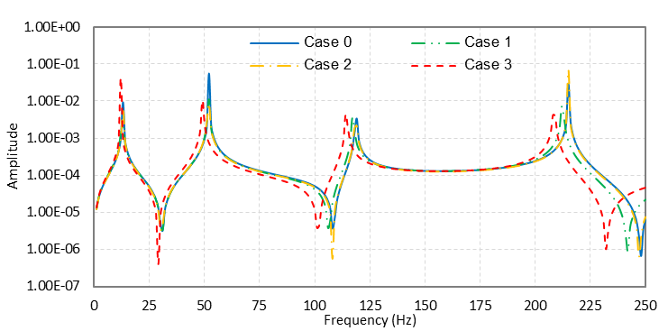

**Fig. 4.** Frequency response function (FRF) spectrum comparison between undamaged and damaged conditions at the 15th node.

**Table 2.** Natural frequency (Hz) comparison between this study and analytic theory (Case 0).

|  |  |  |  |
| --- | --- | --- | --- |
| **Mode** | **This study** | **Analytic theory**  **[21]** | **Difference**  **(%)** |
| Mode 1 | 12.904 | 12.869 | 0.27 |
| Mode 2 | 52.038 | 51.477 | 1.09 |
| Mode 3 | 118.690 | 115.823 | 2.48 |
| Mode 4 | 215.087 | 205.907 | 4.46 |

It can be seen from **Table 2** that the natural frequencies obtained from the ANSYS model are quite accurate compared to the analytic theory. The natural frequency peaks are similar between **Table 2** and **Fig. 4** (Case 0). Furthermore, the differences are smaller than 5%. Therefore, the simulation results are reliable.

* 1. Damage occurrence

When the correlation coefficient value is smaller than "1", it indicates that the damage has occurred in the beam. The nodes along the beam length show these changes. The 1st node (located 0.0 m) and the 21st node (located 1.9 m) are the boundaries of the beam so the values do not fluctuate and default to “1”.

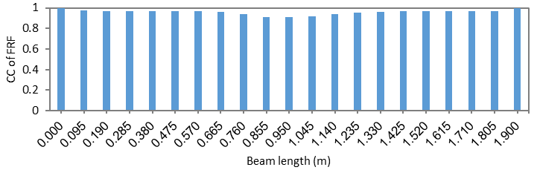

**Fig. 5.** The correlation coefficient of FRF for Case 1.

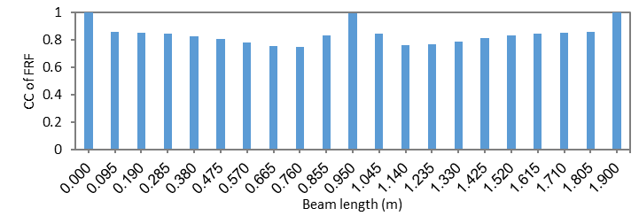

**Fig. 6.** The correlation coefficient of FRF for Case 2.

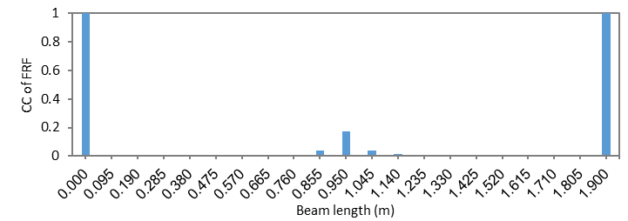

**Fig. 7.** The correlation coefficient of FRF for Case 3.

It can be seen from the three charts shown in **Fig. 5**, **Fig. 6**, and **Fig. 7** that the CC of FRF indicated the damage’s occurrence in both one location damage case and two locations damage case. Finally, the damage’s location is identified in Section 3.4.

* 1. Damage location

For the first damage scenario (Case 1), the FRFBI index is determined for the first 4 modes (Mode 1, Mode 2, Mode 3, Mode 4) and for the combination of 4 modes (i.e., All mode). In the first damage scenario, the first 4 modes are able to detect the damage’s location, as shown in **Fig. 8**a, b, c, and d. Practically, the case of all mode is selected as the priority mode because it helps to quickly identify the damage location. As shown in **Fig. 8**e, the result indicates that the FRFBI index detects the location of the real damage that is covered by the identification line of the damage.

|  |  |
| --- | --- |
| (a) | |
| (b) | (c) |
| (d) | (e) |

**Fig. 8.** The FRFBI damage index (Case 1); (a) All mode, (b) Mode 1, (c) Mode 2, (d) Mode 3, and (e) Mode 4.

For the second damage scenario (Case 2), the 6th element (located from 0.475 m to 0.57 m) is not the mid-beam position and the quantity of 10% reduction in the bending stiffness is quite small, but the FRFBI indexes show that the results of the damage detection for the first 4 modes are high accuracy (see **Fig. 9**a, b, c, and d). On the other hand, in All mode, the line graph of the FRFBI index identifies the position of the actual damage (see **Fig. 9**e) .

|  |  |
| --- | --- |
| (a) | |
| (b) | (c) |
| (d) | (e) |

**Fig. 9.** The FRFBI damage index (Case 2); (a) All mode, (b) Mode 1, (c) Mode 2, (d) Mode 3, and (e) Mode 4.

For the third damage scenario (Case 3), two damage locations are the 6th element (located from 0.475 m to 0.57 m) and the 12th element (located from 1,045 m to 1.14 m) with the same bending stiffness reduction (DI = 50%), the damage index plots of the first 4 modes show that the results are reliable. Especially, All mode identifies both two damaged elements, as shown in **Fig. 10**.

|  |  |
| --- | --- |
| (a) | |
| (b) | (c) |
| (d) | (e) |

**Fig. 10.** The FRFBI damage index (Case 3); (a) All mode, (b) Mode 1, (c) Mode 2, (d) Mode 3, and (e) Mode 4.

1. Conclusions

In this study, a new FRF-based damage detection method is proposed to identify the occurrence and location of the damage. The results of free vibration analysis in the steel beam are reliable. Therefore, the numerical simulation method can be applied in research work as the natural frequencies’ values are compared with analytic theory, and the difference does not exceed 5%. The correlation coefficients of the frequency response functions indicate that the values are smaller than 1 for three damage scenarios. This method effectively identifies the damage's occurrence. Finally, the frequency response function-based index (FRFBI) is the simple and effective formula for detecting the damage’s location. Overall, the main findings from this paper can be summarized as follows:

(1) The method uses only FRF data to identify both the occurrence and location of the damage.

(2) The method effectively detected the occurrence of the damage. In the three damage scenarios, the correlation coefficient of FRF indicated the occurrence of the damage in the steel beam.

(3) The FRFBI index positively detects the damage’s location when the steel beam has one damaged element or two damaged elements at the same time.

(4) The damage threshold, which shows the effectiveness of eliminating some noisy elements, is proposed for this method.

Acknowledgments

We would like to thank Ho Chi Minh City University of Technology (HCMUT), VNU-HCM for the support of time and facilities for this study.

References

1. H. N. Özgüven: Structural modifications using frequency response functions. Mechanical Systems and Signal Processing 4(1), 53–63 (1990).
2. T. Ting: Design sensitivity analysis of structural frequency response. AIAA Journal 31(10), 1965–1967 (1993).
3. R. P. C. Sampaio, N. M. M. Maia, and J. M. M. Silva: Damage detection using the frequency response function curvature method. Journal of Sound and Vibration 226(5), 1029–1042 (1999).
4. W. X. Ren and G. De Roeck: Structural Damage Identification using Modal Data. II: Test Verification. Journal of Structural Engineering 128(1), 96–104 (2002).
5. R. M. Lin and J. Zhu: Model updating of damped structures using FRF data. Mechanical Systems and Signal Processing 20(8), 2200–2218 (2006).
6. Y. J. Yan, L. Cheng, Z. Y. Wu, and L.Yam: Development in vibration-based structural damage detection technique. Mechanical Systems and Signal Processing 21(5), 2198-2211 (2007).
7. X. Liu, N. A. J. Lieven, and P. J. Escamilla-Ambrosio: Frequency response function shape-based methods for structural damage localisation.Mechanical Systems and Signal Processing 23(4), 1243–1259 (2009).
8. K. Nuno: Damage detection of a steel truss bridge using frequency response function curvature method. Stockholm 4289, (2013).
9. S. Mondal, B. Mondal, A. Bhutia, and S. Chakraborty: Damage detection in beams using frequency response function curvatures near resonating frequencies. Advances in Structural Engineering: Dynamics 2, 1563–1573 (2015).
10. A. Esfandiari, F. Shadan, and F. Khoshnoudian: A frequency response-based structural damage identification using model updating method. Structural Control and Health Monitoring 23(2), 286–302 (2016).
11. K. A. Kumar and D. M. Reddy: Application of frequency response curvature method for damage detection in beam and plate like structures. Materials Science and Engineering 149(1), 012160 (2016).
12. R. Murali: Damage Detection of Beam Structure using Frequency Response Functions. SSRG International Journal of Civil Engineering 3(1), 5–9 (2016).
13. E. A. Oskoui, T. Taylor, and F. Ansari: Method and monitoring approach for distributed detection of damage in multi-span continuous bridges. Engineering Structures 189, 385–395 (2019).
14. C. Zhou, Y. Wu, G. Cui, A. Zhang, Y. Gao, X. Wang, J. Ouyang, H. Sun, Y. Liang, Z. Liu, L. Zhang,: Comprehensive measurement techniques and multi-index correlative evaluation approach for structural health monitoring of highway bridges. Measurement 152, 107360 (2020).
15. W. Locke, J. Sybrandt, L. Redmond, I. Safro, and S. Atamturktur: Using drive-by health monitoring to detect bridge damage considering environmental and operational effects. Journal of Sound and Vibration 468, 115088 (2020).
16. A. Esfandiari, M. S. Nabiyan, and F. R. Rofooei: Structural damage detection using principal component analysis of frequency response function data. Structural Control and Health Monitoring 27(7), e2550 (2020).
17. K. Kildashti, M. M. Alamdari, C. W. Kim, W. Gao, and B. Samali: Drive-by-bridge inspection for damage identification in a cable-stayed bridge: Numerical investigations. Engineering Structures 223, 110891 (2020).
18. J. Zhan, F. Zhang, and M. Siahkouhi: A Step-by-Step Damage Identification Method Based on Frequency Response Function and Cross Signature Assurance Criterion. Sensors 21(4), 1029 (2021).
19. M. H. Jalali, and D. G. Rideout: Substructural damage detection using frequency response function based inverse dynamic substructuring. Mechanical Systems and Signal Processing 163, 108166 (2022).
20. J. T. Kim, J. H. Park, D. S. Hong, and D. D. Ho: Hybrid acceleration-impedance sensor nodes on Imote2-platform for damage monitoring in steel girder connections. Smart Structures and Systems 7(5), 393–416 (2011).
21. A. K. Chopra: Dynamics of structures: Theory and applications to earthquake engineering*,* 5th edition, Pearson, Hoboken NJ (2017).